City of Richland
COMPREHENSIVE PLAN SUPPORTING ANALYSIS

October 3, 2017

Prepared for:
City of Richland

Prepared by:
Oneza & Associates

With assistance from: Anchor QEA ECONorthwest
    - Engineers Inc.

TABLE OF CONTENTS

Table of Contents iii
Introduction and Background 1
Section One 1
Introduction 1
Economic Development 5
Section One 5
Introduction 5
Section Two 5
Existing Conditions 5
Future Growth Forecasts 17
Section Three 19
Challenges and Opportunities 19
Land Use 21
Section One 21
Introduction 21
Section Two 21
Description of Land Uses 21
Section Three 25
Population Trend 25
Population Forecast 26
Future Land Capacity 27
Addressing the Demand 30
Section Four 33
Natural Environment 33
Housing 36
Section One 36
Introduction 36
Section Two 36
Exinting Inventory and Programs 36
Section Three 37
Projected Needs 37
Transportation 38
Section One 38
Introduction 38
Section Two 39
Existing Conditions 39
Section Three 43
Level of Service 43
Section Four 45
Deficiencies and Improvements 45
Utilities 65
Section One 65
Introduction 65
Section Two 66
Wastewater Facilities 66
Section Three 71
Water Supply System 71
Section Four 75
Storm Water System 75
Section Five 79
Solid Waste Management 79
Section Six 85
Energy/Electrical Power 85
Utilities by Other Providers 89
Section One 89
Natural Gas Supply 89
Section Two 89
Telecommunications 89
Section Three 91
Irrigation District Facilities 91
Capital Facilities 92
Section One 92
Introduction 92
Section Two 93
Parks, Recreation, and Open Space 93
Section Three 103
Municipal Facilities 103
Section Four 109
Fire and Emergency Services and Facilities 109
Section Five 112
Police Service Facilities 112
Section Six 116
Library Facilities 116
Section Seven 117
Schools 117
Section Eight 121
Essential Public Facilities 121
References 122

List of Figures
Figure ED-1: Real GDP Kennewick-Richland Metropolitan Statistical Area (in millions) 6
Figure ED-2: Benton and Franklin County Annual Population Growth, 2000-2016 6
Figure ED-3: GDP per Capita, 2001-2015 7
Figure ED-4: Benton and Franklin Counties Cumulative Employment by Sector 8
Figure ED-5: Benton and Franklin Counties Cumulative Percent Employment Growth by Sector 8
Figure ED-6: Benton and Franklin Counties Employment Concentration and Change by Sector,
2006-2015.................................................................................................................................................................................. 9
Figure ED-7: Hanford and PNNL Employment, Fiscal Year 2009 to Fiscal Year 2016 10
Figure ED-8: Commercial Building Sizes and Types in Richland 11
Figure ED-9: Labor Force Participation 12
Figure ED-10: Total Employment, 1990 - 2016 12
Figure ED-11: Unemployment Rate, 1990 - 2016 12
Figure ED-12: Median Household Income 13
Figure ED-13: Share of Population Living in Poverty, 2011 - 2015 13
Figure ED-14: Age Distribution, Average from 2011 – 2015 14
Figure ED-15: Select Category Sales, Richland in 2016 Dollars (in Millions) 15
Figure ED-16: Taxable Retail Sales in Millions Indexed to 2000 16
Figure LU-1: Population Growth in Richland in the Last 10 Years 26
Figure LU-2: Richland and Benton County’s Population Forecast 27

Figure LU-3: Future Land Use Map 32
Figure T-1: Functionally Classified Roads 53
Figure T-2: Number of Lanes 54
Figure T-3: Intersection Traffic Control 55
Figure T-4: 2016 All Day Traffic Counts 56
Figure T-5: 2016 Peak Traffic Volumes 57
Figure T-6: Bike Routes and Paths 58
Figure T-7: Airport and Port Facilities 59
Figure T-8: Transit Routes 60
Figure T-9: Volume to Capacity Ratio 61
Figure T-10: Intersection Traffic Control Evaluations 62
Figure T-11: 2017 - 2022 Six-Year TIP 63
Figure T-12: Transportation Improvements 64
Figure U-1: Utility Service Areas 65
Figure U-2: Sanitary Sewer Mains 70
Figure U-3: Water Mains 74
Figure U4: Storm Water 78
Figure U-5: Solid Waste 84
Figure U-6: Major Electrical Transmission Lines 88
Figure CF-1: Parks, Schools and Open Space 102
Figure CF-2: Municipal Facilities 108
Figure CF-3: Emergency Service Zone 111
Figure CF-4: Code Enforcement Incidents 113
Figure CF-5: Police Patrol Zone 115
Figure CF-6: Schools 120

INTRODUCTION AND BACKGROUND

SECTION ONE

INTRODUCTION
This document elaborates on the discussion in the Core Comprehensive Plan. It also contains technical analysis of most of the Comprehensive Plan elements. Organization of this document follows the same hierarchy of elements as in the Core Comprehensive Plan with additional information included in it.
Every comprehensive plan must include key pieces to fulfill its purpose of providing a yardstick for future government activities. The following terms have special meanings in comprehensive planning and it’s important to understand their meaning and purpose.
Vision Statement: The Vision Statement is the target the City decides to aim for. It is a verbal picture of what Richland will be like at the end of the period covered by a comprehensive plan. An important part of future decision-making should be to ask, “Which of our choices will best help us become like the City described in the vision statement?”
Existing Conditions Inventory: We can’t decide how to get from the present to our desired future without a clear picture of where we are today. That’s why comprehensive plans must include a detailed inventory of the existing state of the City: How are our roads? Is our water system adequate to accommodate future growth? Do we have the parks and other recreation facilities to satisfy the community’s desire for such public amenities?
Goals: If the Vision Statement defines the target for comprehensive planning, then goals are like individual points on the target. We set as goals the distinct achievements we hope for: maintain adequate and affordable housing; avoid traffic congestion; protect natural resources; ensure economic vitality. We have reached our vision if all our goals are accomplished.
Policies: Goals are what we want to accomplish; policies define how we accomplish them. For each goal established in a comprehensive plan, one or more policies define the steps that goal calls for. If we have a goal of protecting natural resources, for example, we might establish a policy that says that development shall be restricted on and near wetlands.
Planning Time Frame: A comprehensive plan must define time frames for achieving its vision and goals. These time frames are called the planning horizons. In Washington State, comprehensive plans use both a ten-year short-term planning horizon and a 20-year long-term planning horizon. The long- term planning horizon is the full period for achieving the vision in our Vision Statement. The short- term planning horizon is the period for which we can make more concrete plans for specific steps toward our goals.
These are the features that a Comprehensive Plan needs to include in order to act as our yardstick for the future. The Comprehensive Plan must apply these features to specific aspects of the City’s life. The parts of a plan addressing each of these are commonly called “elements.” Under State law, all Washington city and county comprehensive plans must address at least five specific elements: land use, transportation, utilities, capital facilities, and housing. Each element includes an inventory of existing conditions as well as goals and policies specific to the element. In addition to the required

five elements, the City of Richland has chosen to include an optional economic development element in this Comprehensive Plan.
The final feature of comprehensive plans in Washington is a Finance Plan. This is the proposal for specific capital improvements required over the short-term (six-year) planning horizon. It describes projects to be carried out, their estimated costs, a schedule for completing them, and a plan to pay for them. Financing plans from the City’s Capital Improvement Plan (CIP) are included under the Capital Facilities and Utilities Chapters in this document.
GMA AND BACKGROUND
The Washington State Growth Management Act (GMA) includes 14 broad goals for comprehensive planning, which local governments must balance to develop an approach consistent with their vision of the future. The 14 GMA goals are as follows:
      - Urban Growth - Encourage development in urban areas where adequate public facilities and services exist or can be provided in an efficient manner.
      - Reduce Sprawl - Reduce inappropriate conversion of undeveloped land into sprawling, low- density development.
      - Transportation - Encourage efficient multi-modal transportation systems based on regional priorities and coordinated with county and city comprehensive plans.
      - Housing - Encourage the availability of affordable housing to all economic segments of the population of the state, promote a variety of residential densities and housing types, and encourage preservation of existing housing stock.
      - Economic Development - Encourage economic development throughout the state consistent with adopted comprehensive plans, promote economic opportunity for all citizens of the state, especially for the unemployed and the disadvantaged, and encourage growth in areas experiencing insufficient economic growth, all within the capacity of the state’s natural resources, public services, and public facilities.
      - Property Rights - Private property shall not be taken for public use without just compensation. The property rights of landowners shall be protected from arbitrary and discriminatory action.
      - Permits - Application for state and local government permits should be processed in a timely and fair manner.
      - Natural Resource Industries - Maintain and enhance natural resource-based industries, including productive timber, agricultural, and fisheries industries. Encourage the conservation of productive forest lands and productive agricultural lands, and discourage incompatible uses.
      - Open Space and Recreation - Encourage the retention of open space and development of recreation opportunities, conserve fish and wildlife habitat, increase access to natural resource lands and water, and develop parks.
      - Environment - Protect the environment and enhance the state’s high quality of life, including air and water quality, and the availability of water.
      - Citizen Participation and Coordination - Encourage the involvement of citizens in the planning process and ensure coordination between communities and jurisdictions to resolve conflicts.

      - Public Facilities and Service - Ensure that public facilities and services necessary to support development are adequate to serve the development at the time the development is available for occupancy and use, without decreasing the current service levels below locally established minimum standards.
      - Historic Preservation - Identify and encourage the preservation of lands, sites, and structures that have historical or archaeological significance.
      - Shoreline Management – Develop a Shoreline Master Program (SMP) pursuant to Shoreline Management Act (SMA). The goals and policies of a shoreline master program for a county or city approved under chapter 90.58 RCW shall be considered a part of the county or city's comprehensive plan.
Under the GMA, comprehensive plans should identify essential public facilities that often are difficult to site and ensure that locations for them will be available. These facilities include airports, state education facilities, state, or regional transportation facilities, state and local correctional facilities, solid waste handling facilities, and in-patient facilities including substance abuse facilities, mental health facilities, and group homes. Local comprehensive plans may not prevent outright the location or provision of such facilities. Richland will participate in the siting study for any of these facilities when they are identified for potential siting within the City.
CONSISTENCY AND CONCURRENCY
GMA requires that the Comprehensive Plan must be internally consistent for objectives, goals, policies, text, and maps. At the same time, the comprehensive plans of adjacent jurisdictions must also be consistent and capital budget decisions must be made in conformance with each jurisdiction’s adopted Comprehensive Plan.
The consistency progresses from the broad goal, through its policies, and then to specific actions. The maps of the Plan augment both the text and even the goals and policies. For example, the land use map included in the Land Use Element is, in essence, a graphic policy statement regarding future land development in Richland. As such, the land use policy serves, and is served by, the transportation, housing, utilities, and capital facilities elements. Based upon the land use designations on the Land Use Map, private and public sector service providers can project future locational demands for water, sewer, natural gas, electrical power, roads, fire protection, transit, emergency response, communications, and other services
All development regulations within the City of Richland are required to match with each other and with the Comprehensive Plan. These include the zoning and subdivision codes, the Critical Areas Ordinance, the Shoreline Master Program, and any other City regulation as contained in the Richland Municipal Code and other adopted plans such as the Park & Recreation Plan and the Storm Water Management Plan. A complete listing of adopted plans is included as an Appendix of the Core Comprehensive Plan.
The consistency also applies to adjacent jurisdictions such as Benton County, through the County- wide Planning Policies (CWPP), and the adjacent cities of West Richland and Kennewick.
GMA defines concurrency to mean that needed improvements for water, sewer, and transportation are in place at the time of development; or in the case of transportation, that a financial commitment exists to complete the improvements within six years.
There must be a baseline standard established to use when evaluating the anticipated impacts of new development to determine if concurrency can be met. The minimum acceptable performance level has been chosen as the baseline, and is defined as the level of service (LOS). Levels of service should

be realistic. Setting them too high could result in little or no growth, and would be contrary to GMA. Setting them too low could cause unmanaged growth without optimum service.
AMENDMENTS
Amendments to the comprehensive plan are legislative actions requiring City Council approval. Amendments must be approved as prescribed by GMA. With a few exceptions, they cannot be considered more often than once per year and in accordance with specific procedures. Major updates occur by legislative action on an eight-year cycle as established by RCW 36.70A.130 (4)(c).
Amendments can be requested by the City or by private individuals. Multiple applications for amendments will be considered in a single legislative review process in order to evaluate the potential cumulative effect of the requests. All amendment requests require a public hearing with the Planning Commission. They make a recommendation to the City Council. The City Council will approve or deny the amendments in a public hearing. Public involvement with this process is required and encouraged through direction of the Richland Public Participation Plan.
Annual amendments will address the issues of major or minor land use classification changes; changes to the goals, policies, and text of the comprehensive plan; changes to supporting data and implementation; changes to the land use maps; and changes to the inventories and technical documents.
Every ten years, the annual amendment review may be combined with the required review of the urban growth area to determine the next twenty-years’ anticipated growth. This ten-year review will use the comprehensive plans of each county and city and the permitted densities of the incorporated and un-incorporated areas pursuant to RCW 36.70A.130(3).
Exceptions to the annual amendment limitation, according to RCW 36.70A.130, include the adoption of a subarea plan; the development of an initial subarea plan for economic development located outside of the one hundred year floodplain in a county that has completed a state-funded pilot project that is based on watershed characterization and local habitat assessment; shoreline master programs; or the amendment of the capital facilities element occurring concurrently with the adoption or amendment of the City’s budget.

ECONOMIC DEVELOPMENT

SECTION ONE

INTRODUCTION
PURPOSE
The economic development element of the comprehensive plan is intended to guide investments through a framework of strategy and policy with the overall goal of growing economic opportunities in the City. The intent is to identify sound economic development practices to build a strong economy where local businesses are welcomed and encouraged by the City and ensure the economy is resilient, dynamic, and sustainable for current and future generations.
The City’s ability to understand their competitive advantages and proactively work to attract cutting edge employers will in turn create more living wage jobs which will in turn produce municipal revenues for maintaining and enhancing quality service levels, infrastructure, and facilities.
Strategies outlined in the economic development element are designed to work in concert with the other comprehensive plan elements herein. This element is intended to be consistent with and build upon existing documents such as the policies and strategies outlined in the CWPP, Strategic Leadership Plan, and community visioning documents. The roles of the policies laid out in this plan are to 1) create strong City leadership for economic development, 2) ensure that appropriate land capacity and infrastructure can support future employment and housing growth, and 3) articulate a business environment that supports a dynamic, prosperous, and equitable economy.
BACKGROUND AND OVERVIEW
Washington State’s GMA includes economic development as a central goal and integral to a thriving city. Economic development connects to and is instrumental in informing the other elements of the comprehensive plan; without a strong local economy, goals related to land use, housing, capital planning, and transportation serve little value.
It is due to the hard work and good fortune of the residents and businesses located in the City of Richland that the City has a strong and growing economic base. It is important, however, to consider Richland within the context of the other two Tri-Cities – Pasco and Kennewick – to which the region’s economy is inextricably linked.
The City of Richland’s economy is explored in this section by first examining what drives the growth in the regional economy and then discussing Richland’s role in the economy and some implications for growing as part of this plan.

SECTION TWO

EXISTING CONDITIONS
REGIONAL ECONOMIC TRENDS
Gross Domestic Product
The economy of the Tri-Cities region is primarily a service-based economy. Goods producing industries (such as manufacturing) make up less than 25 percent of the total economic output. Figure

ED-1 shows the trend of gross domestic product (GDP) in 2016 inflation-adjusted dollars. The Tri- Cities economy was less impacted by the recession in 2008 than the rest of the nation due to the increase in employment at Hanford and PNNL as part of the American Recovery and Reinvestment Act (ARRA) of 2009. The total output declined from $10.3 billion in 2010 to $8.6 billion in 2014, partly due to the end of ARRA and partly reflecting the national recession trends. However, most recent data (not shown) have indicated that economic conditions have continued to improve over the past two years.
Figure ED-1: Real GDP Kennewick-Richland Metropolitan Statistical Area (in millions)
2004 2005 2006 2007 2008 2009 2010 2011 2012 2013 2014
$0
$2,000
Private services- providing industries
$4,000
Private goods- producing industries
$8,000

$6,000
$10,000
$12,000
Source: Bureau of Economic Analysis, 2016
The Tri-Cities region (Benton and Franklin Counties) has realized strong population growth over the last 20 years, averaging an annual growth rate of 2.4 percent. Much of that growth occurred in the mid 2000’s fueled by in-migration responding to the growth in jobs, but population growth has slowed since 2010. Calendar year 2015 was the first year in 20 years where net in-migration was nearly zero, where the same amount of people moved out of the region than to the region.

Figure ED-2: Benton and Franklin County Annual Population Growth, 2000-2016

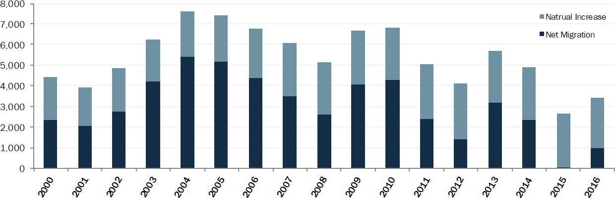
Source: Washington Office of Financial Management, 2016
On a GDP per capita basis, the Tri-Cities region is not as productive when compared to Washington State and to the nation. On this measure, the region has been slower to recover than the state as whole. GDP per capita is the most common economic performance indicator of regions. GDP per capita is calculated by measuring Gross Domestic Product in a year, and dividing it by the population. The reasons for the lower GDP per capita in the region are complex but are due to the large presence of government-supported activities. These activities are, on the whole, less productive than emerging information technology or business services, which have become increasingly productive by comparison.
Figure ED-3: GDP per Capita, 2001-2015
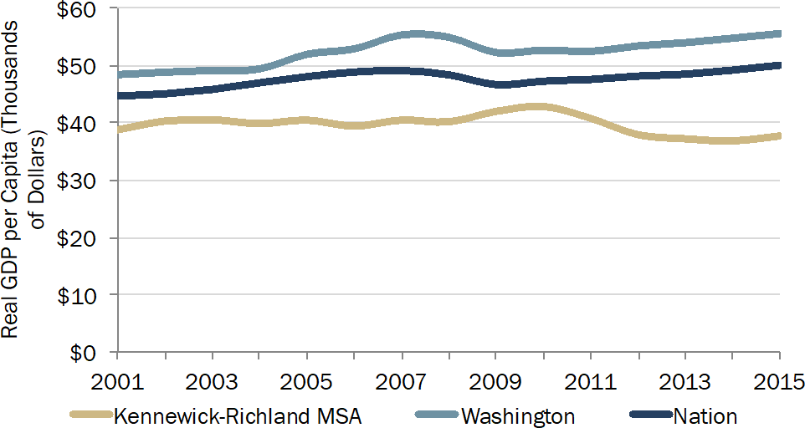
Source: Bureau of Economic Analysis, 2016

EMPLOYER TRENDS
The Tri-Cities is unique in that its employment base is dominated by a select number of large employers. Roughly one in five of estimated 116,000 jobs in the Benton-Franklin area are for one of the ten largest firms/agencies listed below. Eight of the ten top employers in the Tri-Cities are located in Richland, a legacy largely of significant federal investments in the Hanford Nuclear Reservation. These sectors employ many talented workers, many of whom live in Richland.

Table ED-1: Top Ten Tri-Cities Employers

 | Company | Industry | Employees
1 | Battelle/Pacific Northwest National Laboratory | Research & Development | 4,365
2 | Kadlec Regional Medical Center | Health Services | 3,304
3 | Bechtel National | Engineering & Construction | 2,898
4 | ConAgra Foods | Food Processing | 2,727
5 | Kennewick School District | Education | 2,130
6 | Washington River Protection Solutions | Environmental Remediation Services | 2,077
7 | Pasco School District | Education | 2,015
8 | Mission Support Alliance, LLC | Support Services, Hanford/DOE Site | 1,928
9 | Richland School District | Education | 1,500
10 | CH2M Hill | Environmental Remediation Services | 1,400
Source: Tri-City Development Council (TRIDEC), link. Accessed February 14, 2017

Total Employment by Industry Sector
Employment in the Tri-Cities region increased from 2006-2015 by over 22,000 jobs with an average annual growth rate of 2.0 percent. There are roughly 116,000 jobs in the region. All industries experienced positive employment growth by the end of the 10-year period. However, from 2011 to 2014 employment slightly declined as spending cuts at Hanford impacted the entire regional economy.
Figure ED-4: Benton and Franklin Counties Cumulative Employment by Sector
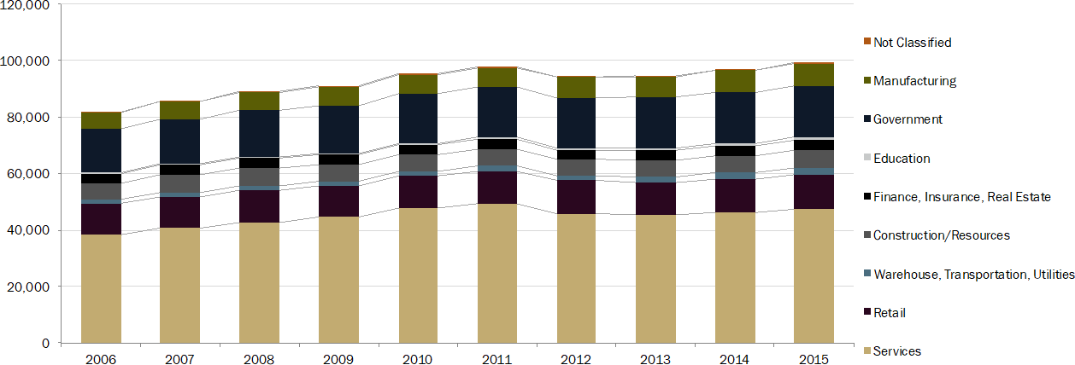
Source: Washington State Employment Security Department
Education, while small in total numbers, grew the most in the region. Warehousing, transportation, and utilities; manufacturing; wholesale trade (the main users of industrial land); and agriculture all grew faster than the regional average. Employment in the retail and finance, insurance, and real estate sectors grew the least.
Figure ED-5: Benton and Franklin Counties Cumulative Percent Employment Growth by Sector

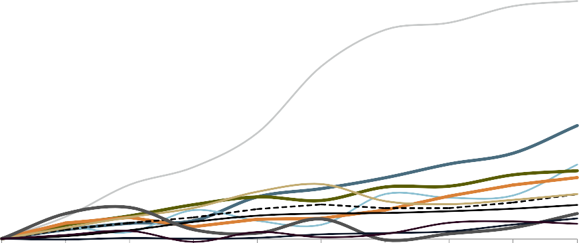
Source: Washington State Employment Security Department
The chart below shows the local concentration of jobs by sector (location quotient) along with measures of industry size and average annual employment change in the Tri-Cities region. Location quotients measure the concentration of jobs in a sector compared to the statewide average. A value of 1.0 signifies that the sector possesses the same level of employment concentration as the state. Values above 1.0 are more concentrated than the state average. The size of the bubble represents the number of jobs within that sector. Sectors with sizable employment and higher than average concentration, represent strengths for the region. Fast growing sectors, even if they are not very large, represent potential opportunity areas.
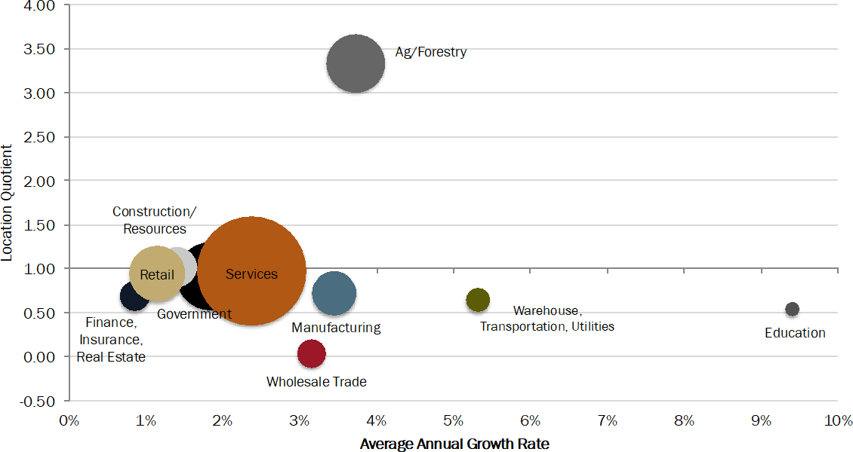Figure ED-6: Benton and Franklin Counties Employment Concentration and Change by Sector, 2006-2015
Source: Washington State Employment Security Department
In the Tri-Cities region, the largest sectors - services and government - have a similar concentration as the state and the region are growing at a rate of one to three percent a year, indicating they are the base of the regional economy. The agriculture sector is a strength in the Tri-Cities; it is much more

concentrated relative to the state and is growing at a rate of 3.7 percent per year. Education; manufacturing; wholesale trade; and warehousing, transportation, and utilities are also growing at a rate of more than three percent a year, but are smaller and less prevalent in the Tri-Cities compared to the state. Much of the growth in food manufacturing; wholesale trade; and warehousing, transportation and utilities may be related to the growth and prevalence of the agriculture sector in the Tri-Cities.
Hanford Employment
While total employment increased over the last ten years, employment at Hanford decreased by over 2,800 jobs in the 2012 fiscal year as part of federal spending cuts. This decrease was part of a region- wide decline in employment from 2012 and 2013, and also the end of ARRA funding. It may also be what led to the decrease in regional GDP shown in Figure ED-1.
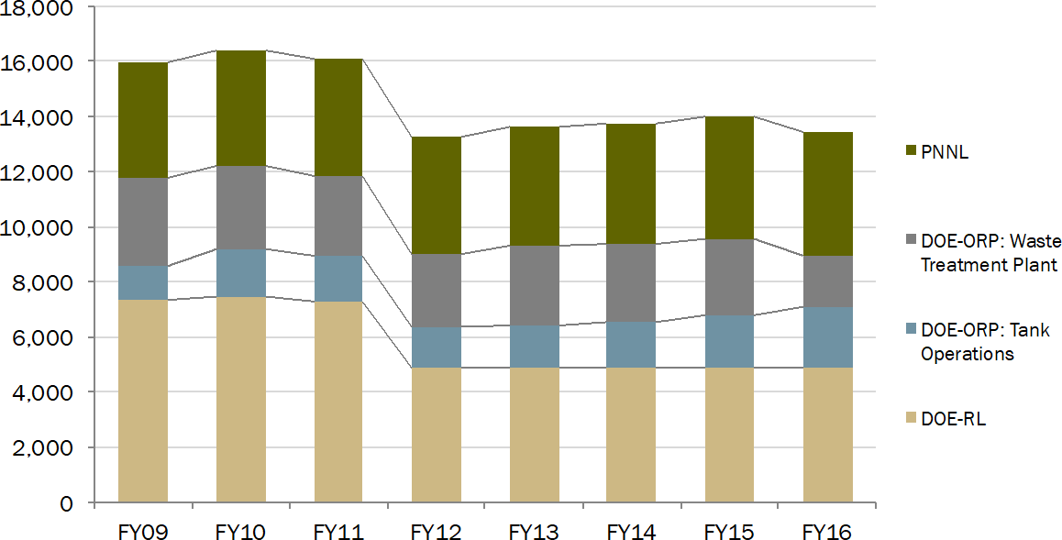Figure ED-7: Hanford and PNNL Employment, Fiscal Year 2009 to Fiscal Year 2016
Source: Tri-City Development Council (TRIDEC), 2016

COMMERCIAL REAL ESTATE TRENDS
With much of the Hanford, PNNL and health care activities located in Richland, the City is home to much of the built commercial real estate in the region. It trails only Kennewick, which is home to the region’s shopping malls. According to the Benton County Assessor, Richland holds the highest share of office and industrial building square footage but lags considerably with respect to retail businesses, primarily located in Kennewick.
Figure ED-8 below shows that office and retail uses are clustered in the downtown core as to be expected; retail is also heavy but isolated near the Queensgate area; a considerable amount of industrial development is located to the north in Horn Rapids; and a cluster of office and retail to the south in Island View.

Table ED-2: Building Square Footage, by Type

Use | Richland | West Richland | Kennewick | Prosser | Rest of County | Total
Retail | 2,775,000 | 205,000 | 5,089,000 | 421,000 | 123,000 | 8,613,000
Industrial | 2,803,000 | 282,000 | 2,475,000 | 924,000 | 1,381,000 | 7,866,000
Office | 3,259,000 | 52,000 | 2,645,000 | 110,000 | 57,000 | 6,123,000
Accommodations | 462,000 | - | 633,000 | 54,000 | - | 1,149,000
Other | 326,000 | 59,000 | 1,087,000 | 57,000 | 259,000 | 1,788,000
Total Commercial | 9,626,000 | 597,000 | 11,930,000 | 1,566,000 | 1,821,000 | 25,540,000
Source: Benton County Assessor, 2016, Washington Office of Financial Management Estimates.
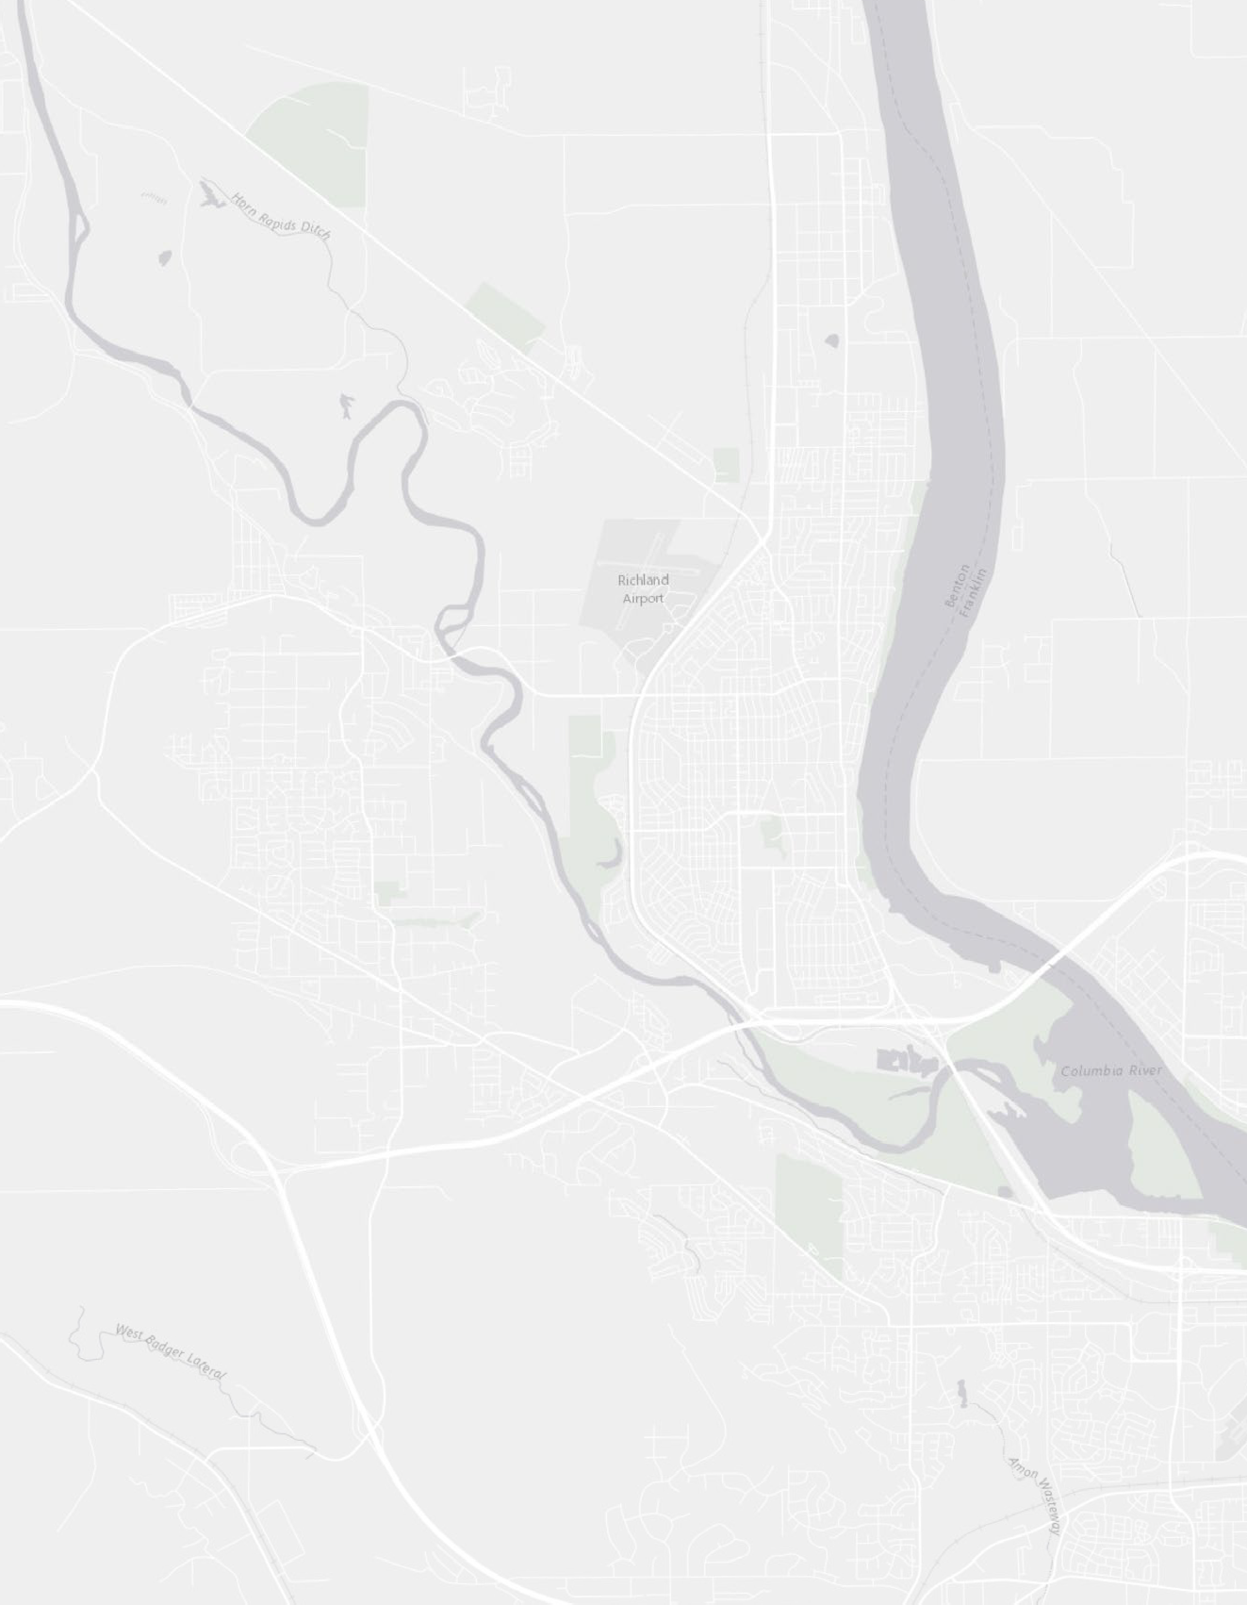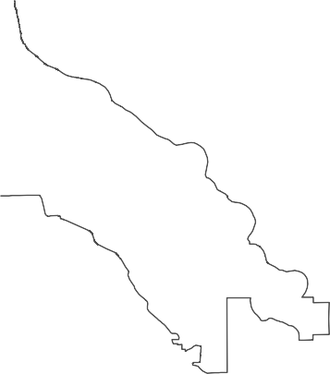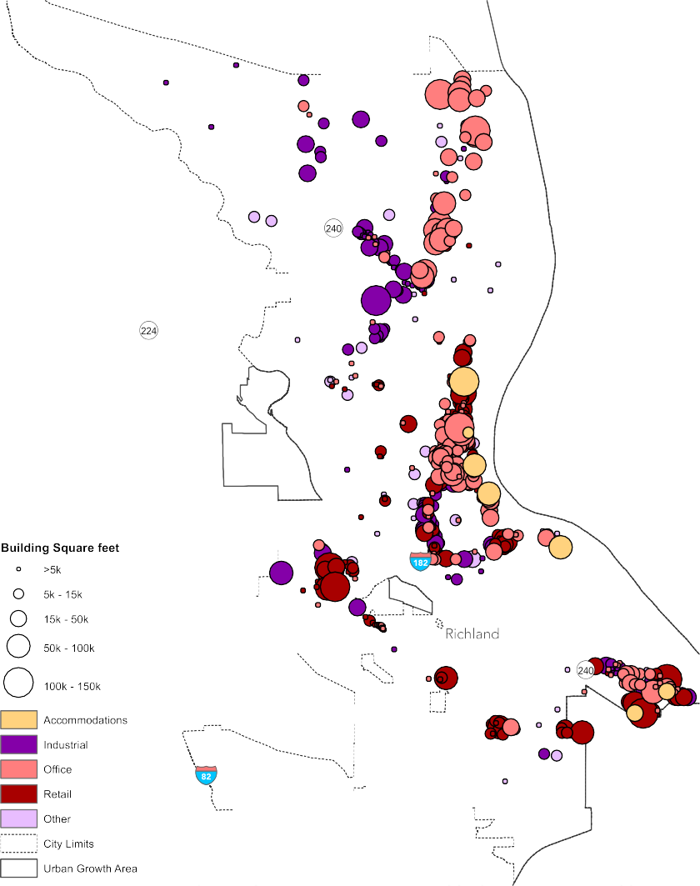Figure ED-8: Commercial Building Sizes and Types in Richland
Source: Benton County Assessor, 2016

EMPLOYMENT AND HOUSEHOLD TRENDS
The following section summarizes selected relevant employment and household characteristics that frame the economic performance in Richland.

Employment Status, Income, and Demographic Characteristics
Relative to Kennewick and Pasco, Richland has high labor force participation for residents with ages between 30 and 54. This typically is the prime working age for most Americans, a time when they are most productive as workers. Rates for younger populations are slightly lower than in Pasco due to a higher share of full-time students in higher education. Similarly, rates are lower for those 65 and older due to their long-term financial stability enabling retirement.
Figure ED-9: Labor Force Participation
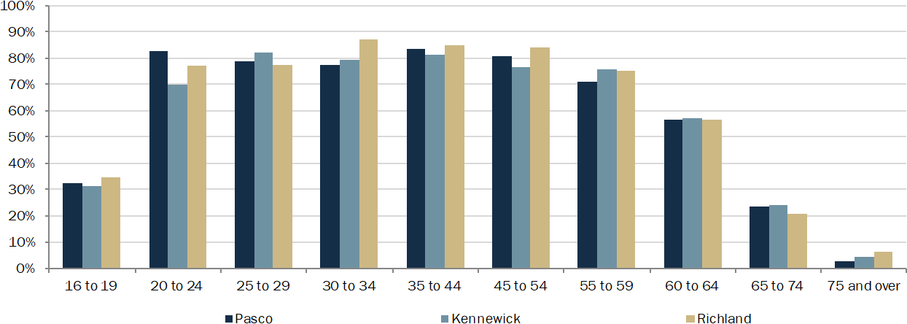
Source: US Census Bureau, American Community Survey, 5-Year ACS, Table S2301
Total employment in Richland has grown over the past 25 years. Current estimates of employment in the City place the number at approximately 25,000. Growth in employment in Kennewick and Pasco has been a function of higher rates of population and labor force growth over the same time.
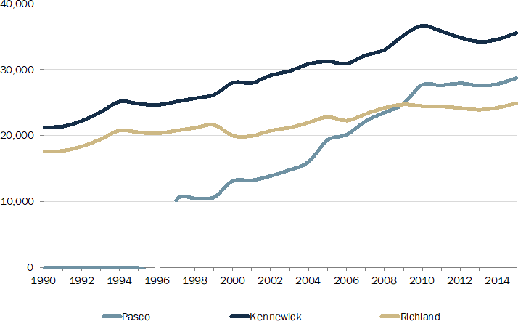Figure ED-10: Total Employment, 1990 - 2016
Source: Bureau of Labor Statistics, Local Area Unemployment Statistics.
Benton County’s unemployment rate is currently 7.0%, which is higher than the state average of 5.3%, but lower than in adjacent Franklin County (Employee Security Department/LMPA, March 2016). Richland has consistently fared better than the cities of Kennewick and Pasco as well as Benton County and Franklin County.
Figure ED-11: Unemployment Rate, 1990 - 2016

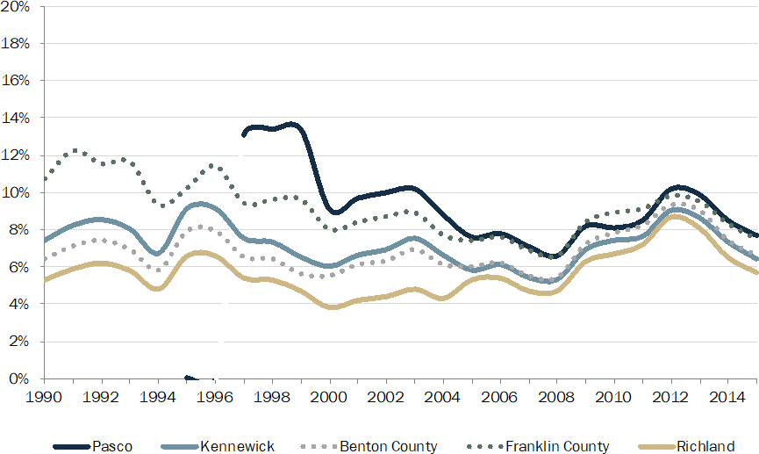
Source: Bureau of Labor Statistics, Local Area Unemployment Statistics.
Federal funding for Hanford has been a significant economic catalyst for the Tri-Cities Region, generally with Richland at the forefront. Even with significant downsizing at Hanford in the 1990s, household incomes in Franklin and Benton Counties continued to grow steadily.
Today, household incomes for Richland residents are nearly ten percent higher than the County average and more than twenty percent higher when compared to those of Kennewick residents. Richland enjoys economic prosperity not just compared to its Tri-Cities neighbors, but compared to state averages as well as illustrated in Figure ED-12 below. Higher incomes are the result of technical and professional positions that require higher levels of education, as illustrated below in Table ED- 3- Educational Attainment, 2011 - 2015.
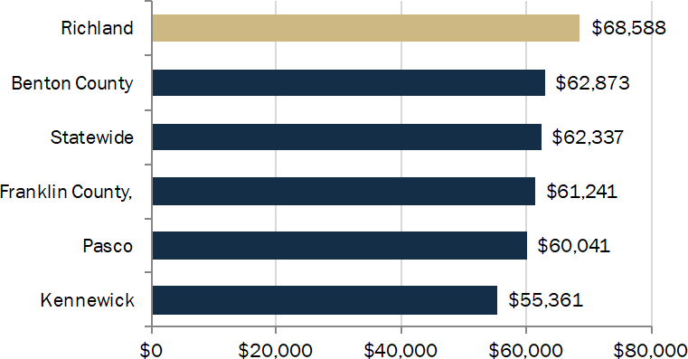Figure ED-12: Median Household Income
Source: US Census Bureau, American Community Survey, 2015 5-year, Table B19013A
Similarly, Richland has fewer households living in poverty when compared to Benton County on the whole, Franklin County, and the statewide average. This indicates a strong economy and access to opportunity.
Figure ED-13: Share of Population Living in Poverty, 2011 - 2015

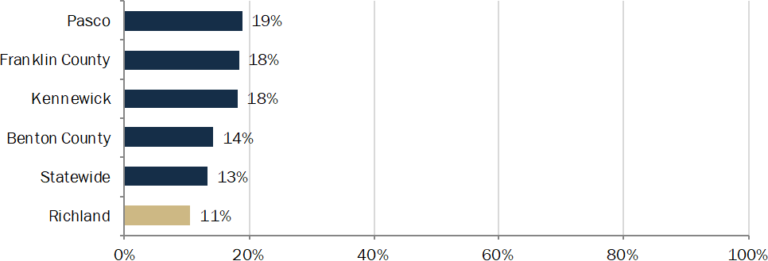
Source: US Census Bureau, American Community Survey, 2015 5-year, Table S1701.
The population living in Richland is not drastically different from the region with respect to age, but upon further examination of job force impacts there are some important differences. For employment purposes, prime working age is defined as 25 to 54 years old. The statewide average for population that falls into prime working age is 41%. Richland’s is 39%, the same for Kennewick, and slightly lower than Pasco’s 40%. However, Richland has a relatively high population of residents over age 55 (28%) as compared to Kennewick (23%) and Pasco (15%). Given this, the share of children, those under 18 years of age, in Richland is low (25%) as compared to Kennewick (28%) and Pasco (34%).
Figure ED-14: Age Distribution, Average from 2011 – 2015
Under 18 18 to 24 25 to 54 55+
Benton County Franklin County
Pasco
Kennewick
Richland
100%
90%
80%
70%
60%
50%
40%
30%
20%
10%
0%
Source: US Census Bureau, American Community Survey, 2015 5-year, Table B01001.
Relative to Kennewick and Pasco, Richland is home to a highly educated workforce. The demand for educated engineers and scientists generated by Hanford , PNNL and their subsidiary research and development activities has been a central employment and demographic characteristic for the Tri- Cities Region, in particular for Richland.
Table ED-3: Educational Attainment, 2011 - 2015

 | Population 25 Years and  Over | High School Diploma/GED | Associate's Degree | Bachelor's Degree | Graduate Degree
Richland | 34,712 | 95% | 56% | 45% | 19%
Kennewick | 47,478 | 86% | 33% | 22% | 7%
Pasco | 37,479 | 72% | 25% | 16% | 5%
Benton County | 118,423 | 89% | 40% | 29% | 11%
Franklin County | 49,013 | 74% | 25% | 16% | 5%
Statewide | 4,721,438 | 90% | 43% | 33% | 12%
Source: US Census Bureau, American Community Survey, 2015 5-year, Table B15003.

Housing Stock
Housing in Richland is generally characterized as single-family (62%) and mostly owner-occupied (65%) with moderate vacancy rates similar to those seen in Kennewick and double that of Pasco; roughly 6%. Most homeowners spend less than 20% of their income on housing (57%) – a larger share than in Kennewick (50%) or Pasco (41%). However, 18% of homeowners are considered cost- burdened defined as spending more than 35% of their income on housing. This is slightly higher than the 17% seen in Kennewick and Pasco. For more on housing conditions, see the Housing Element.
Retail Performance
The location of retail stores and their economic performance are important to cities for two reasons. First, the proximity and mix of retail services is an essential service and amenity for area residents. Second, the importance of sales taxes in funding essential services means jurisdictions have a built- in preference for maximizing the scale, scope, and productivity of the retail sales base. The following set of charts examines the productivity data of taxable retail sales in Richland.
As shown below, the data for Richland show steady growth in retail sales over the past 15 years. The City has seen strong growth in the accommodation and food service sectors with more restaurants taking hold in recent years. Compared to its regional neighbors, Richland has comparable sales to Pasco but both are about half of Kennewick’s totals.

Figure ED-15: Select Category Sales, Richland in 2016 Dollars (in Millions)

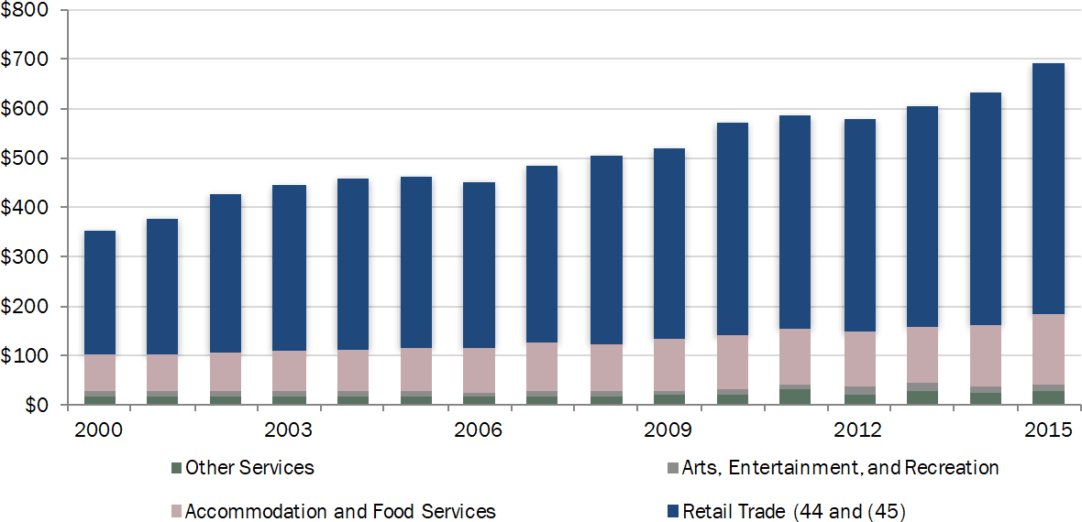
Source: Washington State Department of Revenue, Taxable Retail Sales Link. Accessed October 24, 2016

Richland has seen higher increases in taxable retail sales relative to both Kennewick and Pasco since 2000, as seen in Figure ED-16. This indicates the retail sector is growing and increasing its market share while retail sales in Pasco and Kennewick have slowed relatively. While West Richland has seen significant increases (2009 saw three times their 2000 sales), it continues to provide only a very small share of the overall market.
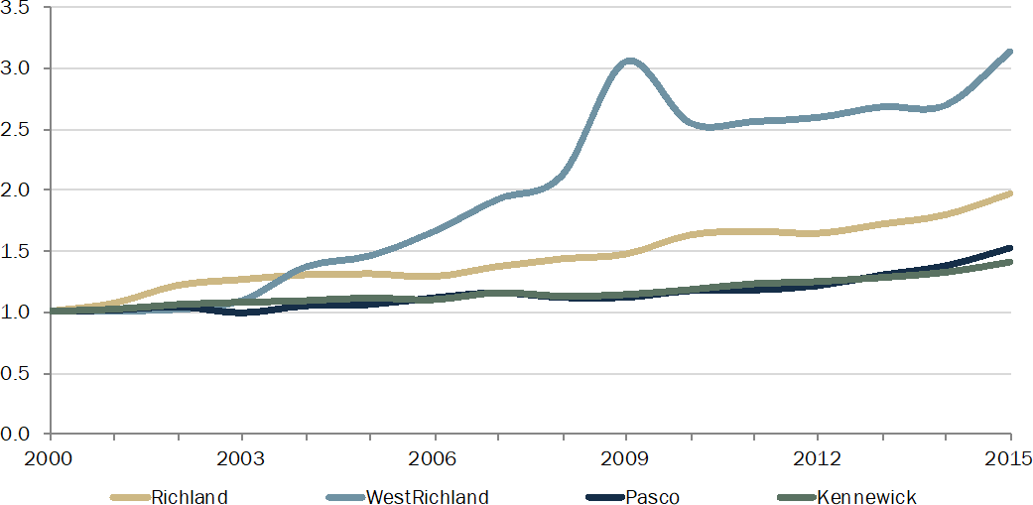Figure ED-16: Taxable Retail Sales in Millions Indexed to 2000
Source: Washington State Department of Revenue. Accessed October 24, 2016

FUTURE GROWTH FORECASTS
Employment Forecasts
Short-term industry forecasts for the region continue to expect positive growth in the region. Strongest growth is forecast in the service sector, specifically business and health services – two sectors where Richland is driving the region’s growth and that are well positioned for future growth.
Table ED-4: Employment Forecast by Industry for the MSA

 |  |  |  | Change
 | 2014 | 2019 | 2024 | # | % | AAGR1
Construction | 6,300 | 7,300 | 7,600 | 1,300 | 21% | 1.9%
Manufacturing | 7,800 | 8,200 | 8,400 | 600 | 8% | 0.7%
Wholesale Trade | 3,300 | 3,700 | 3,900 | 600 | 18% | 1.7%
Retail Trade | 12,200 | 13,400 | 14,100 | 1,900 | 16% | 1.5%
Transportation, Warehousing and Utilities | 2,700 | 3,000 | 3,100 | 400 | 15% | 1.4%
Information | 800 | 800 | 900 | 100 | 13% | 1.2%
Financial Activities | 4,300 | 4,400 | 4,400 | 100 | 2% | 0.2%
Professional and Business Services | 20,600 | 23,400 | 26,000 | 5,400 | 26% | 2.4%
Education and Health Services | 14,400 | 16,100 | 17,600 | 3,200 | 22% | 2.0%
Leisure and Hospitality | 9,900 | 10,900 | 11,800 | 1,900 | 19% | 1.8%
Other Services | 3,300 | 3,600 | 3,800 | 500 | 15% | 1.4%
Government | 18,500 | 19,800 | 20,700 | 2,200 | 12% | 1.1%
Federal | 1,200 | 1,200 | 1,200 | 0 | 0% | 0.0%
State | 8,100 | 8,600 | 8,900 | 800 | 10% | 0.9%
Local | 9,200 | 10,000 | 10,600 | 1,400 | 15% | 1.4%
1 Annual Average Growth Rate
Source: Benton Franklin Council of Governments
The Benton Franklin Council of Government’s transportation and land use model also provides some forecasts on land use and employment for transportation planning purposes. Based on these model results, Richland is estimated to reach some 40,000 jobs by 2030.

Table ED-5: Employment Forecast in Richland

 | 2014 | 2017 | 2024 | 2037 | 2014-  2019  AAGR1 | 2019-  2024  AAGR
Services | 16,414 | 17,305 | 19,577 | 24,617 | 1.78% | 1.78%
Professional Technical Services2 | 7,548 | 7,548 | 7,548 | 7,548 | 0.00% | 0.00%
Retail and Food | 5,012 | 5,306 | 6,060 | 7,755 | 1.92% | 1.92%
Warehousing, Transportation & Utilities | 2,308 | 2,466 | 2,878 | 3,834 | 2.23% | 2.23%
Manufacturing | 1,523 | 1,569 | 1,683 | 1,917 | 1.01% | 1.01%
Construction | 1,390 | 1,518 | 1,866 | 2,737 | 2.99% | 2.99%
Government | 1,251 | 1,303 | 1,433 | 1,710 | 1.37% | 1.37%
Resources | 118 | 124 | 141 | 177 | 1.77% | 1.77%3
Total | 35,564 | 37,675 | 41,185 | 50,295 | 1.94% | 1.31%
1 Annual Average Growth Rate
2 Assumes no new growth; implies e.g. PNNL employees find new related jobs but no new growth
3 Assumes same growth as in 2014-2019
Source: US Census, OnTheMap; Washington Employment Security Department; ECONorthwest

SUMMARY OF EXISTING ECONOMIC CONDITIONS AND FORECAST
Richland is at the epicenter of the major driving economic forces on the Tri-Cities area. The work performed at the Hanford Site, in tandem with the research at Pacific Northwest National Laboratory (PNNL), has driven economic development in the region and City for decades. This circumstance is currently the region’s largest economic strength and a source of its greatest economic fears. These dual assets have driven the need for urban land development and created strong markets for housing, retail, and household services. Along with the agricultural sector, they have also created the foundation for a larger regional economy, which has supported more economic opportunity overall, allowing other unrelated industries to take hold in the area. However, the exposure of such a large segment of the economy to a single entity is a cause for concern for regional leadership and local residents. Recent spending cuts following the recession demonstrate the extent to which the economy depends on government spending to support these activities.
The region has shown strong growth in economic output over the past several decades leading to sustained employment growth. From a regional economic perspective, the agricultural sector is one of the most competitive for the region, which is not surprising given the region’s agricultural advantages. The region has a strong industrial/manufacturing base that has sustained itself over time yet the largest portion of the economy is service-based (both professional/business and personal) that continues to drive economic growth in the recent decade. However, growth in most other sectors have mirrored the nation as a whole; fueling economic conversations that the region needs to find new growth in sectors that can produce and sustain both comparative and competitive advantages.
The City of Richland specifically has been the location where much of the professional service sector is located. The City is home to the two largest non-governmental employers in the region in PNNL and Kadlec Health that account for nearly 8,000 employees in the City. From a land use perspective, Richland has more than half of the region’s commercial office space and industrial space, respectively; and is second only to Kennewick in the amount of retail space. Examination of the recent commercial real estate productivity suggests that much of the built space is well occupied and rents

have been resilient. Richland has seen stronger retail growth and has outpaced growth in the region as a whole.
Richland has strong demographics for future economic growth. Employees and households are on average better educated, better paid, and with a larger segment of the population in its prime working age. The community is also relatively less-burdened with the costs of poverty when compared to the region. Future forecasts of economic growth remain positive of the regions outlook with growth in the service and health sector continuing to drive growth in the future. From this perspective, the City should be well positioned to capitalize on its past performance and existing assets to extend its economic growth.

SECTION THREE

CHALLENGES AND OPPORTUNITIES
Upon review of existing economic conditions, survey results, and in conversations with elected officials, local economic development professionals, visioning work sessions, and through public outreach with business leaders and the general public, stakeholders collectively identified several recurring themes: the need for stronger economic resiliency able to withstand future economic shocks; the need to harness the entrepreneurial spirit and create a more dynamic economy and economic opportunity; leverage the natural landscape and heritage within the City and region to create sustainable economic development opportunities; and diversify and more intensely use the available land within the City. The following is a summary of the primary concerns and goals related to achieving a thriving Richland economy.
Area 1. Create a Resilient Economy
The single greatest threat to the Richland and Tri-Cities economy is the winding down of business and employment and Hanford without suitable economic opportunities in place that would provide for a comparable standard of living. A reduction in work at Hanford will mean less direct employment in Richland and large negative impacts on the businesses that support them directly as well as the resulting households whose wages they support. However, Hanford is also an asset to the community and has been effective at attracting a highly educated workforce in science and technology. These fields produce professional-wage jobs and have produced spinoff businesses coming from PNNL.
To ensure the stability and resiliency of the economy, the City should leverage existing assets but adapt them to a changing economy. These efforts should focus on increasing primary sector, non- Hanford -related science and tech employment by creating a business environment that encourages and welcomes local business. Additionally, the City should develop partnerships with the Tri-Cities Development Council (TRIDEC), PNNL, Kadlec Medical Center, and other major employers to plan for expansion and delivery of adequate infrastructure and services.
Area 2. Build and attract a more entrepreneurial and dynamic economy
Richland is the regional hub for highly educated, science and technology professionals. Labor force participation is high, particularly for the most productive segment of the population – 30 to 54 year olds. With access to innovation partners and relatively low land costs when compared to bigger cities like Seattle, the climate for entrepreneurial startup companies is present. However, attracting innovation and investment is a goal of many municipalities. The City can advance this environment through infrastructure investment, streamlined regulation, and “second paycheck” benefits such as livability and access to recreation. Working with its regional education and economic development

partners, the City can play its role creating and supporting a rich “entrepreneurial ecosystem” in the area.
Area 3. Leverage the natural landscape as an asset for economic development
Richland’s location along the Columbia and Yakima Rivers offers exceptional opportunities to easily access attractive, natural, recreational spaces, as well as close proximity to the region’s vibrant agritourism and wine industries. In addition to this, professional service employees living in Richland enjoy lifestyle amenities, also called the “second paycheck.” These include access to parks, walkable business districts, good schools, diverse housing options, quality restaurants, and arts and cultural activities. Richland’s ability to leverage its natural environment to directly spur economic activities and provide an attractive setting for professionals will further enhance its competitive advantage. However, residents must be cognizant of maintaining a healthy balance between environmental preservation and economic development activities.
Area 4. Closely monitor zoning and land use in the City
The City has the dual challenge of planning for urban infill development as well as planning to accommodate development on many large and relatively undeveloped sites within the City. To ensure zoning is responsive to market conditions, it should be monitored periodically to evaluate potential hindrances. Working to concentrate development in areas with existing infrastructure and near jobs centers will be instrumental to optimize the City’s funding.

LAND USE

SECTION ONE

INTRODUCTION
Due to the linear geographic pattern of the City along the Columbia River, Richland’s land is distributed primarily from north to south covering a little over 27,000 acres in the current incorporated City limits and additional 3,000 acres in the Urban Growth Area (UGA).
Land use patterns determine individual neighborhoods, businesses, amenities, public facilities, and the types and locations of future development and redevelopment. Land use patterns also determine traffic patterns. This element includes future population projections and needs for land use types for the next 20 years. The Comprehensive Plan land use map identifies land use categories within the City limits and the UGA. This section also elaborates on critical areas, shoreline and open space lands in Richland.

SECTION TWO

DESCRIPTION OF LAND USES
Agriculture (AG) - This category includes uses devoted primarily to the tilling of soil, the raising of crops, horticulture, livestock, poultry, feed lots, and related commercial and industrial activities. It allows residential densities up to one dwelling unit per five acres.
Low Density Residential (LDR) - The LDR category includes single-family residential uses with an average density of 3.5 dwelling units per acre.
Medium Density Residential (MDR) - The MDR category includes single-family residential uses with an average density of eight dwelling units per acre.
High Density Residential (HDR) - The HDR category includes multifamily residential uses with an average density of 15 dwelling units per acre. In transitional areas between more intensive commercial uses and lower density residential uses, limited office/institutional uses may also be located within the HDR designated areas.
Badger Mountain South (BMS) - This includes land uses set forth in the Badger Mountain Subarea Plan as adopted by the Richland City Council on September 7, 2010.
Multifamily Residential Office (RO) - This designation applies to areas within Island View where senior housing and condominium projects would be encouraged. Compatible office projects and light commercial uses also would be allowed within this designation.
Central Business District (CBD) - This classification includes a mix of residential, retail, service, and business uses that provide for the daily convenience needs of on-site and nearby employees and residents. The purpose is to provide for pedestrian- and transit-oriented high density employment and cultural uses, together with complementary retail and higher density residential and other compatible uses that enhance the Central Business District.
Commercial (C) - The commercial land use category includes a variety of retail, wholesale, and office uses. Within this category are professional business offices, hotels, motels, and related uses. It also includes a variety of retail and service uses oriented to serving residential neighborhoods, such as grocery stores, hardware supply, and garden supply. Other commercial uses include automobile-

related uses, and uses that normally require outdoor storage and display of goods. In transitional areas between more intensive commercial uses and lower density residential uses, high-density residential development may also be located within the Commercial designated areas.
Retail Regional (RR) - This designation is applied to the existing retail area that is commonly known as Columbia Center North, as well as other nearby locations on Columbia Center Boulevard and Fowler Street. Within this designation infill development is encouraged. Large format region-serving retail establishments are also encouraged on parcels large enough to support such uses.
General Commercial (GC) - This designation is applied to lands in the southernmost portions of Island View that are adjacent to and visible from SR 240. Within this category, new and used auto sales, RV, truck dealers, and similar retail uses are encouraged. Service-related businesses that require a central location within the Tri-Cities are also included in this designation.
Business Commerce (BC) - This designation applies to the Spaulding Business Park and some adjacent properties. It is intended to encourage a variety of professional office buildings, medical and/or dental laboratories, and light industrial uses.
Single Family Overlay (SFO) - This designation is applied to several pockets of single family residences throughout the Island View area where property owners have expressed a preference for this designation. The comprehensive land use plan map identifies a land use designation other than single family residential for all properties within Island View. For these identified parcels, there are two land use designations: the Single Family Overlay designation and another land use designation. The Single Family Overlay designation will remain in effect, allowing for continued residential use of the property, until such time the owner(s) seeks a change in the use of the property. At that time, the City will remove the Single Family Overlay and apply the other land use designation as identified in the comprehensive plan land use map in accordance with Land Use Goal #9, Single Family Overlay.
Commercial Recreation (CR) - This designation typically applies to properties under the ownership of the local, state or federal government. These properties are typically used to site regional recreational, educational, water-oriented facilities, and associated uses.
Waterfront (WF) - The Waterfront category includes a variety of water-oriented uses such as marinas, boat docks, resorts, mixed commercial/residential development, hotels, motels, and offices along the Columbia River shoreline. The intent is to bring significant development to the Columbia riverfront that is consistent with the City’s vision and that incorporates public access recreational features and attractive and high quality development.
Industrial (I) - This category includes a variety of light and heavy manufacturing, assembly, and warehousing and distribution uses. It also includes uses devoted to the sale of retail and wholesale products manufactured on-site, and a variety of research and development uses for science-related activities.
Business/Research Park (BRP) - The Business/Research Park designation provides for a variety of office and research and development facilities in a planned business park setting. Permitted uses include science-related research and development and testing facilities; administrative offices for those uses; and other general office uses.
Public Facility (PF) - This category includes a variety of public and institutional uses including facilities operated by federal, state, county, municipal, or other government agencies; public educational institutions; public libraries; hospitals; cemeteries; and some developed parks.
Urban Recreation (UR) - The Urban Recreation designation includes uses that are intended to provide the public with places to gather for public events as well as provide some limited urban amenities, passive recreation opportunities and open space uses. It is the intent of the UR land use to

provide for a disbursed pattern of development that recognizes and protects both culturally and environmentally sensitive areas.
Developed Open Space (DOS) - This category includes golf courses, federal power transmission and irrigation wasteway easements, private open space, riverfront parks, undeveloped parks, and parks intended for long-term open space.
Natural Open Space (NOS) - The Natural Open Space category includes public lands intended to remain as long-term undeveloped open space with appropriate public access. This category primarily includes, for example, lands associated with the Yakima River floodplain, islands in the Columbia River, steeply sloped areas, sensitive areas along the Amon Basin, and other designated areas. Natural Open Space lands are managed as natural areas and may include riparian corridors along creeks and rivers, wetlands, shrub-steppe, open ridges, and hillsides.
Mineral Resource (MRL) - This classification includes lands that have long-term significance for the extraction of minerals on a commercially-viable basis and are not already compromised by on-site, immediate, or adjacent urban growth. Mineral Resource designation must be requested by the owner of the property and/or of the mineral rights, or her/his designated agent.
Urban Reserve (UR) - The Urban Reserve designation is assigned to lands that are to be held in reserve during the 20-year planning period of the comprehensive plan. A significant amount of the land in this designation is in agricultural use. Uses of land designated Urban Reserve are intended to be temporary to provide the City a basis to evaluate future needs for additional land in other land use designations.
Table LU-1 indicates the land use distribution within the City and in the UGA.

Table LU-1: Existing Land Use Acreage

Land Use Designation | City Limits (acres) | Area within UGA(acres) | Total Acreage1 | % of total
Residential
Low Density Residential | 4,598 | 689 | 5,287 | 18.15
Med. Density Residential | 1,427 |  | 1,427 | 4.90
High Density Residential | 530 |  | 530 | 1.82
Badger Mountain South | 1,431 |  | 1,431 | 4.91
Commercial
Business Commerce | 28 |  | 28 | 0.10
Central Business District | 222 |  | 222 | 0.77
Commercial | 1,046 | 16 | 1,062 | 3.7
General Commercial | 79 |  | 79 | 0.28
Retail Regional | 31 |  | 31 | 0.11
Waterfront | 140 |  | 140 | 0.49
Commercial Recreation | 50 |  | 50 | 0.17
Public Lands/Open Space
Developed Open Space | 2,170 | 144 | 2,314 | 7.62
Natural Open Space | 2,154 | 322 | 2,476 | 8.52
Public Lands/Facilities
Public Facility2 | 1,014 | 27 | 1,041 | 3.63
Industrial
Business Research Park | 750 | 437 | 1,187 | 3.78
Industrial | 5,374 | 1,050 | 6,424 | 22.39
Other Designations |  |  | 0
Agricultural | 903 |  | 903 | 3.15
Residential Office | 21 |  | 21 | 0.07
Urban Reserve | 1,214 |  | 1,214 | 4.23
Public Service Lands
Rights of Way | 2,947 | 163 | 3,110 | 10.84
Total | 25,846 | 2,848 | 28,694 | 100.00%
1 Does not include water area
2 Public facilities lands include public school sites, WSU campus, City owned facilities, and cemeteries
3 Includes proposed UGA expansion area related to Department of Energy land transfer

SECTION THREE

POPULATION TREND
Richland and the Tri-Cities area experienced strong growth from 1973 to 1981 due to the development of nuclear power plants for the Washington Public Power Supply System. In the 1980s, however, the power plant program was discontinued, as was the federal government’s production of nuclear material at the Hanford Site. These changes created a difficult economic period throughout Benton County and neighboring Franklin County as indicated in the reduced growth in 1990 data.
With plutonium production discontinued at the Hanford Site, the federal government redefined its mission there. The new mission became environmental restoration or cleanup of the site, together with ongoing management of the hazardous wastes stored there. In association with these missions, areas near the Hanford Site has become a hub for research and development into energy, health, waste management, and the environment, as well as development for new technologies in these fields in the last two decades. As a result, population in Richland grew 13.87 percent in a decade in 2000, and 24.16 percent in a decade in 2010. Table LU-2 below indicates the historic population growth in Richland and Benton County.
Table LU-2: Historic Population Growth in Richland and Benton County

Year | Richland | % Change Richland | Benton County | % Change Benton County
1950 | 21,809 | n/a | Data not available | Data not available
1960 | 23,548 | 7.97% | 62,070 | Data not available
1970 | 26,290 | 11.64% | 67,540 | 8.81%
1980 | 33,578 | 27.72% | 105,800 | 56.65%
1990 | 33,993 | 1.24% | 112,560 | 6.39%
2000 | 38,708 | 13.87% | 142,475 | 26.58%
2010 | 48,058 | 24.16% | 175,177 | 22.95%
Population in Richland has grown significantly in the last decade from 44,678 in 2007 to 53,410 in 2016. Much of this growth can be linked with the Department of Energy’s nuclear cleanup and related operations at the Hanford Site. However, the economy in the Tri-Cities area is becoming more diverse with the growth of other employment sectors such as healthcare and education. It appeared from the past trends that many of the individuals retiring from Hanford chose to stay in Richland or in the Tri- Cities area. Table ED-14 indicates about 28 percent of Richland’s population are 55 years or older, and 25 percent of the total population are 18 years or under. These contribute to Richland’s family- friendly environment and education sector improvement.

Figure LU-1: Population Growth in Richland in the Last 10 Years
56,000
54,000
52,000
50,000
48,000
46,000
44,000
42,000
40,000
53,080 53,410
51,150
52,090
2007 2008 2009 2010 2011 2012 2013 2014 2015 2016
45,580
44,678
46,957
48,058
49,090 49,890
As discussed in the Economic Development section, Richland’s median household income is the highest in the Tri-Cities, $70,806 in 2017, with Kennewick at $52,831 and Pasco at $53,950 (TRIDEC, 2017). Over 95 percent of the residents in Richland are high school graduates or graduates with higher degrees (US Census, 2015).

POPULATION FORECAST
WASHINGTON GMA REQUIREMENTS
The Washington State GMA requires the Land Use Element to include population densities and estimates of future growth (RCW 36.70A.070(1)). The Benton County CWPP contains several provisions addressing population growth and capacity. They include agreement or cooperation in determining the following:
- The portion of the 20-year population forecast allocated to the City of Richland.
- The boundaries of the urban growth area.
- The amount of land necessary to provide sufficient service capacity to meet projected populations at urban densities and service standards.
- Consistency with Benton County CWPP.
FORECAST
Based on the 2016 estimate of Office of Financial Management (OFM), Richland and its UGA contain a population of 54,733 (53,410 within City limits, 1,323 in the UGA). Benton County’s county-wide allocation and projected population for Richland are 76,533 for the year 2035, and 81,366 for the year 2040.
The current population and the additional 20-year projected population equals 78,431 persons in the year 2037. The projected additional population that will be added to the City during the next twenty years, per consultation between the cities and Benton County and based upon the official projections from the OFM, is 23,699 persons.

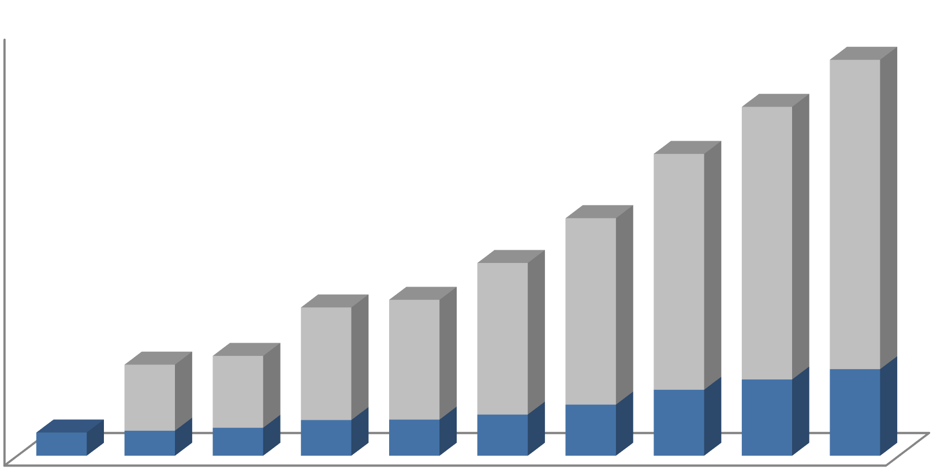Figure LU-2: Richland and Benton County’s Population Forecast
400,000

350,000

300,000

250,000

200,000

150,000
290,592
256,072
221,552
175,177
142,475
100,000 105,800112,560
50,000 62,070 67,540
71,700 81,366
21,809
0
1950
Richland Benton County

23,548 | 26,290 | 33,578 | 33,993 | 38,708 48,058 62,035
1960 | 1970 | 1980 | 1990 | 2000 | 2010 | 2020 | 2030 | 2040

FUTURE LAND CAPACITY
In order to identify land necessary to meet the future demand, a land capacity analysis was performed. The analysis used the City’s existing land use density and land inventory.
The first part of this analysis is based on the capacity of existing vacant and underdeveloped residential land to add additional units. This doesn’t reflect the property owners’ intention of development; neither does it require the property owners to develop their properties.
In this methodology, all vacant and undeveloped lands were identified. Critical areas or environmentally sensitive lands present on the land were excluded in order to estimate the amount of buildable land. Twenty percent of the buildable land area was allocated for infrastructure. The remaining acreage was identified to be buildable and units were projected according to the City’s average land use density.
As discussed in the previous section, 23,699 persons will be added to the City during the next twenty years. This will require 9,874 residential units (23,699/2.4) considering Richland’s average household size of 2.4 persons/unit. In order to assess adequate land for future growth, the second phase analyzes residential units projected primarily on Low Density, Medium Density, High Density lands, and the Badger Mountain South area. Additionally, a percentage of vacant Commercial and Waterfront lands are projected to be developed with multi-family housing. Table LU-3 below indicates projected residential development within different land use categories.

Table LU-3: Land’s Capacity for Future Residential Development

Land Use Category | Projected Units
Low Density Residential  Undeveloped = 1230 acres | BLM ownership (135 acres) 300 Area (23 acres)  McDonald (14 acres) = 172 acres  515 acres constrained by steep slopes 1,058 acres – 515 = 543 acres  543 acres x 80% (after infrastructure) = 434 acres @ 3.5 units/acre = 1,520 units  515 x 80% (after infrastructure) = 412 acres @ 2 units/acre = 824 units  2,344 units projected
Medium Density Residential  Undeveloped = 255 acres | Horn Rapids Open Space areas = 25 acres  230 acres x 80% (after infrastructure) = 184 acres  184 x 6.5 units/acre = 1196 units  1,196 units projected
High Density Residential  Undeveloped = 107 acres | 107 x 80% (after infrastructure) = 86 acres  86 x 75% (available for residential) = 65 acres Average density = 15 units/acre  65 x 15 = 975  975 units projected
Badger Mountain South  Undeveloped = 1416 acres | Currently 60 dwellings  Total Projection at Full Build Out: 4,150 to 5,000 units  4,090 units projected
Commercial  Undeveloped = 471 acres  39 acres undeveloped in Commercial Limited Business zoned land (8% of undeveloped commercial land) | Average density = 15 units/acre  39 x 80% (after infrastructure) = 31 acres  465 units projected
Waterfront  Undeveloped = 56 acres | 10 acres unusable (landfill/shoreline setback areas) 1/3 waterfront area used for residential  15 acres @15 units/acre = 225 units  225 units projected
Total | 9,295 units projected

As indicated in the table above, 9,295 residential units can be developed at full buildout to accommodate 22,308 people. This still leaves the City with the need to accommodate an additional 1391 people (23,699-22,308) in a full buildout scenario. The City currently has an urban reserve land use category. Re-designation of this land for residential uses will satisfy the City’s need for an additional residential land base.
Table LU-4: Vacant and Developed Commercial, Industrial and Public Lands

Land Use | Developed (acres) | Vacant (acres) | Total Acres
Commercial (City) | 1,007 | 538 | 1,546
Commercial (UGA) | 11 | 5 | 16
Industrial (City) | 2,914 | 2,026 | 4,940
Industrial1 (UGA) | 447 | 1863.5 | 1,487
Public Lands2 (City) | 4,385 | 953 | 5,338
Public Lands2 (UGA) | 351 | 0 | 351
1 Includes Department of Energy (DOE) transferred land
2 Includes open space and public facilities land
The amount of vacant commercial land is anticipated to be sufficient to meet the needs of the projected population expected over the 20-year planning period. Re-development of underutilized lands within the Central Business District will also help to satisfy the demands for commercial lands created by an expanding population.
The City’s industrial land base has recently been expanded significantly by an act of Congress that transferred 1,641 acres from the Department of Energy (DOE) to the City, the Port of Benton, and Energy Northwest. This land is located north of Horn Rapids Road and is specifically set aside for industrial development. The City and Port plan to market the property to industrial developers as “mega-sites” of 200 acres or larger. The proximity of this land to highways, rail, and utility services together with the large acreages available provide development opportunities for industries that exist in very few places throughout the Pacific Northwest.
Industrial lands located south of Horn Rapids Road will continue to be developed with industrial developments of a more typical scale. The available industrial lands within these two areas will ensure that the City has an adequate industrial land base throughout the planning period.
LANDS FOR PUBLIC PURPOSES
According to RCW 36.70A.150, the county and jurisdictions within it are required to work together to identify the needs for public facilities, including lands for public purposes. Current City-owned public facilities include parks and open spaces, transportation, water, sewer, storm water, solid waste, energy, and municipal facilities. Other public facilities include schools, irrigation, natural gas, and telecommunication services. Table LU-1 indicates public facility and transportation rights of way lands.

Table LU-5: Public Land in the City and UGA

Land Use | Acres in the City | Acres in the UGA | Total
Developed Open Space | 2,170 | 144 | 2,314
Natural Open Space | 2,154 | 322 | 2,476
Public Facility2 | 1,014 | 27 | 1,041
Public Lands Subtotal | 5,338 | 493 | 5, 831
2Public facility lands includes public school sites, WSU campus, City owned facilities and cemeteries
Excluding the open space land, there are about 361 acres of vacant public facility land within the City limits. Richland’s current land per capita for public facility use (without including open space per capita) is 0.0122 acres. Based on this ratio, the additional 23,699 people will require 289 acres (23,699 x 0.0122) of land. Considering the vacant 361 acres, the City will have a surplus of approximately 72 acres of land for public facilities.
This analysis indicates the total land deficits and surpluses. However, the surplus land may not always be useful to meet specific needs due to its location and compatibility for specific public use. Additional information regarding park and open space lands can be found in the Capital Facilities Chapter of the Plan under “Parks, Recreation, and Open Space”.

ADDRESSING THE DEMAND
The City is planning to accommodate additional growth in two currently undeveloped areas to the north and west sides all within the City limits. One area is located on the southwest side of the City near the City View and Queensgate area, abutting Kennedy Road to the south and Queensgate Drive to the east. The other area is located on the north side abutting the Horn Rapids residential development to the south. See Figure LU-3 and Appendix C of the Comprehensive Plan for details.
The land use in these areas is re-designated from underutilized Urban Reserve to a mix of Low, Medium, and High Density Residential, Commercial, Public Facility, and Developed and Natural Open Spaces as shown in Table LU-6.

Table LU-6: Proposed Land Use in Horn Rapids Northwest and City View West

Land Use | Existing Land Use (acres) | Proposed Land Uses (acres)
Horn Rapids Northwest
Urban Reserve | 272
Low Density Residential |  | 230
Medium Density Residential |  | 42
Total | 272 | 272
City View West
Urban Reserve | 340
Low Density Residential |  | 143
Medium Density Residential |  | 25
High Density Residential |  | 34
Commercial |  | 55
Public Facility |  | 40
Developed Open Space |  | 5
Natural Open Space |  | 38
Total | 340 | 340
Additional land use re-designation includes a portion of an area in Columbia Point South, re- designated from Developed Open Space and Public Facility to Urban Recreation. The proposed land use is shown in Table LU-7. Also see Figure LU-3, the Future Land Use Map.
Table LU-7: Proposed Land Uses in Columbia Point South

Land Use | Existing Land Use (acres) | Proposed Land Uses (acres)
Public Facility | 33
Developed Open Space | 71
Natural Open Space | 153 | 177
Urban Recreation |  | 80
Total | 257 | 257

Figure LU-3: Future Land Use Map

SECTION FOUR

NATURAL ENVIRONMENT
CRITICAL AREAS
Richland’s critical areas include wetlands, fish and wildlife habitat areas, aquifer recharge areas, and geologically hazardous areas.
The critical areas map in the Comprehensive Plan, Figure LU-4, indicates floodplains, geologic hazard areas (steep slopes), and wetlands in Richland.
- Wetlands. Wetlands are ecosystems that serve a number of important beneficial functions. They help maintain water quality, store and convey storm water and floodwater, and recharge groundwater. Wetlands provide important wildlife habitat and serve as areas for recreation, educational and scientific study, and aesthetic appreciation.
- Fish and Wildlife Habitat Areas. These areas are important for maintaining flora and fauna species diversity; providing opportunities for food, cover, nesting, breeding, and movement for fish and wildlife; serving as areas for recreation, educational and scientific study, and aesthetic appreciation; helping to maintain air and water quality; controlling erosion; and providing neighborhood separation and visual diversity within urban areas.
- Frequently Flooded Areas. Floodplains and other areas subject to flooding perform important hydrologic functions and may present a risk to persons and property. Classifications of frequently flooded areas should include, at a minimum, the 100-year floodplain designations of the Federal Emergency Management Agency (FEMA) and the National Flood Insurance Program (NFIP).
- Aquifer Recharge Areas. Critical aquifer recharge areas are defined as those areas having a critical recharging effect on aquifer use for potable water in community systems. They consist primarily of wellhead protection areas associated with City water supplies and are intended to protect public health and safety, prevent degradation of ground water supplies, and control risks to the degradation of ground water quality and quantity.
- Other Critical Areas. These are characterized by geologic hazards that pose a risk to public and private property and human life and safety. Geologically hazardous areas include areas susceptible to landslide, erosion, or seismic activity. Because of this susceptibility, these areas may not be suitable for new development. In many cases, hazards can be reduced or mitigated through engineering design or modified construction practices.
The City uses the best available science (BAS) in developing policies and development regulations to protect the functions and values of critical areas and give special consideration to conservation or protection measures. The BAS involves adopting information from local, state, or federal natural resource agencies that are appropriate for local circumstances; consultation with a qualified scientific expert or team to assess applicability to the local critical area; and determination if a person is a qualified scientific expert.
SHORELINE
The GMA requires that Shoreline Management Plan (SMP) goals and policies are included in the Comprehensive Plan and that they are consistent with each other. The City of Richland received grant funding from the Washington State Department of Ecology to develop an updated SMP. A primary purpose of this effort is to update the SMP to comply with Chapter 90.58 Revised Code of Washington

(RCW), the Shoreline Management Act (SMA), and the Department of Ecology’s 2003 Shoreline Master Program Guidelines (Chapter 173-26 Washington Administrative Code [WAC]).
The City of Richland worked closely with the citizens and the Department of Ecology and updated the SMP in 2014. The goals and policies of the SMP are incorporated by reference in the Comprehensive Plan.
The City has prepared an Inventory and Analysis of local shoreline ecological, land use, and other resources to provide the scientific basis of the program. The City has approximately 2,600 acres of land on the Columbia and Yakima Rivers shoreline. The City’s overall approach of shoreline use is as follows:
- The utilization of shorelines for economically productive uses that are particularly dependent on shoreline location or use.
- The utilization of shorelines and the waters they encompass for public access and recreation.
- Protection and restoration of the ecological functions of shoreline natural resources.
- Protection of the public right of navigation and corollary uses of waters of the state.
- The protection and restoration of buildings and sites having historic, cultural, and educational value.
- Planning for public facilities and utilities correlated with other shoreline uses.
- Prevention and minimization of flood damages.
- Recognizing and protecting private property rights.
- Coordination of the SMP with other relevant local, state, and federal programs.
OPEN SPACE
Open space in the Richland and its UGA comprises over 17 percent of the total land. These areas include natural areas (Natural Open Space) and more formal developed parks and trails (Developed Open Space). Park and trail facilities are discussed in detail in the Capital Facilities Element. This section discusses the natural elements of Richland’s open space system, which comprise approximately 9 percent of the land area within the City.
The Tapteal Greenway, located on the lower Yakima River, is one of Richland’s most notable open space areas. The entire Greenway is a 35-mile natural corridor that runs from Kiona at Benton City to the river’s confluence with the Columbia River at Bateman Island in Richland. It goes through the Chamna Natural Preserve and W.E. Johnson Park that are discussed below. It has been preserved as an area where wildlife, natural vegetation, and people can co-exist. It provides potential opportunities for non-motorized recreation, education, and habitat protection.
The Chamna Natural Preserve is about 276 acres and is located on the north bank of the Yakima River. It is part of the Yakima River delta and is managed by the Tapteal Greenway Association. The Tapteal Greenway Association manages other lands owned by the USACE as a nature preserve with limited non-motorized access. Habitat area includes about 100 acres of upland, with 50 acres of abandoned farm fields (Anchor QEA, 2014). Riverview Preserve is a 268-acre area owned and managed by the USACE at the confluence of the Yakima and Columbia Rivers; Bateman Island is 160 acres in the Yakima River Delta under USACE ownership and leased to the City.
W.E. Johnson Park is primarily a natural open space area consisting of 236 acres. It has about a half mile of Yakima River frontage. It is located south of Van Giesen Street.
The Amon Basin includes approximately 75 acres of City-owned open space and is located on the southeast side of the City east of Leslie Road. The Amon Basin Natural Preserve has been preserved

as compensatory mitigation for SR 240 bridge expansion project over the Yakima River delta that took place in 2005. The mitigation area includes upland and wetland habitat. Irrigation canal system operations, raised groundwater tables and associated seepage and return flow surface in this natural drainage and run through the Amon Basin and other areas into the Yakima River near the confluence with the Columbia River.
On the Columbia River, the City managed major open space land includes Leslie Groves Park located between Snyder Street and Ferry Street; and the Columbia Point South area, which is a largely undeveloped area of 230 acres located at the confluence of the Yakima River and the Columbia River. Other major open space land includes the islands on the river that are part of the McNary National Wildlife Refuge.
MINERAL RESOURCES
Mineral resource lands are natural resource lands primarily devoted to the extraction of minerals or that have known or potential long-term commercial significance for the extraction of minerals.
Each city and county planning under the Washington State GMA is required to designate natural resource lands where appropriate, and adopt development regulations to assure the conservation of agricultural, forest, and mineral resource lands (RCW 36.70A.060, RCW 36.70A.170). Jurisdictions need to designate mineral resource lands that are not already characterized by urban growth and that have long-term significance for the extraction of minerals.
In order to classify mineral resource lands, cities and counties are required to consult with the Department of Natural Resources. Lands from which extraction of mineral occurs or can be anticipated shall be identified and classified as mineral resource lands (WAC 365-190-070).
Classification criteria shall be established according to the state guidelines in WAC 365- 190-070. Areas shall be classified as mineral resource lands based on geologic, environmental, and economic factors, existing land uses, and land ownership. Cities and counties should classify lands with long- term commercial significance for extracting at least one of the following minerals: sand, gravel, and valuable metallic substances. Other minerals may be classified as appropriate. Classification should be based on the maps and information provided by the Washington State Department of Natural Resources and the United States Bureau of Mines.
The City undertook a detailed analysis of its mineral resources in 1998 and determined that no lands within the Richland Urban Growth Area should be designated as mineral resource lands.

HOUSING

SECTION ONE

INTRODUCTION
The Washington State GMA established Housing as one of the fourteen planning goals to be used exclusively for guiding the development of comprehensive plans and development regulations. The adopted goal for Housing states: “Encourage the availability of affordable housing to all economic segments of the population of this state, promote a variety residential densities and housing types, and encourage preservation of existing housing stock.” This section analyzes existing housing and projected housing demand in Richland.

SECTION TWO
EXISTING INVENTORY AND PROGRAMS
The 2015 American Community Survey (ACS) data indicates 22,130 housing units in Richland. About 65 percent of the housing units are owner-occupied, and 35 percent renter-occupied. Table HE-1 below indicates housing types and occupancy.
Table HE-1: Existing Housing Inventory

 | Estimate in 2015 | %
Total Housing units | 22,130 | 100.00
Occupied housing units | 20,792 | 94.00
Vacant housing units | 1,338 | 6.00
Owner-occupied housing units | 13,622 | 65.50
Renter-occupied housing units | 7,170 | 34.50
Unit types
1-unit, detached | 13,858 | 62.60
1-unit, attached | 1,142 | 5.20
2 units | 1,356 | 6.10
3 or 4 units | 666 | 3.00
5 to 9 units | 1,098 | 5.00
10 to 19 units | 1,077 | 4.90
20 or more units | 2,112 | 9.50
Mobile home | 786 | 3.60
Boat, RV, van, etc. | 35 | 0.20
Source: American Community Survey, 2015
The US Department of Housing and Urban Development provides the City of Richland with federal Community Development Block Grant (CDBG) and Home Investment Partnership Program (HOME) funds on an annual basis.

In 2016, $468,330 of HOME funds was awarded to the Tri Cities HOME Consortium (Cities of Richland, Kennewick, and Pasco). Each year, ten percent of the award is used for administrative purposes, fifteen percent is set aside for a Community Housing Development Organization (CHDO) affordable housing development project, and the balance of the award is divided among the three Cities. The HOME funds were used to provide eligible low- and moderate-income first-time homebuyers with the necessary funds to assist with down payment and closing costs, making it more affordable to purchase their first home in Richland. In 2016, the City provided approximately $ 163,581 in funding to assist sixteen borrowers with the purchase of their first home.
A portion of CDBG funds are made available each year through the revolving loan fund to eligible low- and moderate-income homeowners to make needed health and safety repairs to the home they own and are living in through the Owner-Occupied Rehabilitation program. Homeowners can apply for up to $20,000 to make needed repairs and weatherization improvements to their home. The loan is secured by a lien on the property. The loan is zero percent interest, non-payment. The loan is due and payable when the homeowner refinances, sells, or no longer uses the property as their primary residence.
Similar to the rest of the state, Richland faces the challenge of homelessness. The total number of homeless population in Benton and Franklin Counties in 2014 was 226 (Benton-Franklin Health District, 2014). The City recognizes the need to address homelessness through various measures, programs and outreach.

SECTION THREE

PROJECTED NEEDS
As discussed in the Land Use Chapter, Richland’s population is expected to grow from 53,410 in 2016 to 78,431 in 20 years, adding 23,699 people in the City and UGA by 2037. Using the average household size of 2.4 persons per unit, this additional population will require 9,875 housing units. According to the land use analysis, existing vacant buildable land will provide 9,295 units in a variety of housing types (single-family, multi-family, townhome, condo, etc.). An additional 580 housing units will be required to meet the demand of future housing.
Currently, there is a shortage of senior affordable housing in Richland. Based on the discussion with the affordable housing groups for seniors (Shalom Ecumenical Center and Luther Senior Center), over the period of 2010 and 2016, occupancy at the senior housing communities averaged 98%. Some senior rental housing communities also have a long waiting list.
RECOMMENDATIONS
This demand of additional housing will be met by developments in the existing planned areas, infill developments, and by re-designating two underutilized areas currently designated Urban Reserve to a mix of residential, commercial, and public facilities land use. One area is located on the west side near the City View area, and the other area is located on the north side near the Horn Rapids development. Details of the land uses are discussed in the Land Use Chapter of this Plan.
The City’s current housing assistance programs - CDBG and HOME - will continue to assist homeownership for Richland citizens.

TRANSPORTATION

SECTION ONE

INTRODUCTION
Washington’s 1990 GMA requires rapidly growing cities and counties in Washington State to develop comprehensive plans that describe and plan for their future development. These plans must discuss facilities, functions, and financing for specific elements of the community. The specific goal of the GMA with regard to transportation is to “encourage efficient multi-modal transportation systems that are based on regional priorities and coordinated with county and city comprehensive plans.” The GMA also requires that local comprehensive plans, including the land use and transportation elements, be consistent and coordinated with required regional programs.
The ability to move goods and people is essential for a healthy community, and the Transportation Element of Richland’s comprehensive plan describes how it is done now and will be done in the future. To meet GMA requirements, the Transportation Element must identify existing transportation system characteristics, establish standards for levels of service (LOS), and identify existing and future deficiencies based on traffic growth projections.
The GMA also requires that a jurisdiction’s transportation plan contain a funding analysis of the capital transportation projects it recommends. This analysis covers funding needs and resources, and includes a multi-year funding plan. The purpose of the analysis is to ensure that each jurisdiction’s transportation plan is affordable and achievable.
PURPOSE AND INTENT
Over the next 20 years Richland is projected to experience a 28 percent increase in population. This growth will result in an increase in traffic volumes to, from, through, and within the City. Transportation strategies must be developed to maintain or achieve acceptable levels of congestion and roadway condition. This Transportation Element will serve as Richland’s strategy for accommodating anticipated growth. It combines technical and financial analyses of the City’s transportation system using methods that meet GMA requirements.
The Transportation Element analyzes the current transportation system, identifies what improvements need to be made to serve the City, and determines how the improvements can be financed. Levels of service have been developed to reflect the system’s ability to serve City users, applied to the existing facilities to determine current deficiencies, and used to predict deficiencies for the horizon years. Each year the City prepares a 6-year Transportation Improvement Program. In accordance with the GMA, the plan will be updated each year, maintaining the 6-year planning horizon.
Coordination with other elements of the City’s Comprehensive Plan and the plans of adjacent jurisdictions is important to the success of this element. The land use designations from the Land Use Element are used to forecast traffic, and the City’s transportation goals and policies are used to guide project selection. The City has shared information and coordinated with the Benton-Franklin Council of Governments (BFCOG), the Washington State Department of Transportation (WSDOT), and neighboring cities in the preparation of this element. The plan meets the concurrency requirement of the GMA, under which improvements are required to match growth and development.
This element is divided into the following sections: existing conditions, level-of-service development and analysis, and existing and future deficiencies and recommendations. The roadway system

inventory detailed in the Existing Conditions section and land use information from the Land Use Element are used together with a traffic model and the desired level of service to form the basis for the analysis of conditions in 2040. The results of this analysis are reported in the Deficiencies and Recommendations section. In addition to the roadway system, non-motorized transportation systems, air, rail and transit systems are also discussed.
ANALYSIS METHODOLOGY
The Transportation Element of the 2008 Comprehensive Plan was based on the 2005 Transportation Plan and the significant evaluation of the transportation system that was completed at that time. The City of Richland has completed many of the projects identified in the current Transportation Plan and continues to perform studies and develop projects that address transportation needs within the City. Since a formal update of the City Transportation Plan has not been completed since 2005, substantial evaluation of the system has been undertaken for this current effort. For the purposes of this Comprehensive Plan Update, four primary inputs have been used to evaluate the transportation system for the need for transportation improvements.
  - Results of recent studies where known deficiencies exist and solutions have been identified.
  - Roadway segment traffic volumes collected by the Benton Franklin Council of Governments during 2016 were used to evaluate the vast majority of functionally classified roadway segments and intersections of functionally classified roads at a planning level.
  - Other projects developed by City staff to address issues and concerns.
  - Future conditions have been evaluated through the use of the Benton Franklin Council of Governments’ regional traffic model which incorporates future population and land use projections to forecast year 2040 traffic volumes throughout the Tri-Cities region.

SECTION TWO

EXISTING CONDITIONS
The Tri-Cities is the largest metropolitan area between Spokane to the northeast, Seattle to the northwest, Portland to the west, and Boise to the southeast. Because of its location, the Tri-Cities is a major transportation hub for travelers and commodities in the Pacific Northwest. As part of the Tri- Cities, Richland has easy, direct access to all modes of commercial transportation services. This section provides an inventory of the existing transportation system, which will be used as the baseline for assessing future development of the system.
DATA COLLECTION AND REVIEW
This element focuses on facilities operated by the City of Richland, as well as those operated by others, within the UGA. Additional facilities and services operated outside this area by other jurisdictions that are critical to the functioning of the transportation system are briefly described. Data for this section were obtained from the City of Richland Public Works Department, Information Services Department and the Benton Franklin Council of Governments. Data for non-City-operated transportation systems were obtained from service providers and secondary documents.
EXISTING ROADWAY SYSTEM
Each City roadway is classified according to its function within the system. The currently approved functionally classified roadway system is shown in Figure T-1. The City uses the following street classifications, based on the amount of traffic and the origin and destination of the traffic:

- Interstate (4.84 miles)
- Other freeway/expressway (14.87 miles)
- Principal arterials (18.0 miles)*
- Minor arterials (23.0 miles)*
- Collectors (59.0 miles)*
- Local (residential) streets (203.3 miles)*
*as updated in 2023
The Tri-Cities is connected to the interstate highway system. I-82 links the Tri-Cities metropolitan area to I-90 to the north and west, through Yakima, and to I-84 to the south, in northern Oregon. I- 182, which passes through Richland, links Richland to these interstates and US 395. US 12 links the Tri-Cities to the interstates and to US 395, and provides access to Walla Walla and other southeastern Washington locales. The limited-access interstates serving the Tri-Cities carry between 40,000 and 60,000 vehicles per day. SR 240, which originates at US 395, links Richland and Kennewick and provides a western bypass route around the City to the Hanford Site, then continues northwest to connect with SR 24. Access to West Richland is via SR 224 (Van Giesen Street) and I-182. WSDOT is responsible for maintaining an adequate level of service on these highways.
Arterials are used in an urban setting and are divided into principal and minor arterials. They carry the highest volumes of traffic within the urban roadway system, provide connections within the system for traffic using other classifications of roadways, and link high-volume destinations and land uses, such as major employers or larger commercial centers
Collectors connect traffic from residential streets to arterials. They can be used for through trips, or they may be the origin or destination of trips for purposes such as neighborhood services.
Residential streets are low volume roadways serving specific residential areas. They are typically not used for through trips, and are often the origin or destination of vehicle trips. Residential streets are typically designed for travel at no more than 25 miles per hour.
The existing number of lanes on City streets is shown in Figure T-2, with the existing traffic control at intersections of functionally classified roads shown in Figure T-3. As shown in Figure T-3, there are 66 traffic signals within the City of Richland, some of these are operated by the Washington State Department of Transportation or through partnership by the City of Kennewick.
The Benton Franklin Council of Governments collected roadway segment volumes on the vast majority of the functionally classified roadways in the region from which to calibrate the regional traffic model. The results of these traffic counts within the City of Richland are shown in Figures T-2 and T-3 representing average weekday traffic volumes and PM peak hour traffic volumes.
EXISTING NON-MOTORIZED SYSTEM
Pedestrian Facilities
Pedestrian facilities within the City of Richland are mainly composed of sidewalks constructed in association with streets and a separate bicycle and pedestrian trail discussed below. Current design standards for residential collectors and residential streets include provisions for 5-foot sidewalks; current standards for the Central Business District and C-2, C-3 zoning areas adjacent to collectors is 8-foot. However, not all existing residential areas have sidewalks. Bicycle paths, described below, also serve as pedestrian pathways.

Bicycle Facilities
The City of Richland currently has a bicycle/pedestrian path network of about 30 miles of Class I trails that run along the Columbia River as part of the Sacajawea Heritage Trail network that traverses both sides of the Columbia River throughout the Tri-Cities area, Keene Road, SR-240 By- Pass, and a portion of the Yakima River. The bicycle/pedestrian network of facilities also includes
  - miles of secondary trails and more than 36 miles of soft trails primarily in natural areas of Badger Mountain, South Columbia Point, Chamna Natural Preserveand the Amon Basin. There are continued plans to expand this bikeway network through the construction of additional segments. Since the last Comprehensive Plan Update, the City has designated about 68 miles of City streets as bicycle routes, including principal and minor arterials and some collectors, which now provide major routes through and across the City. Links to the other cities in the area are also included in the bicycle route network. Figure T-6 shows the existing bicycle route system.
OTHER TRANSPORTATION SYSTEMS
Airport Facilities
Primary air traffic to Richland uses the Tri-City Airport in Pasco. Downtown Richland and Richland’s industrial areas are a 20 minute drive via I-182 to the airport. The airport is classified as an air carrier airport, and offers direct passenger service to Seattle, Portland, Salt Lake City, San Francisco, Minneapolis/St. Paul, Denver, Los Angeles, Las Vegas, and Mesa, Arizona. Commuter airlines also link the Tri-Cities with other regional cities. Tri-City Airport passenger carriers include Allegiant, Delta, Alaska/Horizon, and United Express. UPS, Federal Express, and Ameriflight freight service is also provided. MedStar provides air ambulance service from the Tri-Cities Airport. In 2016, annual passenger enplanements at the Tri-Cities airport were over 375,000, making it the third busiest airport in the state of Washington. The Port of Pasco owns the Tri-City Airport, which features a newly expanded 110,000 square-foot terminal with state of the art services. The airport contains 2,235 acres and has three runways. The airport master plan identifies a runway extension to accommodate larger aircraft to serve the region.
The Richland Airport, owned and operated by the Port of Benton, is classified as a commuter service airport. Located northwest of Richland’s core area, it is the second largest airport in the area. A system of roadways links hangars, fixed-based operators, and commuter terminal facilities to associated industrial properties. The 650-acre airport has two 4,000-foot runways capable of supporting commuter aviation. The airport master plan calls for a runway extension to the north for a total of 5,000 feet in order to accommodate faster aircraft and corporate jets. This runway extension will require study and potential mitigation since the Runway Protection Zone will be extended over SR 240 and some developed industrial properties. At this time, the airport serves general aviation aircraft only, with 165 aircraft based there. This is a marked increase in recent years due to the closure of Vista Field in Kennewick. DHL provides daily flights for domestic and international shipping from the Richland Airport. MedStar also provides air ambulance service from the Richland Airport.
Rail Freight Facilities
Both the Burlington Northern and Union Pacific railroads provide mainline rail service to more than 35 states from the Tri-Cities, including service from Richland’s industrial area. The Tri-Cities urban region is the only major metropolitan and manufacturing area between the Cascade Range and the Rocky Mountains offering this level of service from these two major national carriers.

Burlington Northern, the nation’s longest railroad, has its Pacific Northwest hub in the Tri-Cities. Union Pacific, the nation’s second longest railroad, connects the Tri-Cities to the Great Lakes and the Gulf of Mexico. Union Pacific operates the largest fleet of refrigerated rail cars in the nation.
Tri-City rail service passes through Pasco’s computerized terminal or through the Kennewick rail yard. Both are within 10 miles of downtown Richland. Computerized rail service and flatcar ramps provide quick, efficient truck-to-rail exchanges, an important consideration for the area’s large fresh, frozen, and processed food industry. Significant extensions of the rail system have been made in recent years to serve the Horn Rapids Industrial Park, including a loop that accommodates Unit Trains which are typically longer than one mile in length. Total length of railroad track within the City of Richland is 30 miles and is shown in Figure T-7. There are 11 at-grade crossings of the railroad.
The Port of Benton owns a railroad track connecting Richland to the Union Pacific Railroad and Burlington Northern Santa Fe systems. The Port track enables rail service to the City's Horn Rapids Industrial Park, in which the City has developed a City-owned industrial service railroad track. Several existing industrial businesses now take rail service over these tracks. Additional available development property could expand rail shipping businesses in the future. At present the Port leases its track to the Tri-City Railroad, who maintains the Port's track and provides local rail connection to the Union Pacific Railroad.
The United States Department of Energy controls rail entry into the Hanford Site north of Richland. Both Burlington Northern and Union Pacific have unlimited access to these tracks, which pass near Richland’s industrial areas. A public rail dock has been constructed on Richland’s northwest side, and there are plans to extend tracks west into Richland’s vacant industrial area, north of the Richland Airport.
Passenger Rail Facilities
Amtrak’s Empire Builder line provides passenger rail service daily from the Tri-Cities to Spokane and to Portland. Trains use the passenger station at West Clark Street and Tacoma Avenue in Pasco.
Port Facilities and Barge Services
Three port districts operate on the Columbia and Snake Rivers in the Tri-Cities metropolitan area. The Port of Benton has more than 6,000 feet of Columbia River frontage zoned for heavy industrial use at the Richland Industrial Park, which includes a barge facility that includes a high dock as well as a barge slip with 14 feet depth berths. The Port of Pasco has nearly two miles of waterfront, including a 650-foot dock, 20-foot-depth berths, and a 36-ton overhead crane. The neighboring 28- acre marine terminal facility has the largest bulk cargo tonnage movement on the upper Columbia River system. The Port of Kennewick has dock facilities along a 12-mile stretch of the Columbia
The Columbia-Snake River System is one of the most modern transportation networks in the nation. Numerous barge lines dock in the Tri-Cities, 325 river miles inland from the Pacific Ocean, furnishing easy, direct access to domestic and Pacific Rim markets. River transportation is a cost-effective shipping mode for the Tri-Cities. Commodities often move from the Tri-Cities to Pacific Rim nations at a time advantage when compared to ports in San Francisco and Los Angeles. Nearly three million tons of barge freight, composed of a wide variety of bulk and raw agricultural and industrial cargoes and intermodal container cargoes, enter and leave the Tri-Cities annually. Seven barge companies service the Tri-Cities, with a container dock offering direct access to truck and rail service. Port facilities are shown in Figure T-7.

Public Transit System
Ben Franklin Transit provides community fixed route bus service in Richland as shown in Figure T- 8 and throughout the Tri-Cities area. This service radiates from the Bob Ellis/Knight Street Transit Center in the core area of Richland, with routes, 23, 25, 26, 27, and 39 providing local service within the Richland City limits. Route 10 serves West Richland; routes 110, 120, 170, 225 and 815 provide inter-city connections between West Richland, Richland, Kennewick, and Pasco. Current fares are
$1.50 for adults and $1.00 for youths (ages 6 to High School); senior citizens 65 and over and children under 6 ride free. Monthly passes are available as well. The fixed route bus system does not operate on Sundays, but evening and Sunday transit service can be obtained through TransPlus. Ben Franklin Transit serves some areas of the community through a shuttle service called Taxi Feeder. Such areas within and near Richland include: Broadmoor/Bellerive, Crested Hills, Rancho Reata and Willowbrook. Ben Franklin Transit also provides transit and vanpool services to the Hanford Site.
Trucking Lines
Richland and the Tri-Cities metropolitan area are served by more than 35 local, regional and national trucking lines. Eleven western states, Alberta, and British Columbia are within second-morning delivery service of the Tri-Cities.
Other Services
Several taxi and limousine services operate in the Tri-Cities area. Greyhound Bus Lines also serves the Tri-Cities, with daily stops at the joint Amtrak station in Pasco. Connections can be made there through the Ben Franklin Transit System In addition, several transportation companies offer charter bus service throughout the region on an as-needed basis.

SECTION THREE

LEVEL OF SERVICE
LOS DEVELOPMENT
The GMA requires jurisdictions to maintain standards for transportation LOS. These standards are used during transportation studies to determine appropriate improvements to achieve acceptable Levels of Service. For future conditions, these standards are also used in conjunction with forecasts that come from a computerized model of the City’s roadway system to analyze the transportation network and determine deficiencies under the Comprehensive Plan.
A capacity-based system for measuring LOS, developed by the Transportation Research Board, is outlined in the Highway Capacity Manual. Levels of service for different types of transportation facilities are based on parameters that best describe operating conditions for that type of facility, as well as the perceptions of drivers and passengers. These parameters are called measures of effectiveness. The measures of effectiveness used for Richland’s transportation system are outlined in Table T-1.

Table T-1: LOS Measures of Effectiveness

Type of Facility | Measure of Effectiveness
Freeways (basic segments) | Density (vehicles/mile/lane)
Multi-lane highways | Density (vehicles/mile/lane) or Free-flow speed (miles/hour)
Arterials | Average travel speed (miles/hour)
Signalized intersections | Average stopped delay (seconds/vehicle)
Un-signalized intersections | Average total delay (seconds/vehicle)
Levels of service are expressed using a scale with letter designations ranging from A to F. LOS A represents the highest level and the best operating conditions, and LOS F is the lowest level. The computerized traffic model replicates the operating conditions of the network and is used to assign an LOS to each roadway segment and intersection. Table T-2 generally defines the LOS rating scale.
LOS MEASUREMENT
Methodology
Levels of Service for Richland used during traffic impact studies and corridor studies are measured using the Highway Capacity Manual procedures and methods.
The afternoon peak time period (PM peak hour) was used for the traffic modeling; this has been determined through research to provide the best overall results and is a standard used in all traffic model preparation. Roadway data collected from City records included traffic counts, locations of stop signs and signals, speed limits, and lane configurations. Land use data were collected for existing employment and housing. The model output can be expressed in terms of both traffic volumes and average speeds. These are used to determine levels of service.
Table T-2: Level of Service Criteria for Intersections

LOS Rating | Signalized Intersections and Roundabouts  Control Delay per Vehicle (s/veh) | Un-signalized Intersections Control Delay per Vehicle (s/veh)
A | > 0-10 | >0 - 10
B | > 10-20 | >10 - 15
C | > 20-35 | >15 – 25
D | > 35-55 | >25 – 35
E | > 55-80 | >35 – 50
F | > 80 | >50

Threshold LOS
To determine whether service levels of a roadway system are deficient, a threshold LOS must be established. Any roadway with an LOS better than the threshold is considered acceptable, and a roadway with an LOS worse than the threshold is considered deficient. For this analysis, the threshold is LOS D, which is the same level adopted by Benton Franklin Council of Governments and used in the Regional Transportation Plan. Existing conditions was evaluated using a single peak-hour

calculation. As with the previous analysis, the minimum threshold LOS will be D, and roads with an average LOS of E or F will be considered deficient.
The threshold for all movements in signalized intersections and roundabouts is LOS D. Signalized intersections and roundabouts at LOS D or better but have movements at LOS E or F then analysis of queues impacting adjacent signalized intersections and movement delay is required. If failures to individual movements are caused by delay, then exceptions may be considered by demonstrating a volume to capacity ratio of 95% or less for left-turn movements while demonstrating a volume to capacity ratio of 85% or less for thru movements, while still achieving an overall LOS D for the intersection. 95th percentile queue length extending into adjacent signalized or roundabout intersections or major driveways (over 1000 vehicles per day) are considered deficient.
Unsignalized intersections at LOS E may not be considered deficient if all minor street movements operate at LOS E or better. Unsignalized intersections at LOS F may not be considered deficient if an accessible signalized intersection or roundabout operating at LOS D or better is within a quarter mile of the unsignalized intersection as an alternative route than using the unsignalized intersection.

SECTION FOUR

DEFICIENCIES AND IMPROVEMENTS
The City meets its transportation concurrency requirements by identifying deficiencies based on the LOS established above, and addressing deficiencies through short and long term improvements. The City plans to provide adequate transportation facilities within it growth areas as growth occurs according to the GMA.
SHORT TERM IMPROVEMENTS
As mentioned above, existing conditions analysis was performed for the purposes of this Comprehensive Plan update by reviewing recent studies that have been performed within the City of Richland to determine the impacts of proposed development. Other studies have been commissioned by the City to evaluate corridors for which short and long-range improvements were necessary in order to address congestion caused by growth in the region. City staff’s knowledge of the transportation system has also contributed to identifying where problems are, especially at existing stop-controlled intersections.
Traffic volumes collected by the Benton Franklin Council of Governments in 2016 were reviewed as well and examined at a planning level for both roadway segments and intersection levels to identify other potential areas of concern that may not meet City LOS standards. The resulting roadway network PM peak hour existing volume to capacity ratios are shown in Figure T-9. Intersection entering volumes were also examined and evaluated for two conditions. First, whether stop control is adequate when comparing major street and minor street traffic volumes. Second, for signalized intersections, whether additional turn lanes are warranted based on volume to capacity ratios. Because of these studies, several roadway network improvements have been identified and are shown in Figure T-10.
As shown in Figure T-10, new traffic signals, and associated roadway improvements as applicable, are proposed at six existing un-signalized intersections. Improvements to existing signalized intersections are proposed, as determined through various studies to increase capacity at six locations as well. The most significant areas of concern are in the Queensgate Corridor from just north of I-182 south to Keene Road, and George Washington Way north of I-182.

Table T-3: City of Richland 2017 - 2022 Transportation Improvement Program as amended by City of Richland 2022-2028 Transportation Improvement Program

Project Title | Project Description | Total Cost ($)
Duportail Bridge | New bridge and roadway over Yakima River | 35,000,000.00
Center Parkway Extension | Extend Center Parkway from Tapteal Drive to Gage Boulevard | 1,334,120.00
I-182/Queensgate Drive Ramp Terminal Improvements | Construct roundabout at EB I-182 ramp terminals | 2,715,000.00
Queensgate Drive/Columbia Park Trail Improvements | Add lanes to Queensgate Drive between Keene  Road and I-182. Construct roundabout at Queensgate/Columbia Park Trail | 1,700,000.00
Swift Boulevard Improvements | Pavement rehab, widen sidewalks, reduce lanes, streetscaping | 1,365,000.00
Vantage Highway Pathway - Phase 2 | Separated multi-use pathway between Robertson Drive and Stevens Drive | 670,000.00
S. George Washington Way Intersection Improvements | Reconfigure GWW/Col. Point Drive intersection and modify I-182/SR 240 ramps | 9,890,000.00
Columbia Park Trail - East | Reconstruct roadway to provide 3 lanes, curb and gutter, sidewalks, bike lanes, and  streetscaping | 1,300,000.00
Steptoe Street/Tapteal Drive Intersection Improvements | Realign Tapteal Drive to construct a new intersection with Steptoe Street including modifications to the at-grade rail crossing | 1,380,000.00
Rachel Road Improvements | Construct a collector street between Bellerive Drive and Leslie Road | 2,200,000.00
Queensgate Drive Extension | Construct a 3-lane roadway between Shockley Road and Keene Road | 1,100,000.00
Gage Boulevard Improvements | Add bike lanes, shoulders, sidewalks, street lights, and storm drainage between Penny  Royal and Morency | 825,000.00
Bellerive Drive Extension | Construct a two-lane collector street between Wenatchee Lane and Rachel Road | 70,000.00
Marcus Whitman Elementary - SRTS | Construct sidewalks and frontage improvements and overlay on Snow Avenue between Duportail Street and Hoffman Street,  and Gray Street between Snow Avenue and Winslow Avenue | 491,200.00
Stevens Drive Pathway | Construct a separated multi-use pathway on the east side of Stevens Drive between  Spengler Street and Horn Rapids Road | 950,000.00

Project Title | Project Description | Total Cost ($)
Queensgate Drive - Phase II | Construct a two-lane collector street between Bermuda Road and Alla Vista Road, including  frontage improvements | 3,400,000.00
Vantage Highway Pathway - Phase 3 | Construct a separated multi-use pathway on the north side of SR 240 between Twin Bridges Road and Kingsgate Way | 600,000.00
Downton Connectivity Improvements | Conversion of George Washington Way and Jadwin Avenue to a one-way couplet between Symons Street and Jadwin Avenue. Add active transportation connectivity and safety improvements. | 16,000,000.00
Systemic Pedestrian Crossing Safety Improvements | Construct safety improvements at various pedestrian crossings identified in the Local Road Safety Plan | 1,300,000.00
Systemic Stop-Controlled Intersections Safety  Improvements | Construct safety improvements at various stop-controlled intersections identified in the  Local Road Safety Plan. | 2,200,000.00

LONG TERM IMPROVEMENTS
This section discusses the future roadway network to serve the anticipated growth within the City. It identifies additional bicycle and pedestrian projects as well.
Future Functionally Classified Roadway Network
Growth in the City of Richland is anticipated in several undeveloped areas, including the south Richland area south of the Yakima River, as well as the Badger Mountain South sub-area and the Horn Rapids Industrial Park in north Richland. The City of Richland has planned a roadway network to serve these developing areas and many of the improvements will be paid for by private development.
The City Municipal Code has definitions for various types of streets, identifying the purpose for each road along with associated standards. The code divides collectors into two types, the Arterial Collector and Neighborhood Collector, which is somewhat different than the currently approved state classified system. The future functionally classified street system of roadways is shown in Figure T-11 and is the network towards which the City is working to provide in order to serve development. It includes the following mileages of the various types of roads.
FUTURE DEFICIENCIES
Roadway System
The GMA requires that communities forecast anticipated growth in traffic volumes for at least a 10- year horizon based on the adopted land use plan to provide information on the needs of future growth.
As a tool in preparing the Regional Transportation Plan (RTP), the Benton Franklin Council of Governments maintains a set of regional computerized transportation models. The model is developed using current traffic data and land uses in the region using Transportation Analysis Zones (TAZs) that are defined by various attributes describing the number and type of households and

employees as well as other land uses within each zone. The model is calibrated for existing conditions using Federal Highway Administration procedures and methods. Once calibrated for existing conditions, changes in assumptions for future land uses and roadway networks can be made to determine the potential impacts of developments and roadway scenarios. Land use assumptions representing future conditions are developed to determine various impacts on the roadway network at a regional level. The future year model representing the year 2032 developed by Benton Franklin Council of Governments and prepared in 2012 represents the best land use and roadway assumptions available at the time it was created and substantially represents the land use scenario presented in this Comprehensive Plan Update. The current RTP is in the process of being updated to the year 2040 but is unavailable during this Comprehensive Plan Update. Once updated, the City will review the results and plan accordingly to address congestion that is anticipated in the long-range scenarios beyond those that are already identified.
It must be recognized that although traffic models are calibrated within acceptable ranges, the model is just one tool in transportation planning and traffic forecasting. The Benton Franklin Council of Governments model is a PM peak hour model that provides roadway segment volumes (not specific turn movement volumes).
A major transportation challenge within the City of Richland transportation system is for north-south travel. Several factors contribute to this situation, including the major regional employers situated north of the City, combined with the fact that significant housing that is provided south and east of the Yakima and Columbia Rivers within the region. Regional commute traffic from south Richland, Kennewick and Pasco, is currently limited to SR 240 and George Washington Way for north-south travel through the City of Richland because of the challenge of providing adequate capacity to cross the Yakima River to the south and Columbia River to the east. I-182 also creates a barrier given that there are only three access points and four crossings within the City as well.
Congestion as a result of this north-south demand at commute times is manifest at the I-182/George Washington Way interchange and also at I-182/SR 240/Aaron Drive interchange as well as most other cross-streets of SR 240 such as Duportail Street, Swift Boulevard, Van Giesen Street and Jadwin Avenue. A related issue with this north-south congestion is the associated congestion at city street facilities that interface with the state highway facilities. For example SR 240/Columbia Park Trail and I-182/Queensgate Drive.
The 2032 Regional Transportation Model was reviewed for deficiencies, and as noted above identifies several locations of anticipated future deficiencies. Many of the corridors discussed above have been studied by the City to better understand future conditions in more detail and to determine appropriate solutions to address anticipated transportation issues. Such studies have considered the following improvements for these corridors, and the projects have already been included above in Table T-3 Transportation Improvement Program:
    - Southern portion of the George Washington Way corridor in the vicinity of I-182 interchange
    - Queensgate Drive/I-182 Interchange eastbound ramps to the south
Relatively few congestion issues exist on the local street system as the City has engaged in planning and financing efforts for the South Richland Collector system. Completed projects such as Steptoe Street south of Gage Boulevard to Clearwater Avenue have helped to alleviate congestion. The extension of Rachel Road between Leslie Road and Steptoe Street will also help to address congestion on other facilities such as Gage Boulevard. Some long range projects, in addition to those listed above under existing deficiencies, have already been identified by City Staff and are included in the 2040 regional modeling process, that to address issues identified in the 2032 regional traffic model. Major projects of note include:
    - I-182 / SR240 / Aaron Drive Interchange Improvements

    - Kingsgate / Queensgate Corridor
These projects are listed below in the recommendations section as well, along with other projects identified in the South Richland Collector Financing Program that has set impact fees for development.
The BFCOG also conducted a study for an additional crossing of the Columbia River. Although not likely to be funded within the next 20 years, the City of Richland is supportive of an alternative north of the Hanford 300 Area in north Richland.
Air and Rail Services
Growth in Richland and the Tri-Cities area will increase demand for airport services, but air transportation demand is more directly related to regional changes. For example, the closure of Vista Field in the City of Kennewick significantly increased the number of based aircraft at the Richland Airport and therefore the demand for more hangars. As mentioned earlier, the Richland Airport Master Plan calls for a runway extension to the north for a total of 5,000 feet in order to accommodate faster aircraft and corporate jets. This runway extension will cause the Runway Protection Zone (RPZ) to be extended over SR 240 and some developed industrial properties. The Federal Aviation Administration (FAA) in recent years has taken significant interest in development within Runway Protection Zones, thus this action will require study and potential mitigation. Of note also is the fact that the future roadway deficiencies list the widening of SR 240 between Stevens Drive and Kingsgate Way. Since this roadway widening is within the future RPZ, the FAA would require an RPZ Analysis as well.
Demand for freight and passenger rail facilities could increase, depending on the type of new commercial and industrial development the plan’s economic strategy attracts. The City of Richland has put significant investment into additional rail lines to serve the Horn Rapids Industrial Park. Additional rail lines may be warranted as well to serve areas to the north of Horn Rapids Road.
Bicycle and Pedestrian Facilities
The Benton Franklin Council of Governments completed a Regional Active Transportation Plan in 2016. As part of the planning process several workshops were held to give participants the opportunity to identify issues and concerns with providing facilities that foster active transportation. Specific issues within the City of Richland ranged from specific maintenance locations as well as barriers such as missing trail segments, railroad crossings, freeway overpasses, and shared parking lanes that make bicycle travel more challenging. Five specific projects within the City of Richland were identified, four of which were listed in the TIP projects for 2017 – 2022 in Table T-3. The fifth project is a pedestrian overpass along Columbia Center Boulevard over SR 240.
The City also considers multi-modal needs in new corridors and in street standards for when new roadway facilities are constructed.
There are no identified deficiencies in bicycle and pedestrian facilities within the City from a Level of Service perspective. However, the City regularly develops stand-alone bicycle and pedestrian projects and also incorporates bicycle and pedestrian facilities into roadway projects to enhance the transportation system and improve the quality of life of its citizens and visitors.
Improvement Projects
The Comprehensive Plan will require improvement projects for both planning periods to address level of service deficiencies. Additional improvements will be needed as part of the Plan’s proactive strategy to encourage economic development. Projects also may be needed to address safety or maintenance needs. Table T-4 shows the preliminary recommended improvements to address LOS

deficiencies. It also includes projects anticipated to be constructed not just to address LOS deficiencies, but to provide the future functionally classified network shown earlier in Figure T-11. Improvements identified in both tables T-3 and T-4 are shown in Figure T-12.
Some projects will be City’s responsibility; others will be the responsibility of the Washington State Department of Transportation (WSDOT), and in many cases developers will be required to construct improvements associated with proposed subdivisions or other developments.
Table T-4: Long Range Transportation Improvements

Project Title | Project Description | Total Cost 1  ($)
Kingsgate South Extension | New arterial route from the existing west end of Queensgate to SR224 (Van Giesen)(Portions of the route will likely be on Jones Road right of way) | 60,000,000
Kingsgate North Extension | New arterial route from south end of Kingsate @ SR 240 to SR 224 (Van Giesen). Portions of the route will likely be on the Jones Road right of way | 4,280,000
Queensgate West Extension | New arterial route from the existing west end of  Queensgate to west of the Kingsgate South extension | 3,000,000
City View Extension | New route extension from Duportail Street to Kingsgate. | 2,000,000
I-182 / Eastbound Onramp | New eastbound onramp at Queensgate / I-182 Interchange | 15,000,000
I-182 / SR240 / Aaron Drive Interchange Improvements | Interchange improvements to grade-separate key movements | 40,000,000
SR240 Pedestrian Overpass | Pedestrian bridge parallel to Columbia Center Blvd. over SR240 | 4,000,000
SR240 / Twin Bridge Road Improvements | Twin Bridge extension to Horn Rapids Road and signal at SR240 | 1,425,000
SR240 Widening | Add travel lanes between Beardsley Road and Stevens Drive | 5,000,000
SR240 Intersection Improvements | Improve intersections of SR-240 and Logston, Kingsgate, Twin Bridges, and Beardsley. | 8,000,000
Gage Boulevard Improvements | Extension from Morency to Queensgate | 1,250,000
Trowbridge Boulevard | New route extension from Dallas Road to Queensgate | 2,625,000
Dallas Road Improvements | Urban street improvements between I-82 and Keene Road | 2,904,300
Shockley Road | New route extension from Keene Road to Columbia Park Trail | 360,000

Project Title | Project Description | Total Cost 1  ($)
Reata Road Improvements | Urban street improvements between KID Canal and Leslie Road with signal at Leslie | 3,045,735
Van Giesen, Swift Blvd. Duportail Street / SR240  Intersection Improvements | Add lanes | 1,700,000
Columbia Park Trail/Leslie Road | Add traffic signal | 300,000
Badger South Sub-Area Plan | Collector roadway network | TBD,  Developer Funded
Horn Rapids Industrial Area | Collector roadway network | TBD,  Developer Funded
1Funding for these projects will come from a variety of sources, including impact fees, developer construction, City General Funds, Transportation Improvement Board grants, Highway Safety Program grants, State funding, Federal Surface Transportation Program funding as well as other Federal Grants.

Transportation Demand Management
Consistent with TE Goal 1, Policy 4, the City of Richland also actively participates in the preparation of the Regional Transportation Plan and the planning process with the Benton Franklin Council of Governments. This process regularly includes efforts regarding all modes of travel including transit, bicycle and pedestrian facilities, rail, and air. The Regional Transportation Plan includes a chapter on Transportation Choices that discusses the results and benefits of these alternative modes of travel that can reduce congestion, postpone the need for roadway improvements and improve air quality.
Other common strategies to reduce the automobile travel and the need for roadway improvements include the following:
    - Assignment of a transportation coordinator to help employees find alternative commuting options;
    - Cash-out parking programs that pay employees to give up their parking spaces;
    - Employer-sponsored shuttles or vanpools;
    - Carpool or vanpool incentives or subsidies;
    - Ride-matching services;
    - Preferential carpool and vanpool parking;
    - Commute alternatives information;
    - Provision of showers and locker facilities for bicycle and pedestrian commuters;
    - Employer-provided travel allowances that employees can use to pay for parking or to commute by a travel alternative;
    - Flexible work hours;
    - Compressed work-week schedules; and

    - Telecommuting programs allowing employees to work from home for certain tasks or positions.
    - Form a transportation demand management committee made up of major employers and government representatives.
    - Develop park-and-ride facilities near freeway interchanges.
    - Develop pedestrian and bicycle facilities between key destinations.
FINANCING AND RECOMMENDATIONS
The City receives funding for transportation projects from a variety of sources, including impact fees, developer construction, City General Funds, Arterial Street Funds, Transportation Improvement Board grants, Highway Safety Program grants, State funding, Federal Surface Transportation Program funding as well as other Federal Grants.
The City collects impact fees established in the Richland Municipal Code (12.03) and began in 2004. It is called the Richland Street Collector Financing Plan and assists to develop the arterial street network in Richland and to make other improvements such as traffic signals as traffic volumes grow. The impact fee area generally involves four zones, South Richland’s fee zones covers the area south of the Yakima River in two zones with the exception of the Badger Mountain South Sub-Area which is covered in a third zone. A fourth zone was added in 2022 and covers the area north of Van Giesen/SR-224 and west of Stevens Drive in north Richland. The impact fee was updated in 2008, 2012, 2018, 2022, and another update expected in 2023. Projects that identified in the Richland Municipal Code (12.03) are also shown on Figure T-12.
Richland CIP and Transportation Improvement Plan (TIP) are updated every year. The TIP prioritized projects that are listed in Table T-3 above .

City of Richland

T-1 - Street Functional Classification System

UV240
Horn Rapids Rd

Battelle Blvd
Twin Bridges Rd
Kingsgate Way

University Dr

W e s t R i c h l a n d

Van Giesen St
Jones Rd
Stevens Dr

Williams Blvd
Wright Ave

Swift Blvd
By-pass Hwy
Thayer Dr

Lee Blvd

§¨¦182
Wellsian Way
Goethals Dr

Aaron Dr

§¨¦182
UV240

Shockley Rd

Westcliffe Blvd
Steptoe St

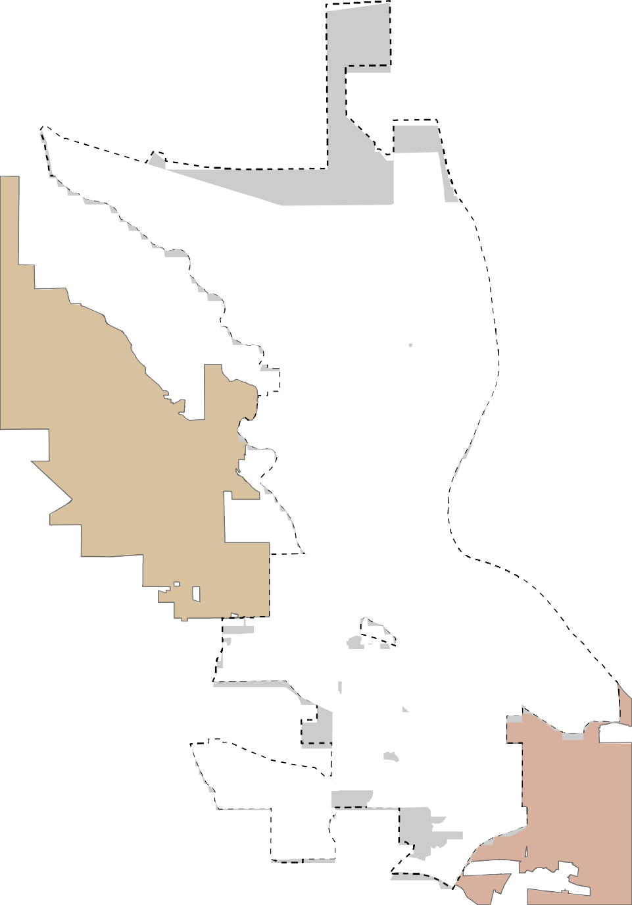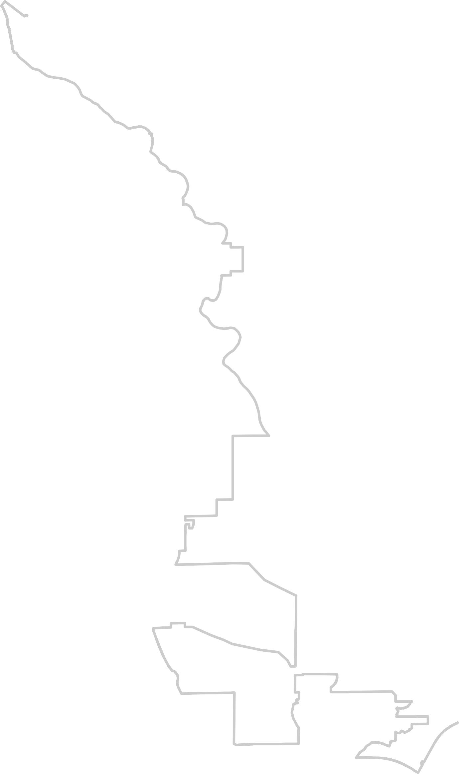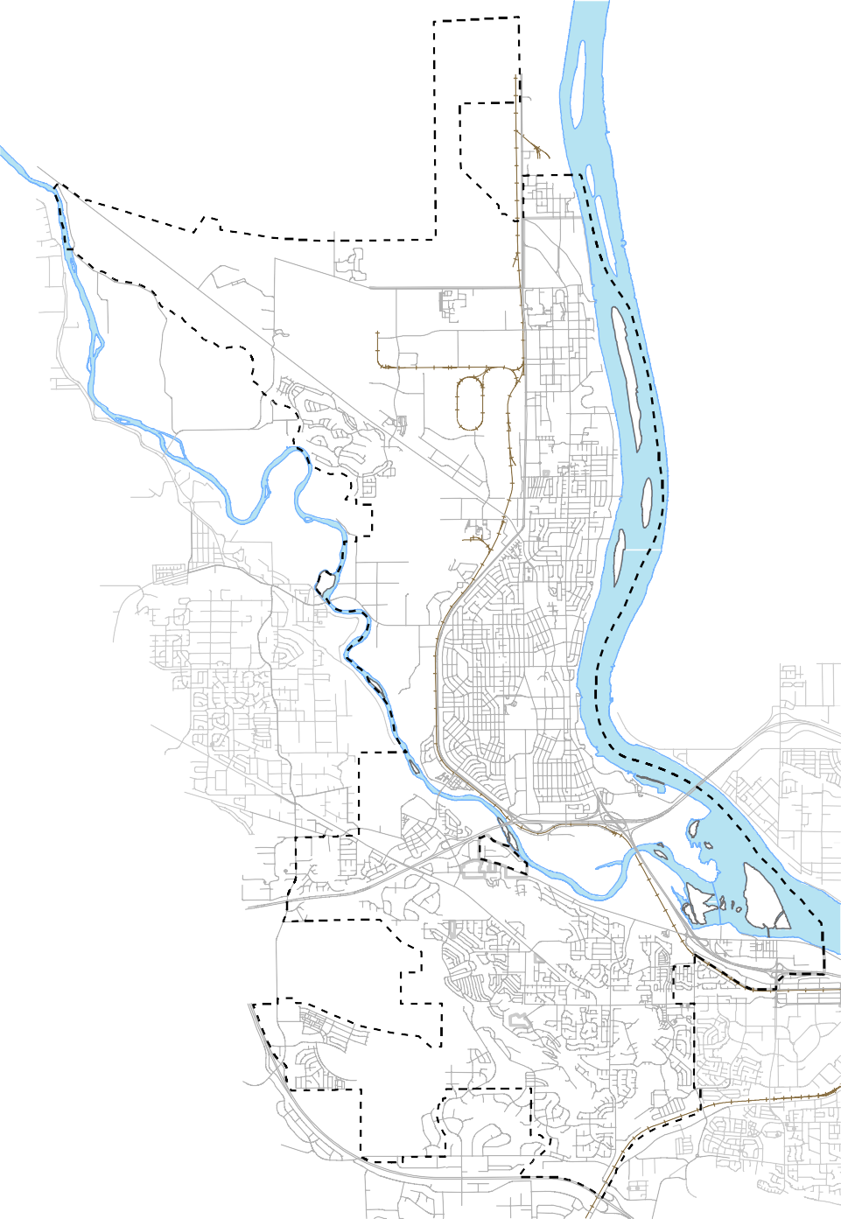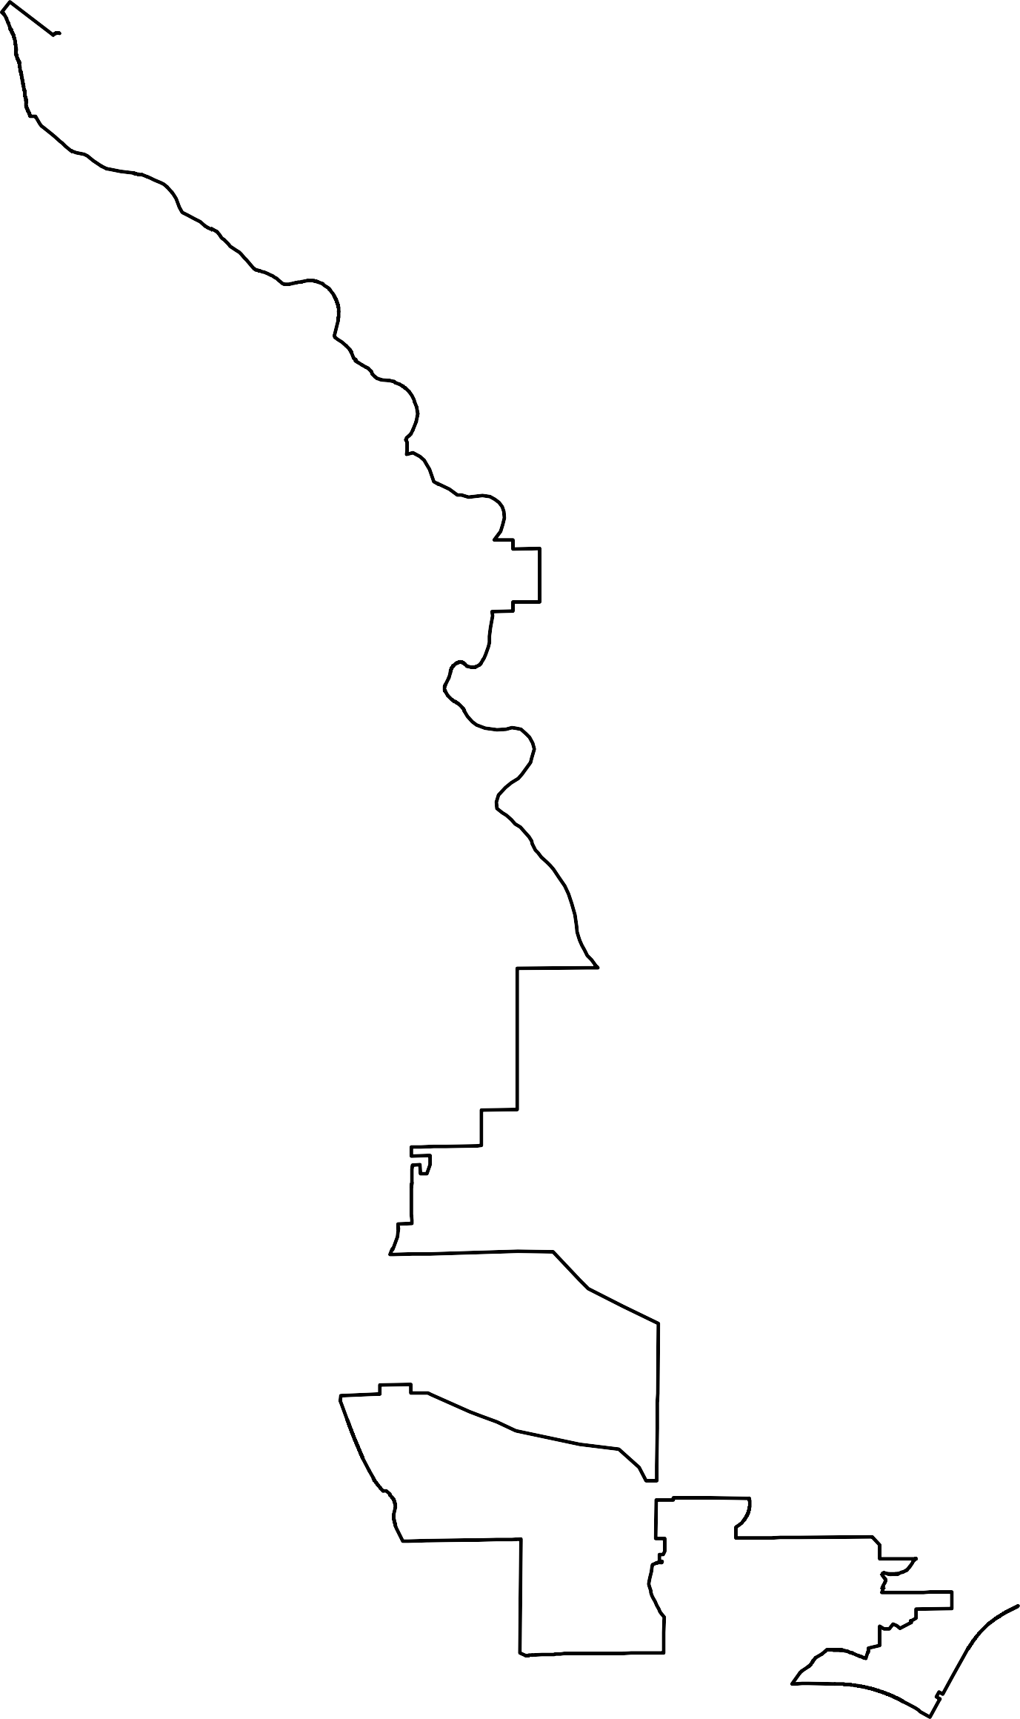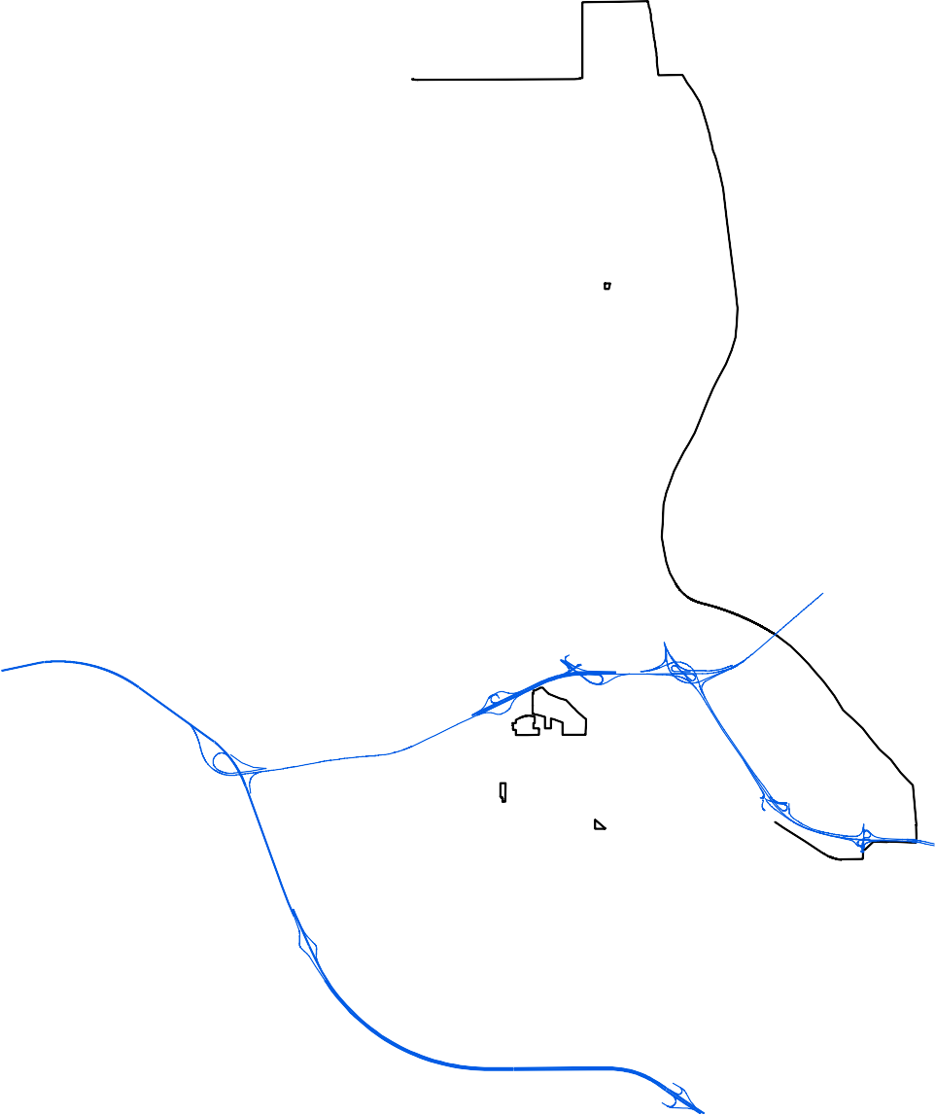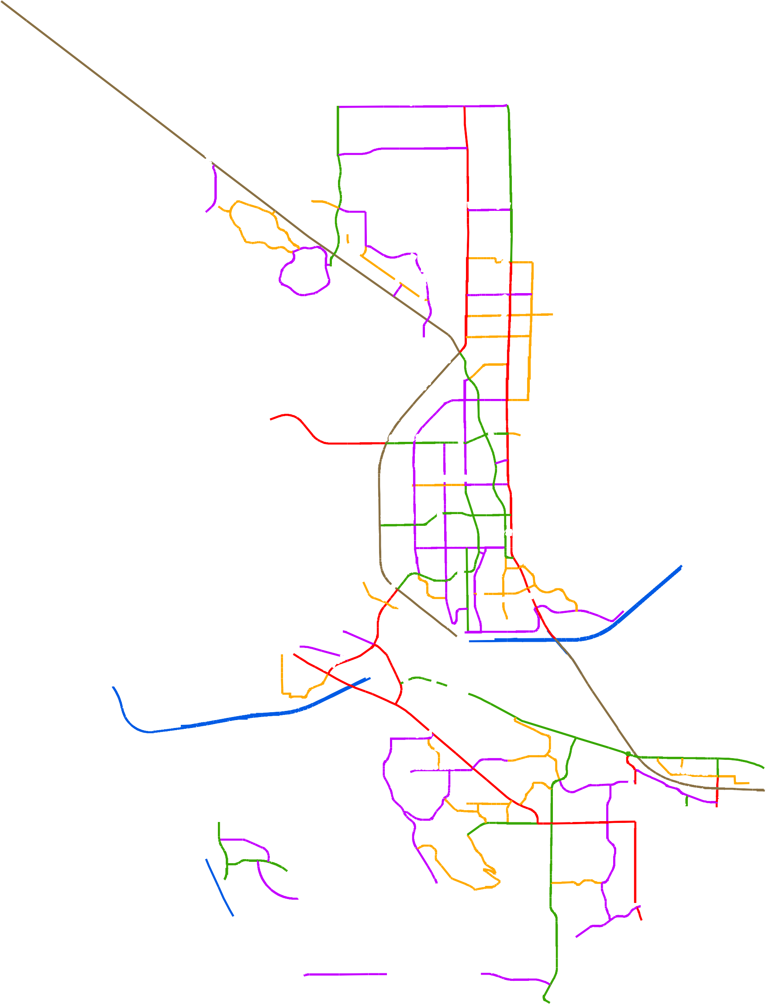Richland City Limits Urban Growth Area
Street Classification
Interstate
Other Freeway - Expressway (14.4 Miles) Principal Arterial (18.0 Miles)
Minor Arterial (23.0 Miles) Major Collector (35.7 Miles) Minor Collector (23.3 Miles) Local Streets (203.3 Miles)

§¨¦82

K e n n e w i c k
Dallas Rd
Leslie Rd

March 28, 2023

City of Richland
T-2 - Number of Lanes

UV240
Horn Rapids Rd

Battelle Blvd
Twin Bridges Rd
Kingsgate Way

University Dr

W e s t R i c h l a n d
Jones Rd
Van Giesen St

Williams Blvd
Wright Ave
Stevens Dr

Swift Blvd
By-pass Hwy

Lee Blvd
Thayer Dr

Knight St

§¨¦182
Wellsian Way
Goethals Dr

Aaron Dr

§¨¦182
VU240

Shockley Rd

Westcliffe Blvd
Steptoe St

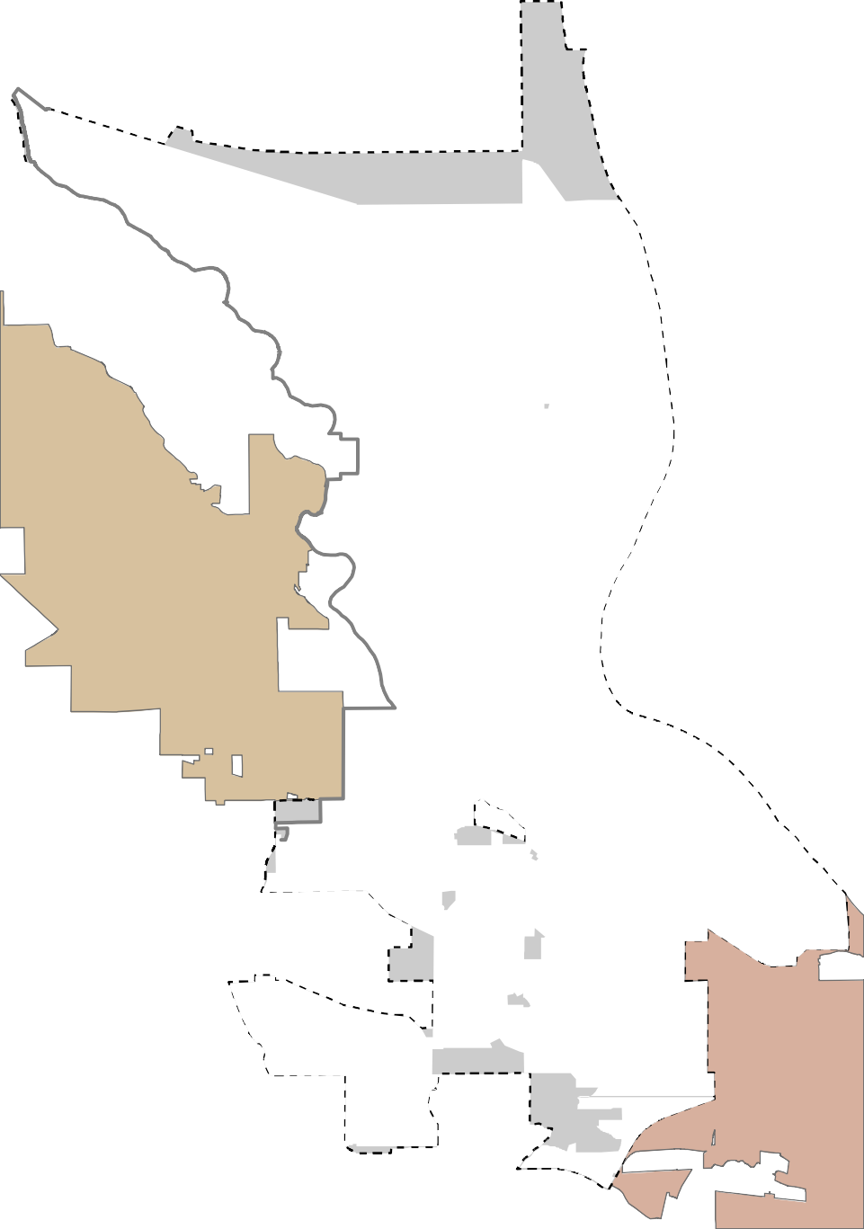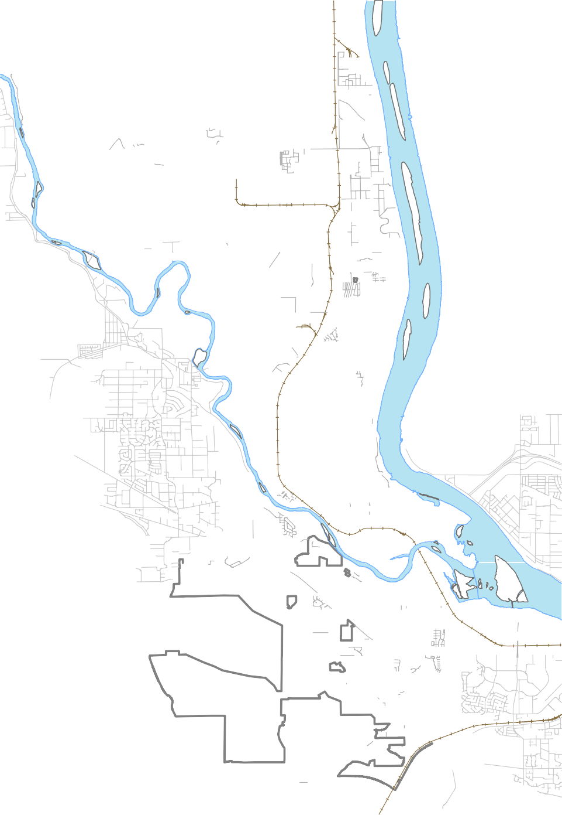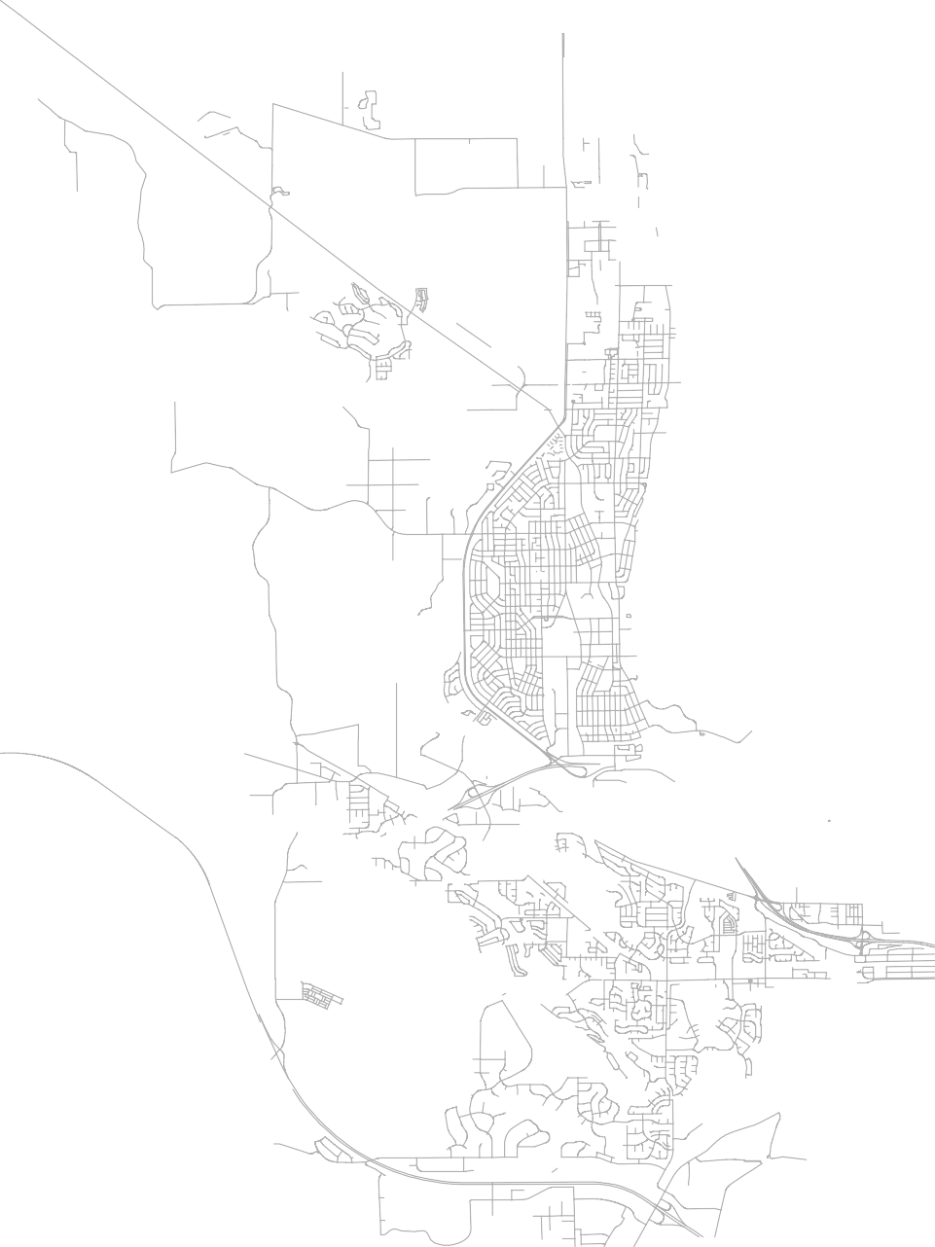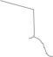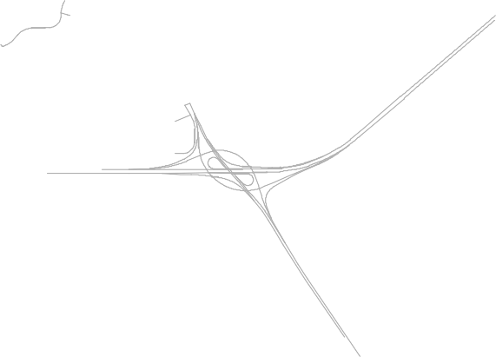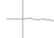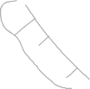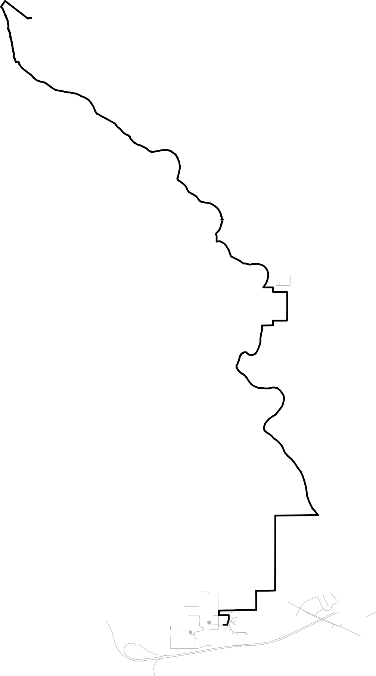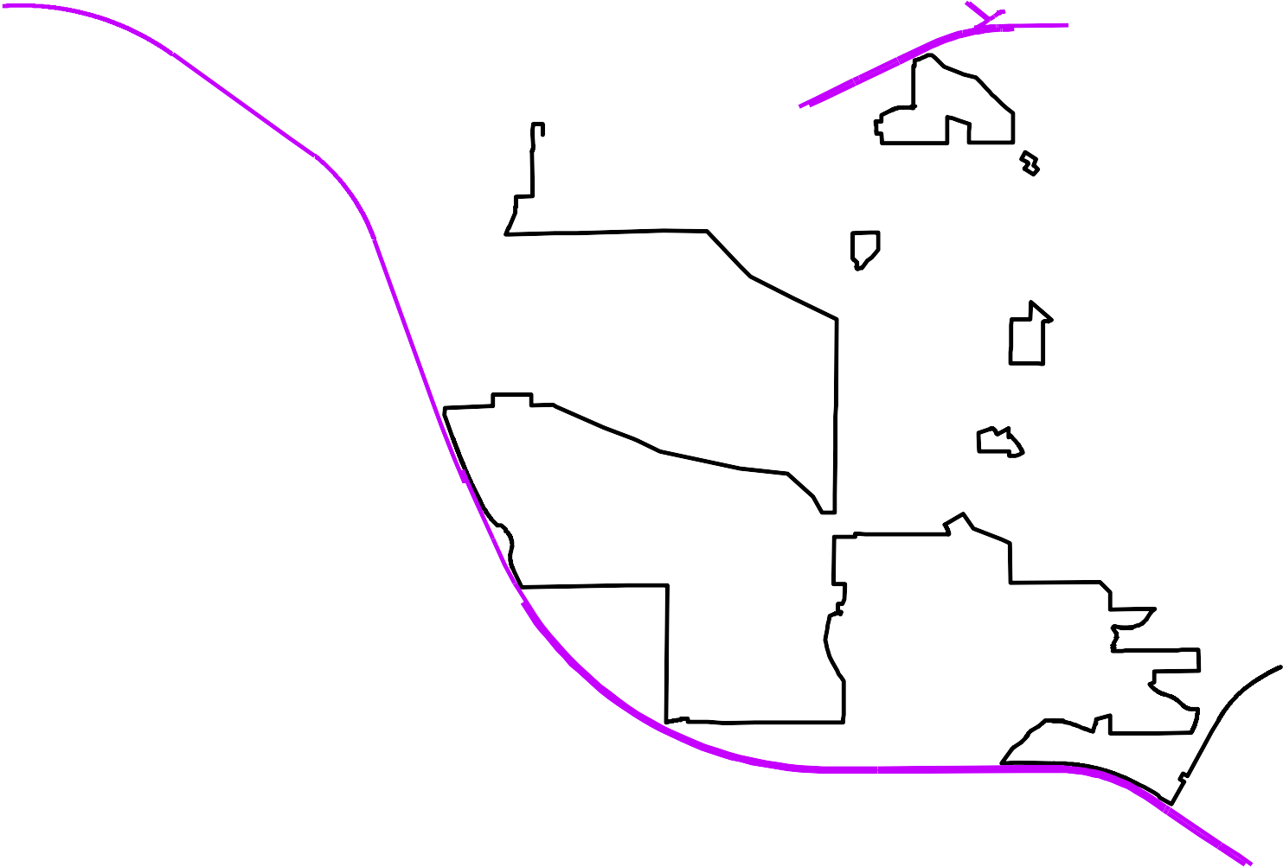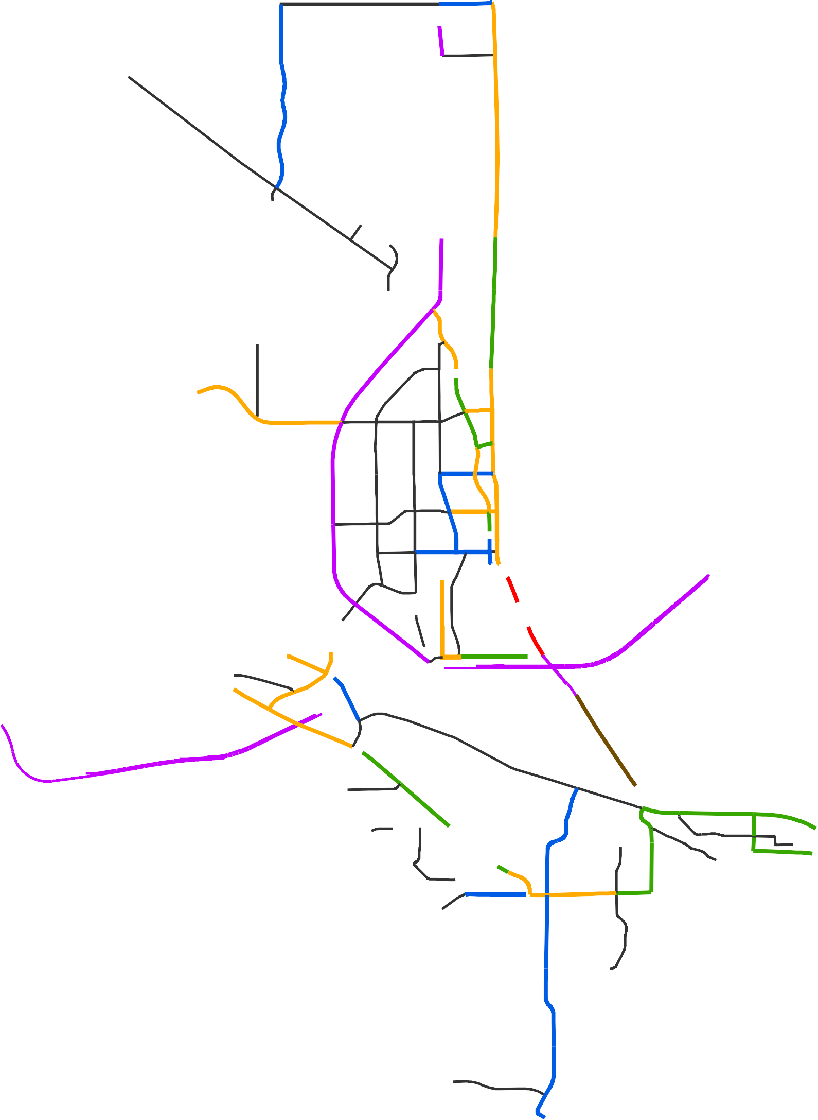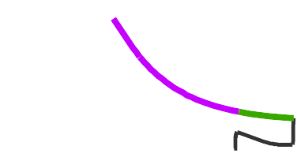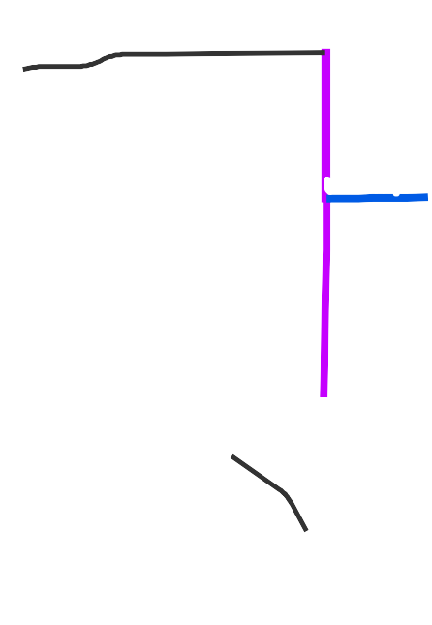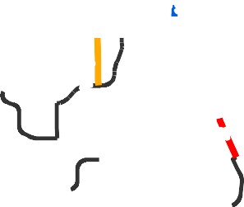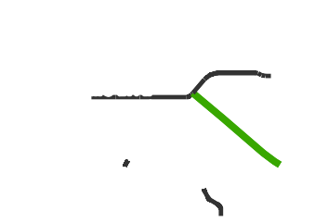Number of Lanes
Dallas Rd
2 (40.13 Miles)
3 (9.54 Miles)
4 (8.59 Miles)
5 (13.27 Miles)
6 (8.02 Miles)
7 (0.82 Miles)
8 (1.04 Miles)

§¦¨82

K e n n e w i c k
Leslie Rd

February 24, 2017

City of Richland
  - - Intersection Traffic Control

UV240

!"$
Twin Bridges Rd
$"!

!$"
Kingsgate Way

Horn Rapids Rd

Battelle Blvd

èéíìë ëìíéè
$"!

íèéëì

éíìëèUniversity Dëìíèér

èíìëé

!"$

ëìíèé
íéìëè éëèíì
íèéëì ìèíéë
!$"
éèëìí ëìéèí
èéëìí èéëìí

íìëéè
Jones Rd
ëéìíèèéëìí èéíìë

W e s t R i c h l a n d

$"!

Vaéìíëèn Gieseèéíìën St

!"$

èìëíé
Stevens Dr
ìíëéè
éèìíë
èéëì
éëìíè èéíëì

WilliamsèéëìíBlvd
Wright Ave
Thayer Dr
í

èíìëé éëìíè

ëíìéèSwift Blv"$!d
By-pass Hwy

èéíìë
éëìíè

!"$
èíìëéLeeìéëèíBlvdìíéèë

éèíìë

íéëèì

2!!

2!!

$!"

èéìëí

!$"
Wellsian Way
Knight St

ìèéëíèíìëé èéëìí
éëèìí
Goethals Dr
èéëíì
èéëìí

§¨¦182

$"!
íéëìè$!"Aaron Dr

§¦¨182

íìëèé

"!$
ìëéíè
è

ëéèíì$"! ìíéèë
Shockley Rdëíìèé

"!$

VU240

2!!

!"$
Steptoe St

!"$

Westcliffe B!"$lvd

$"!
íìëéè

íéëìè
$"!

!"$
"$!éíìëè
!$"ëìéíè

$"!
$"!
Dallas Rd
íèéëìèéëìí èéíìë
éèíìë

Intersection Control Type
Leslie Rd

èéëìí Signalized (66)

2!!

$"

Roundabout (3)

Not Signalized (29)
Other Freeway - Expressway (14.87 Miles) Principal Arterial (15.57 Miles)
Minor Arterial (28.62 Miles) Major Collector (18.61 Miles) Minor Collector (4.36 Miles) Local Streets (191.97 Miles)

§¨¦82

$!"

ëìíèé

K e n n e w i c k

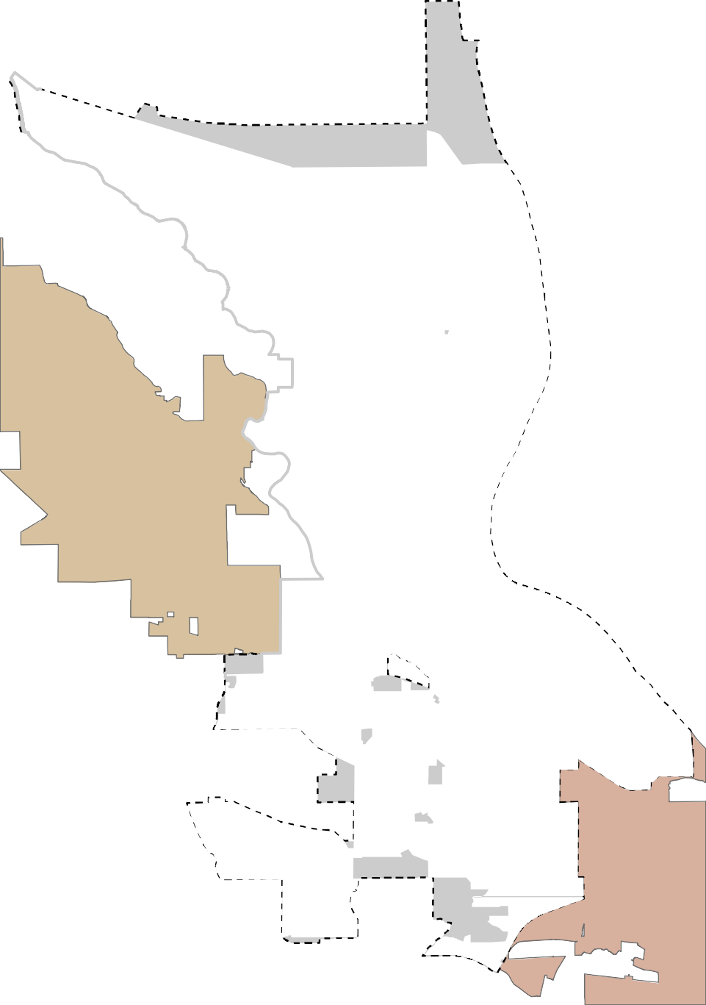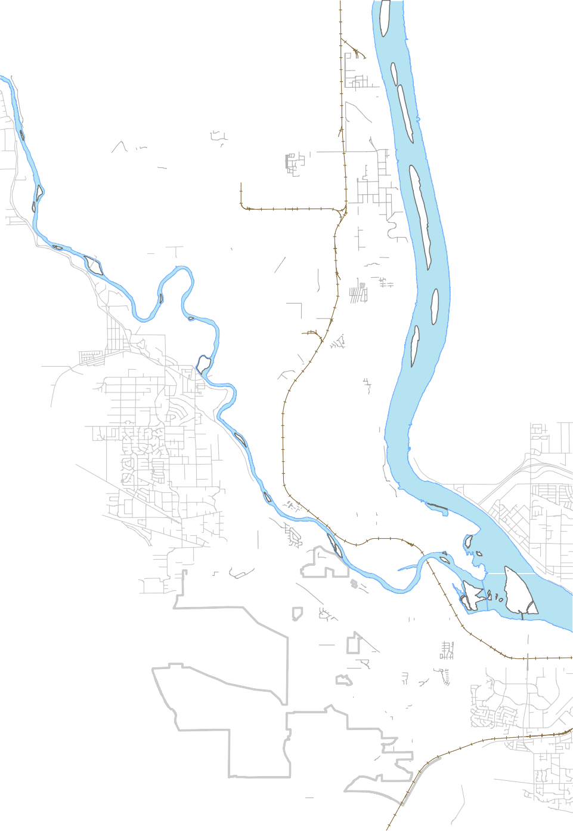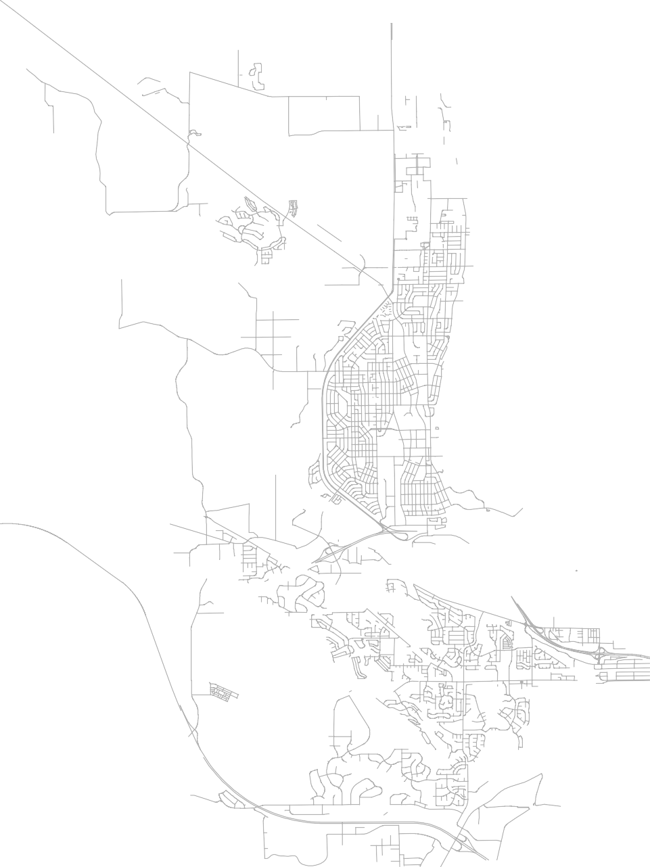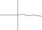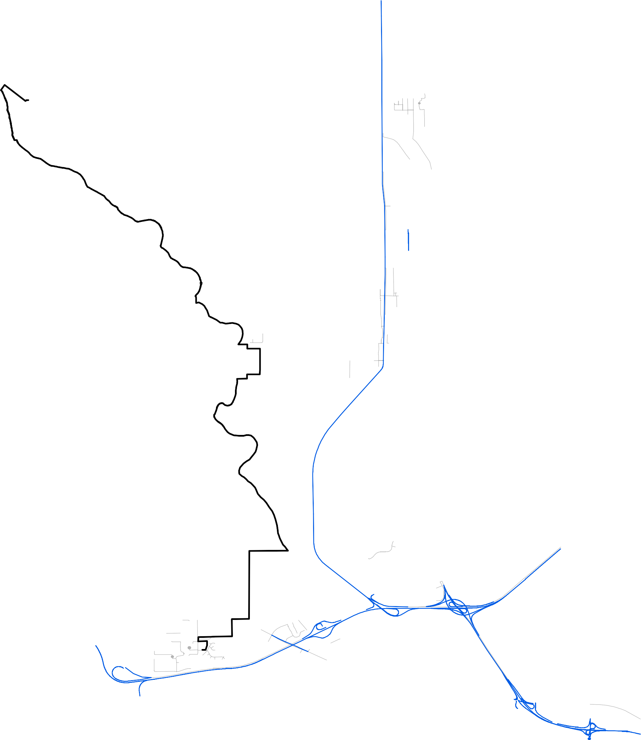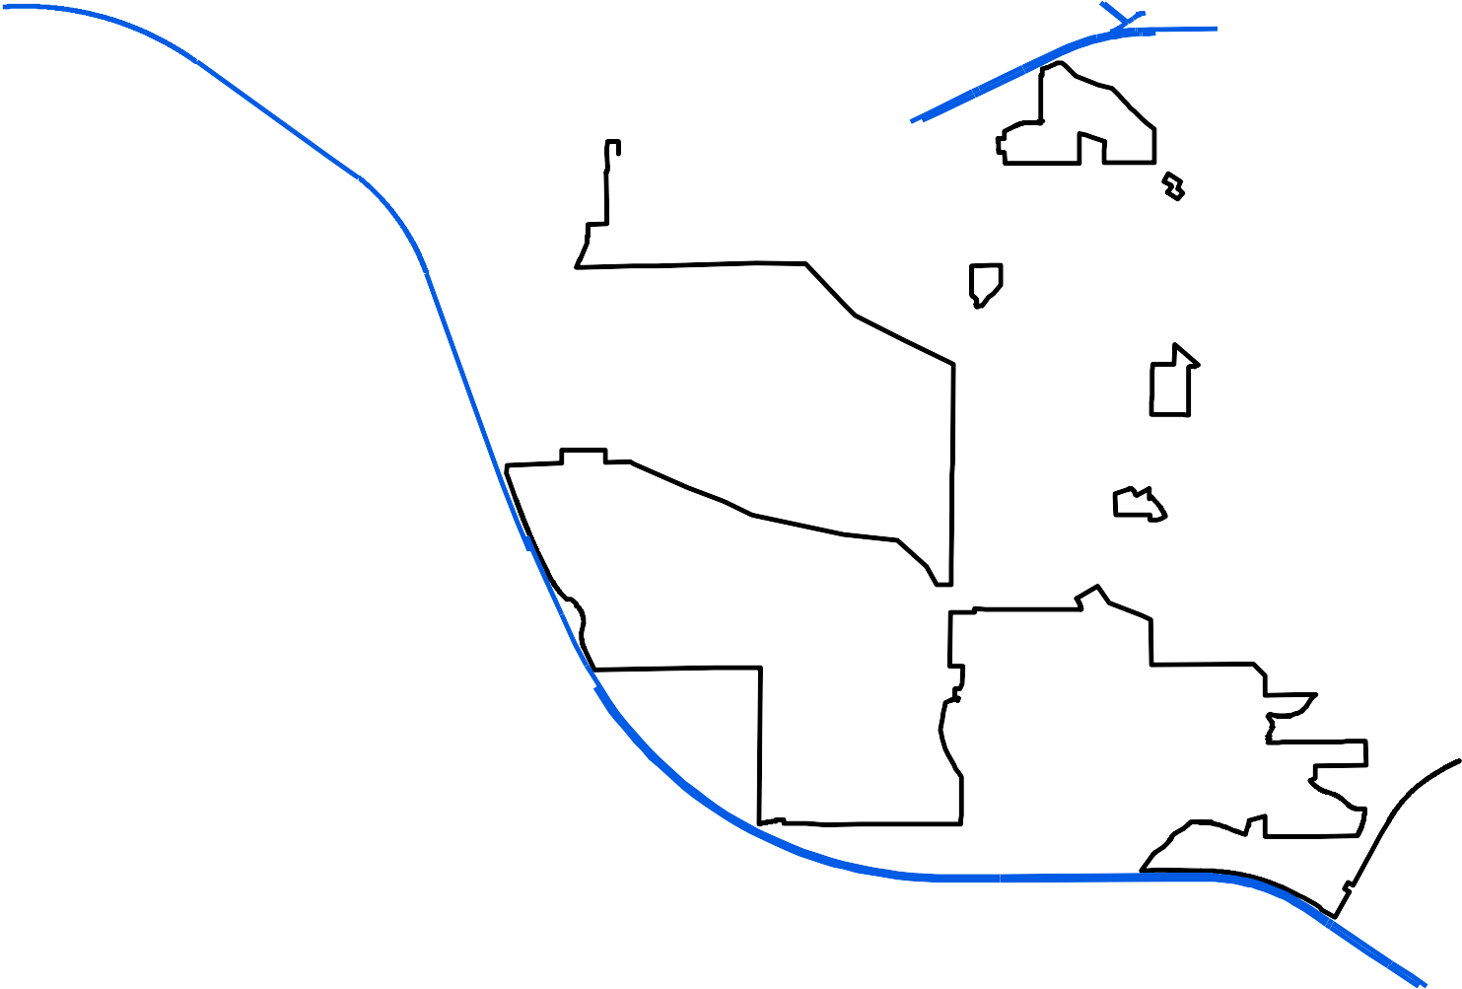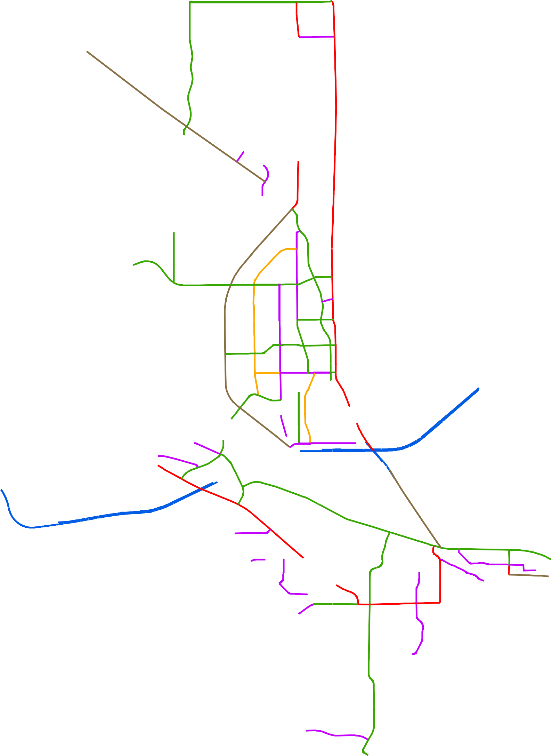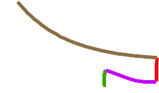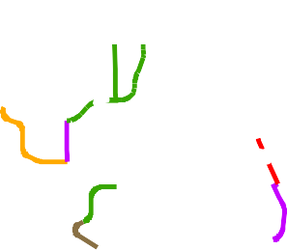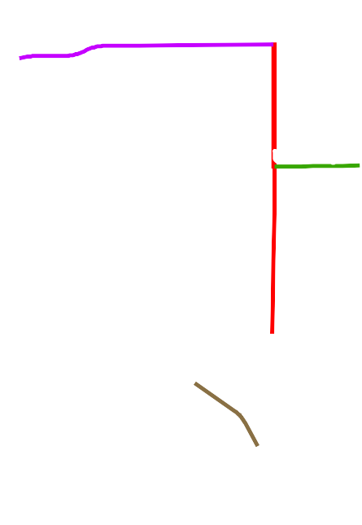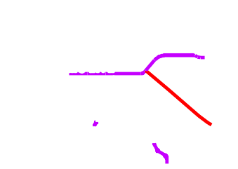Street Classification
Interstate

February 24, 2017

City of Richland
  - - 2016 All Day Traffic Counts

UV240
Horn Rapids Rd

Battelle Blvd
Twin Bridges Rd
Kingsgate Way

University Dr

W e s t R i c h l a n d
Jones Rd
Van Giesen St

Williams Blvd
Wright Ave
Stevens Dr

Swift Blvd
By-pass Hwy

Lee Blvd
Thayer Dr

Knight St

§¦¨182
Wellsian Way
Goethals Dr

Aaron Dr

§¨¦182
VU240

Shockley Rd

Westcliffe Blvd
Steptoe St

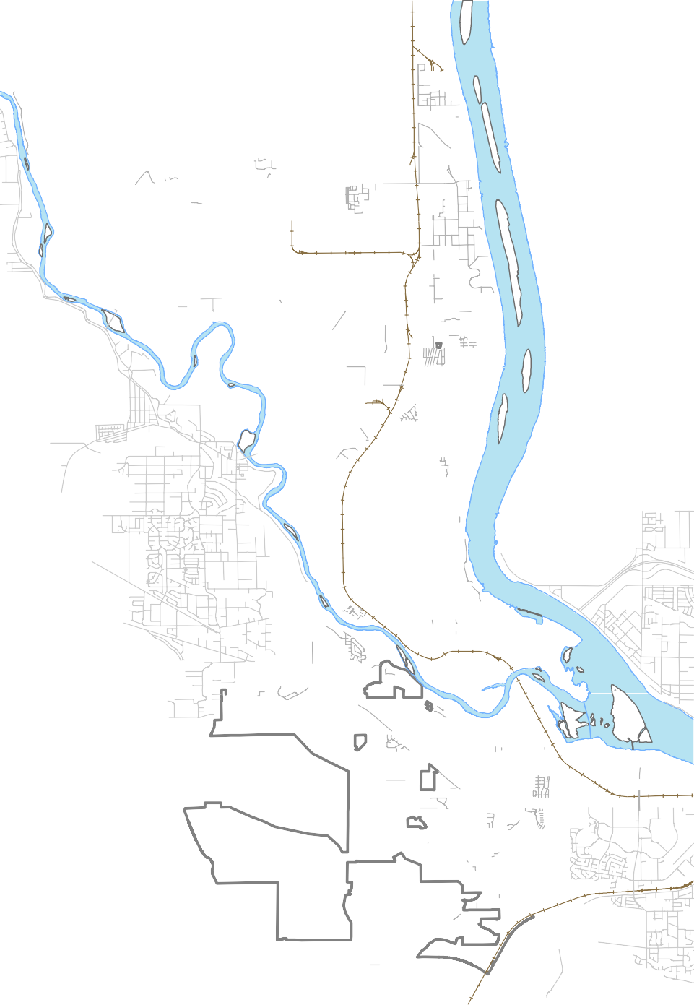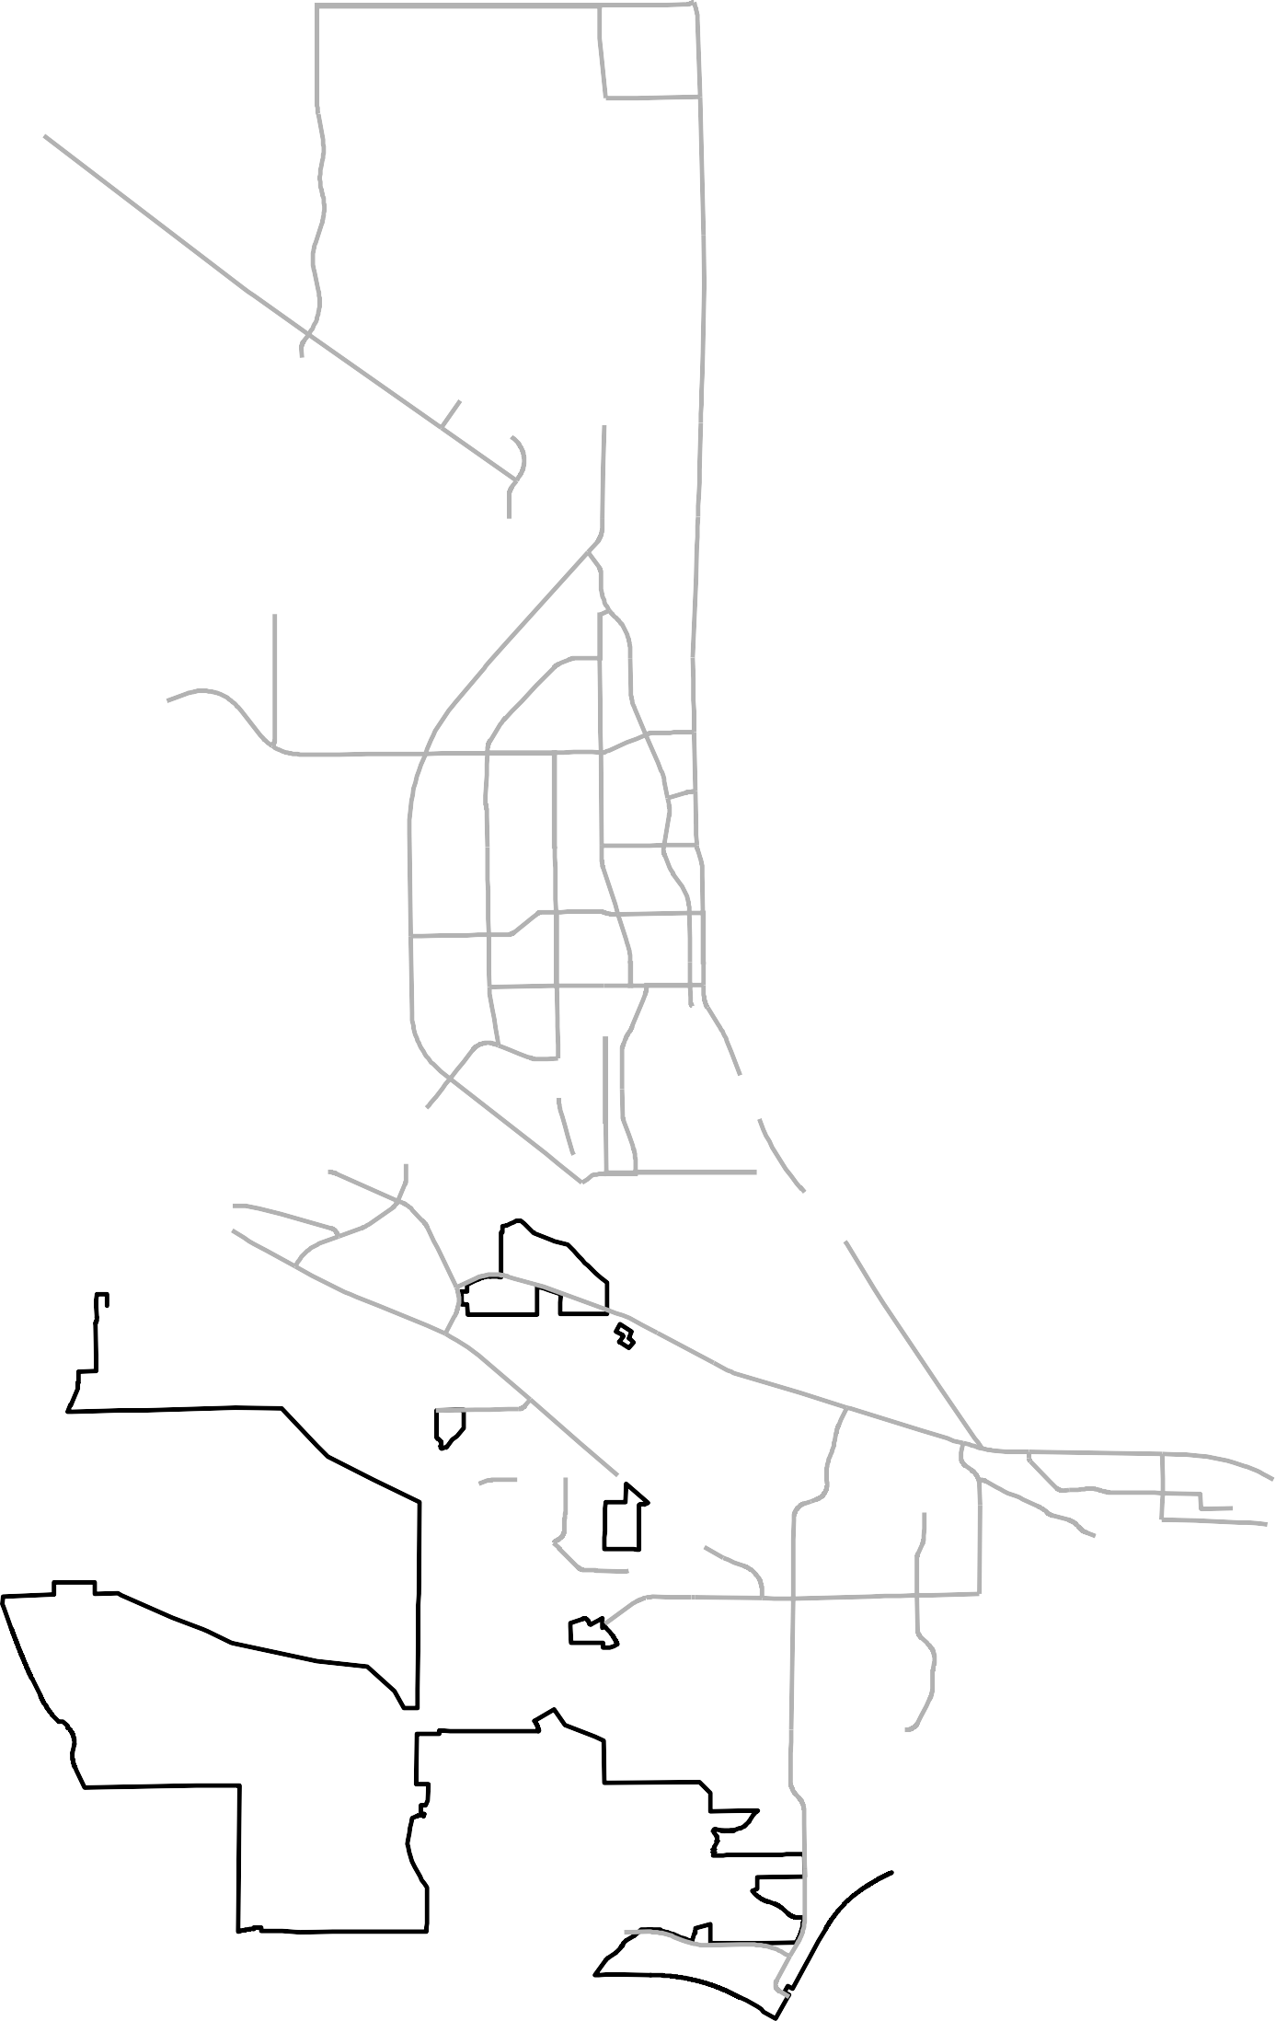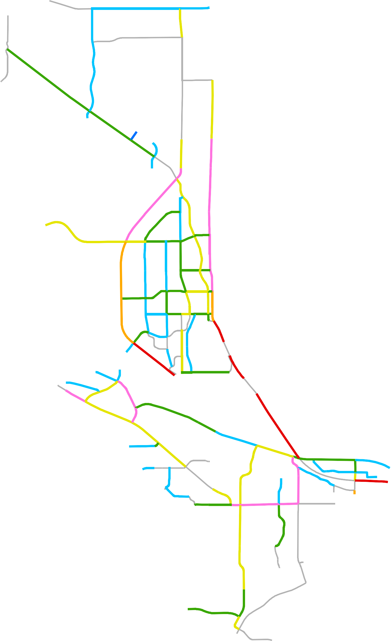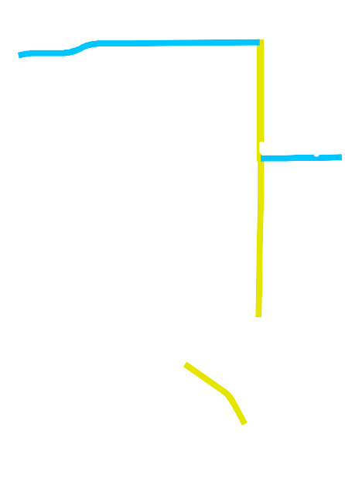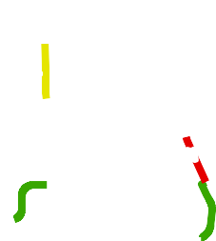All Day Traffic Counts
Dallas Rd
0 to 1,000
1,001 to 5,000
5,000 to 10,000
10,001 to 20,000
20,001 to 30,000
30,001 to 40,000
More than 40,000
No Count Data

§¦¨82

K e n n e w i c k
Leslie Rd

February 24, 2017

City of Richland
  - - 2016 Peak Traffic Volumes

VU240
Horn Rapids Rd
15 / 46
Kingsgate Way

Battelle Blvd
Twin Bridges Rd
190 / 190
7 / 76
113 / 1258

University Dr
165 / 160
182 / 1357
296 / 812

W e s t R i c h l a n d

720 / 1080
990 / 1140
Van Giesen St
527 / 585
Jones Rd

Williams Blvd
124 / 168 Wright Ave
164 / 203 130 / 221
105 / 89
229 / 182
Stevens Dr
275 / 301

227 / 299

172 / 278
737 / 1137

Swift Blvd
By-pass Hwy
360 / 385

214 / 412 279 / 320
Knight St
Thayer Dr
278 / 224
Lee Blvd
440 / 626 374 / 399
245 / 139
Wellsian Way

§¦¨182

Aaron Dr
Goethals Dr
386 / 188
290 / 216

§¨¦182

Shockley Rd
115 / 55
Steptoe St
1115 / 1103
UV240

Westcliffe Blvd
190 / 190
453 / 696
314 / 346

Peak Traffic Volume (5 PM)
Dallas Rd
Up to 200
201 to 500
501 to 1000
1001 to 1500
More than 1500
No Count Data
256 / 382
804 / 1035

K e n n e w i c k
Leslie Rd
595 / 818

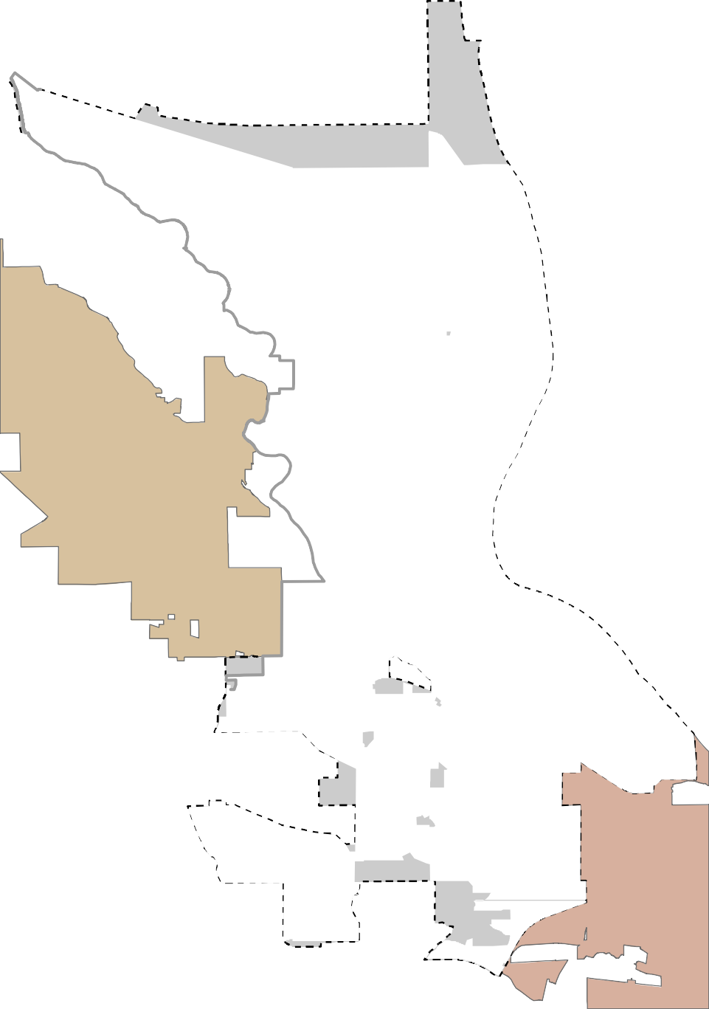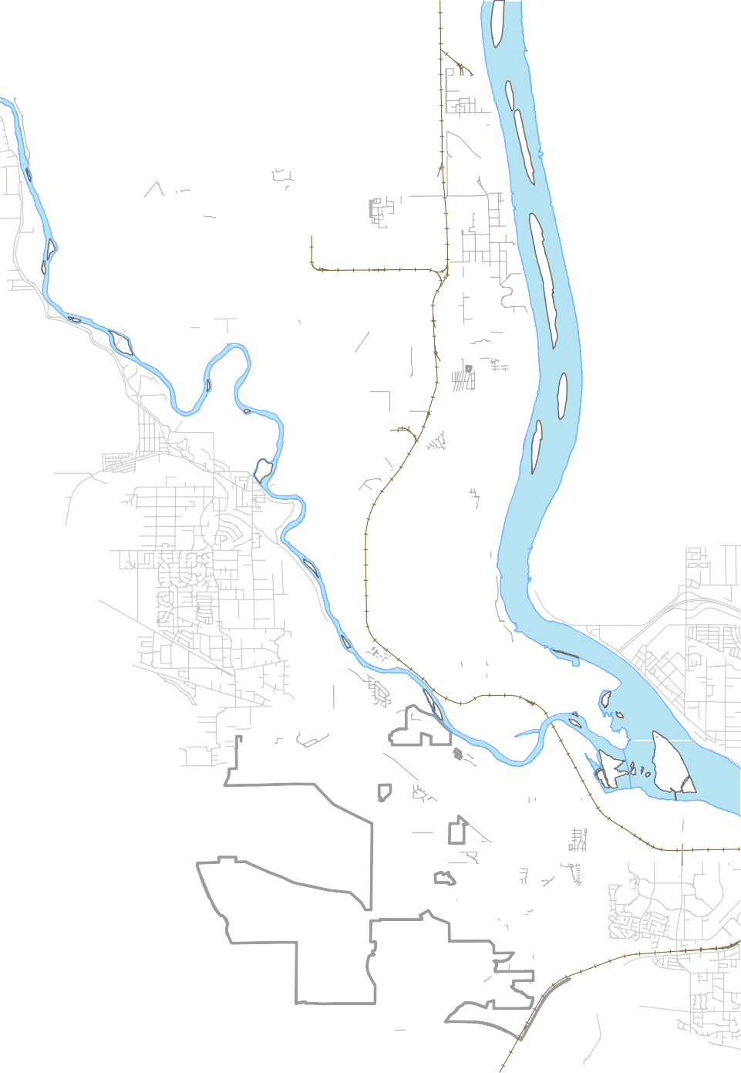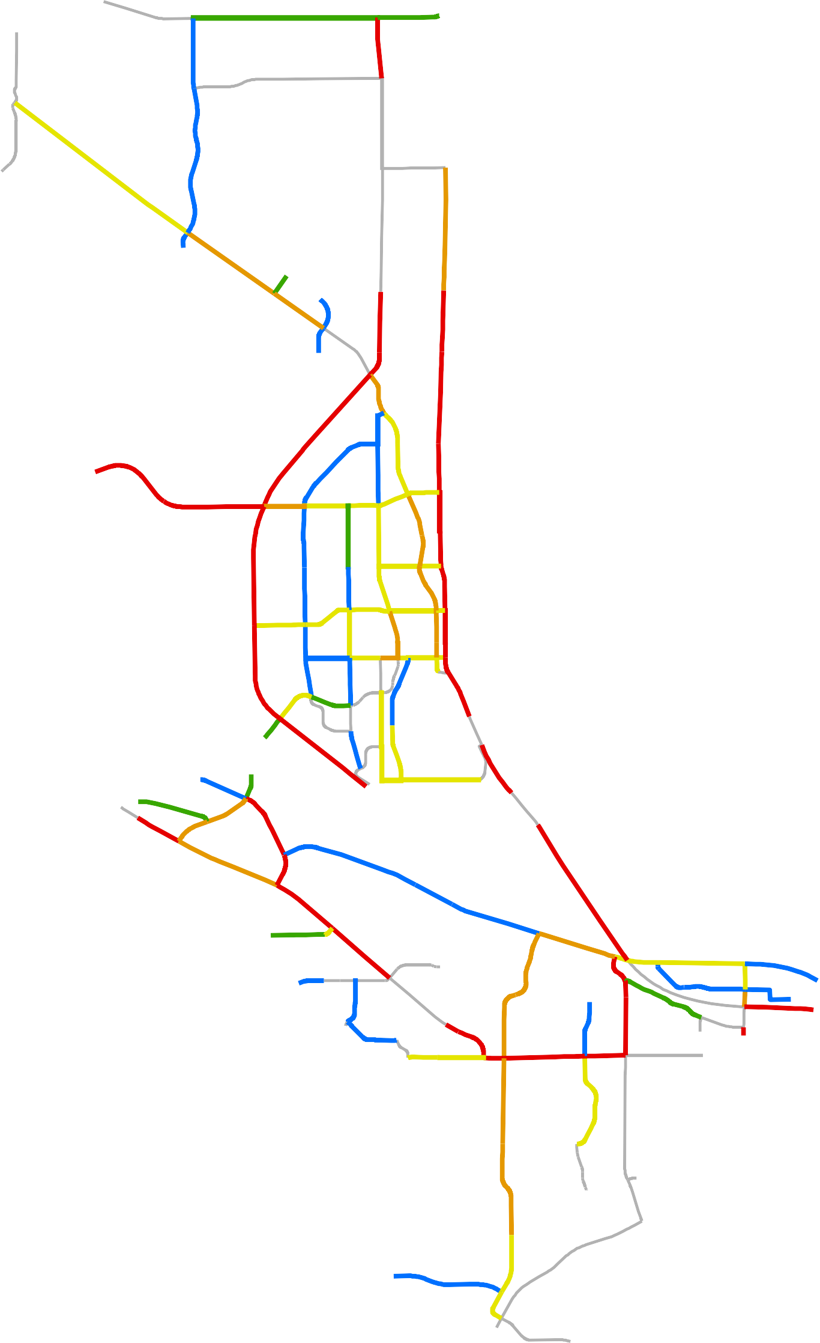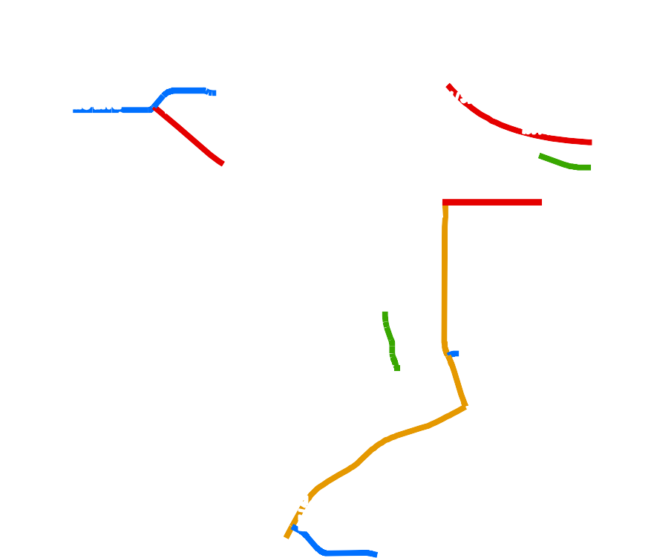Note: Volume labels show eastbound or northbound volumes first and westbound or southbound volumes second as follows: EB / WB or NB / SB
§¨¦82

February 24, 2017

City of Richland
  - - Bike Routes and Paths

VU240
Horn Rapids Rd

Battelle Blvd
Twin Bridges Rd
Kingsgate Way

University Dr

!O
Jones Rd
Stevens Dr

W e s t R i c h l a n d
Van Giesen St

Williams Blvd
Wright Ave

Swift Blvd
By-pass Hwy

Lee Blvd
Thayer Dr
K!Onight St

§¦¨182
Wellsian Way
Goethals Dr

Aaron Dr

§¨¦182
UV240

Shockley Rd

Westcliffe Blvd
Dallas Rd
Leslie Rd
Steptoe St

Richland City Limits Urban Growth Area

!O Transit Center
On-Street Bike Route Class I Trail
Soft Trail

§¨¦82
!O

K e n n e w i c k

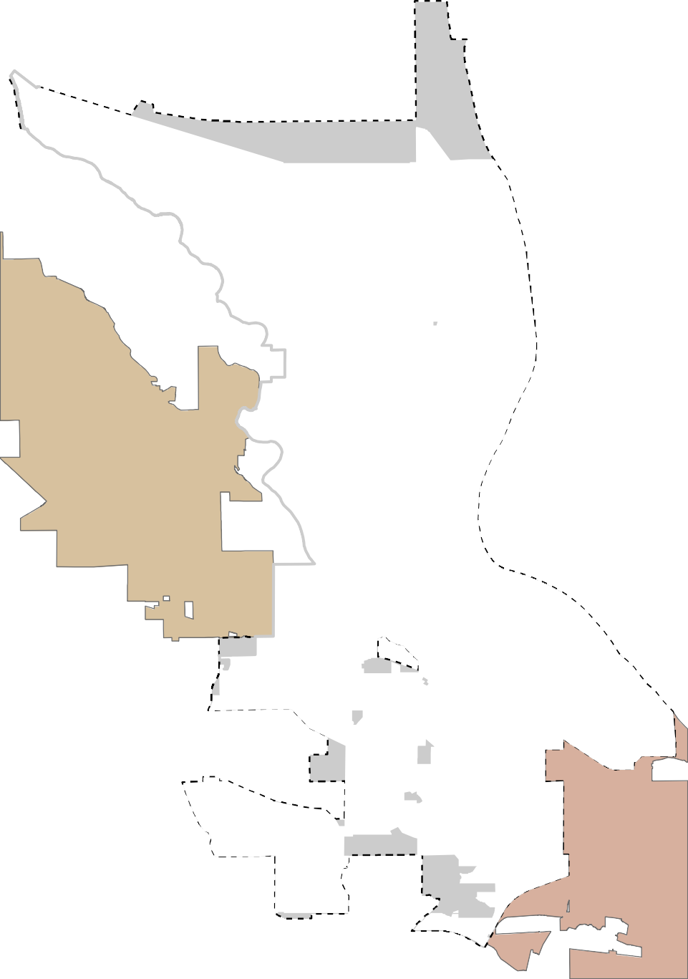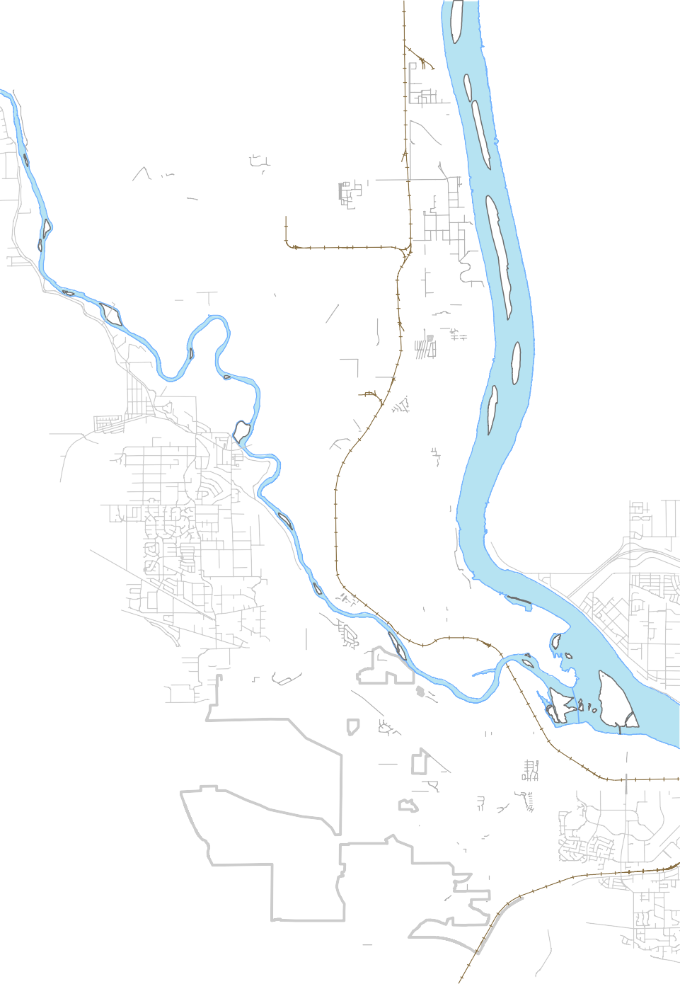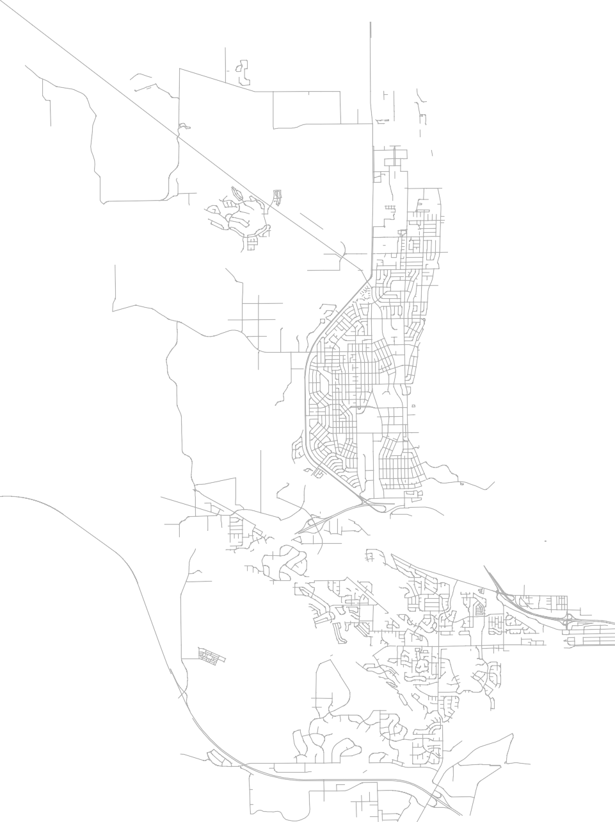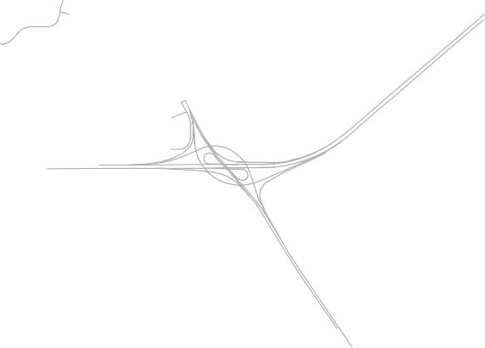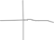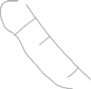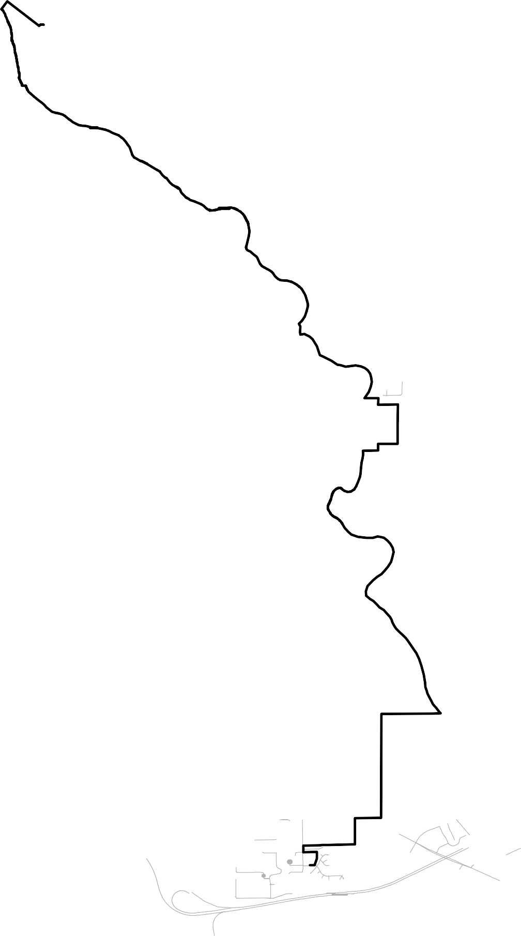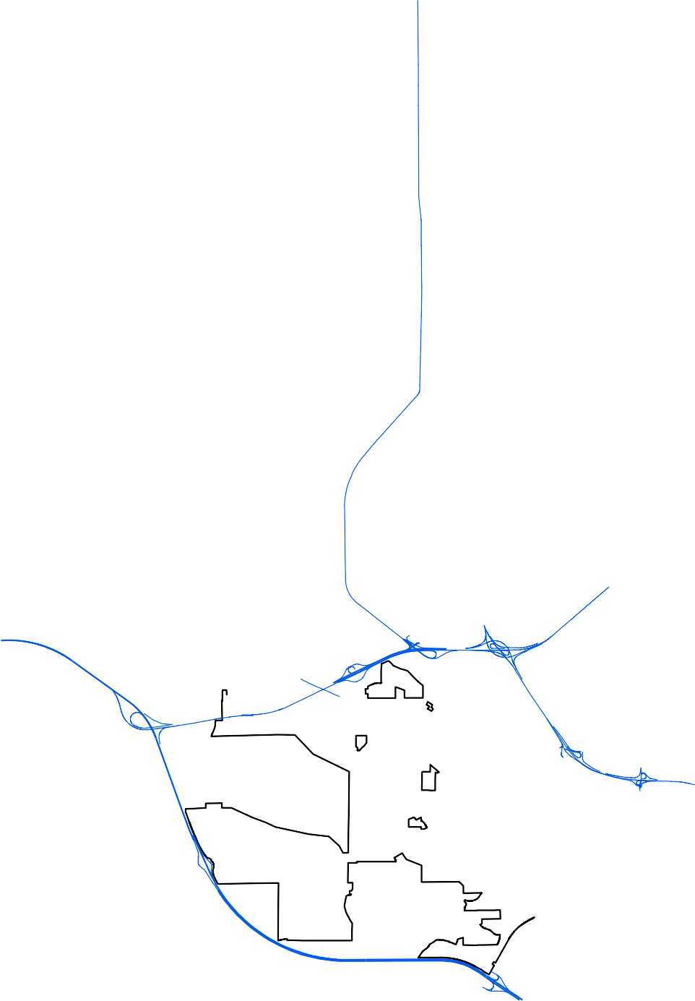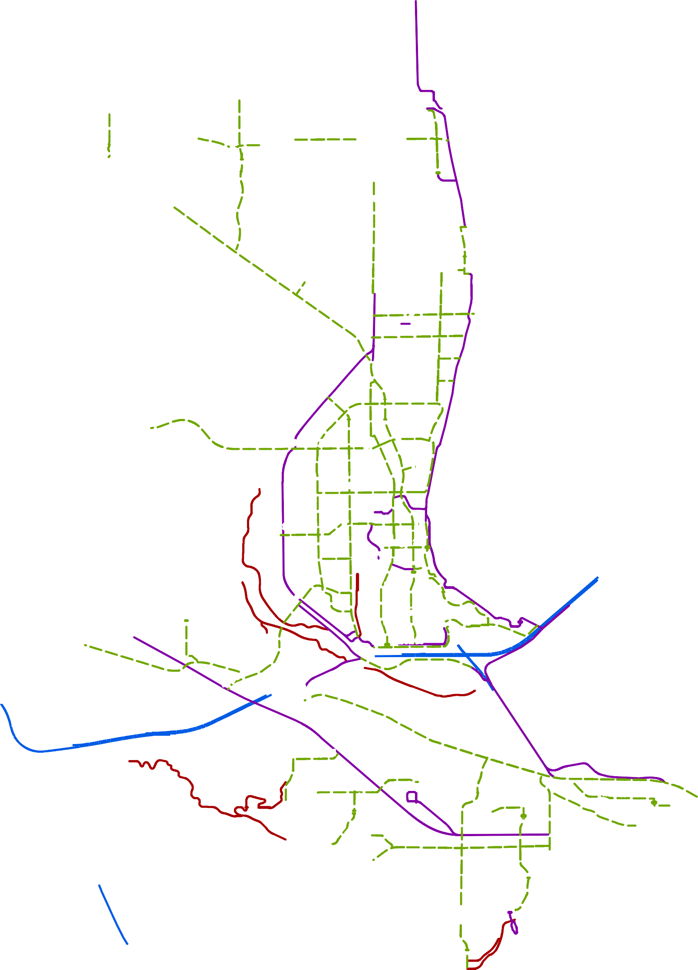
February 27, 2017

City of Richland
  - - Airport and Port Facilities

UV240
Horn Rapids Rd

Battelle Blvd
Twin Bridges Rd
Kingsgate Way

University Dr

W e s t R i c h l a n d
Jones Rd
Van Giesen St

Williams Blvd
Wright Ave
Stevens Dr

Swift Blvd
By-pass Hwy

Lee Blvd
Thayer Dr

Knight St

§¦¨182
Wellsian Way
Goethals Dr

Aaron Dr

§¨¦182
VU240

Shockley Rd

Westcliffe Blvd
Dallas Rd
Steptoe St

K e n n e w i c k
Leslie Rd

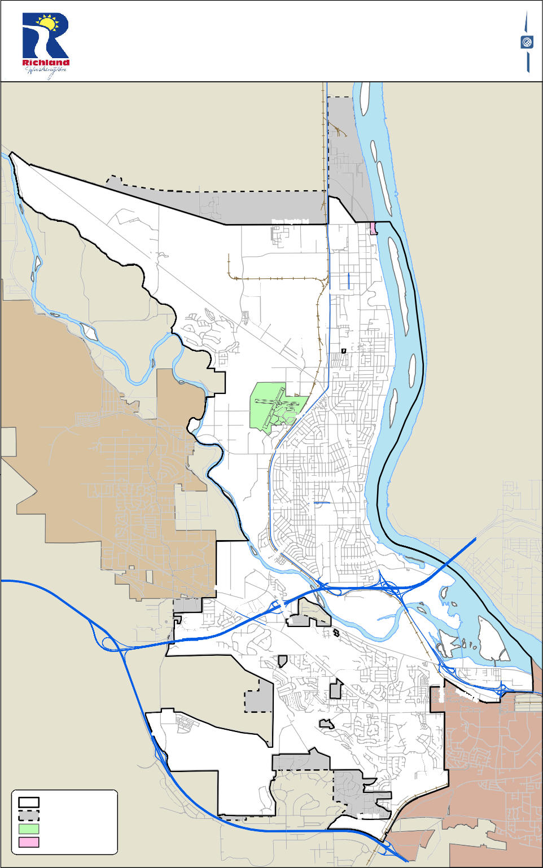
Richland City Limits Urban Growth Area Richland Airport Port of Benton

§¦¨82

February 24, 2017

City of Richland
  - - Transit Routes

UV240
Horn Rapids Rd

Battelle Blvd
Twin Bridges Rd
Kingsgate Way

University Dr

!O
Jones Rd
Stevens Dr

W e s t R i c h l a n d
Van Giesen St

Williams Blvd
Wright Ave

Swift Blvd
By-pass Hwy

Lee Blvd
Thayer Dr
K!Onight St

§¦¨182
Wellsian Way
Goethals Dr

Aaron Dr

§¦¨182
UV240

^!(

Richland City Limits
Urban Growth Area
Maintenance, Operations, and Administration
Dallas Rd
Leslie Rd
Shockley Rd

Westcliffe Blvd
Steptoe St
^!(

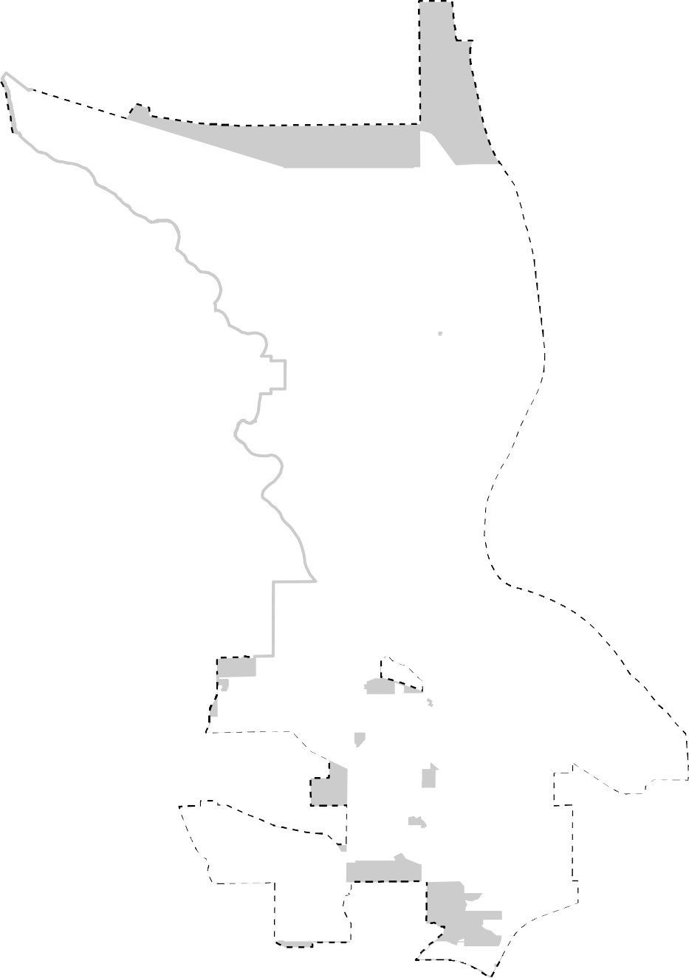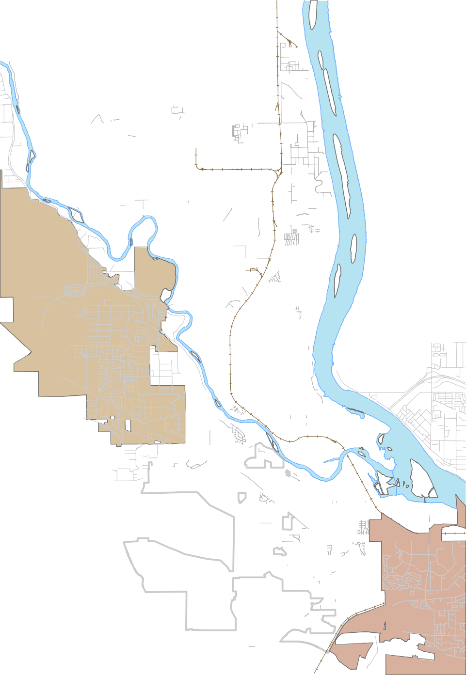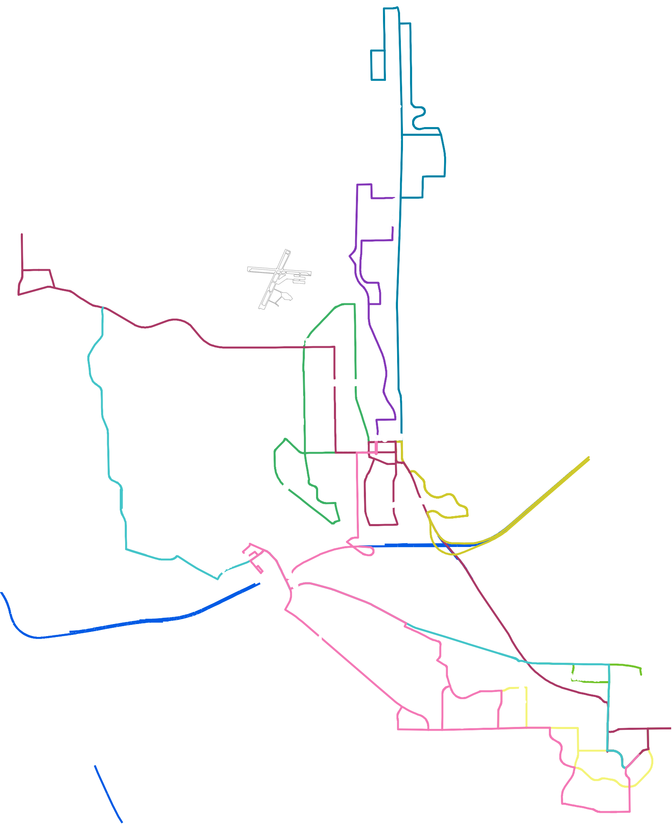!O Transit Center
Bus Route 23
Bus Route 25
Bus Route 26 Bus Route 39K Bus Route 50
Bus Route 110
Bus Route 120
Bus Route 225
Bus Route 815

§¦¨82
!O

K e n n e w i c k

February 27, 2017

City of Richland
  - - Volume to Capacity Ratios

UV240

46 / 800
Twin Bridges Rd
190 / 800
Kingsgate Way
295 / 800
Horn Rapids Rd

Battelle Blvd
76 / 800
1258 / 2400

87 / 800

University Dr

W e s t R i c h l a n d
Jones Rd

1080 / 1600
Van Giesen St

428 / 800
229 / 800 105 / 800
Stevens Dr
278 / 800
301 / 800
1140 / 1600 1140 / 1600
1137 / 1600

Williams Blvd
Wright Ave
203 / 800
330 / 800
Thayer Dr

Swift Blvd
By-pass Hwy
2940 / 3600
385 / 800

168 / 800

Lee Blvd
245 / 800
278 / 800

412 / 1600
Knight St
618 / 800
1140 / 1600

§¦¨182

49 / 800
Wellsian Way
536 / 1600
Goethals Dr

Aaron Dr
613 / 1600
290 / 1600

§¨¦182

Shockley Rd
VU240

Westcliffe Blvd
Steptoe St
346 / 1600

190 / 800
696 / 800
141 / 800

382 / 800
Dallas Rd
717 / 1600

382 / 800

1309 / 1600
Leslie Rd
818 / 800 818 / 800

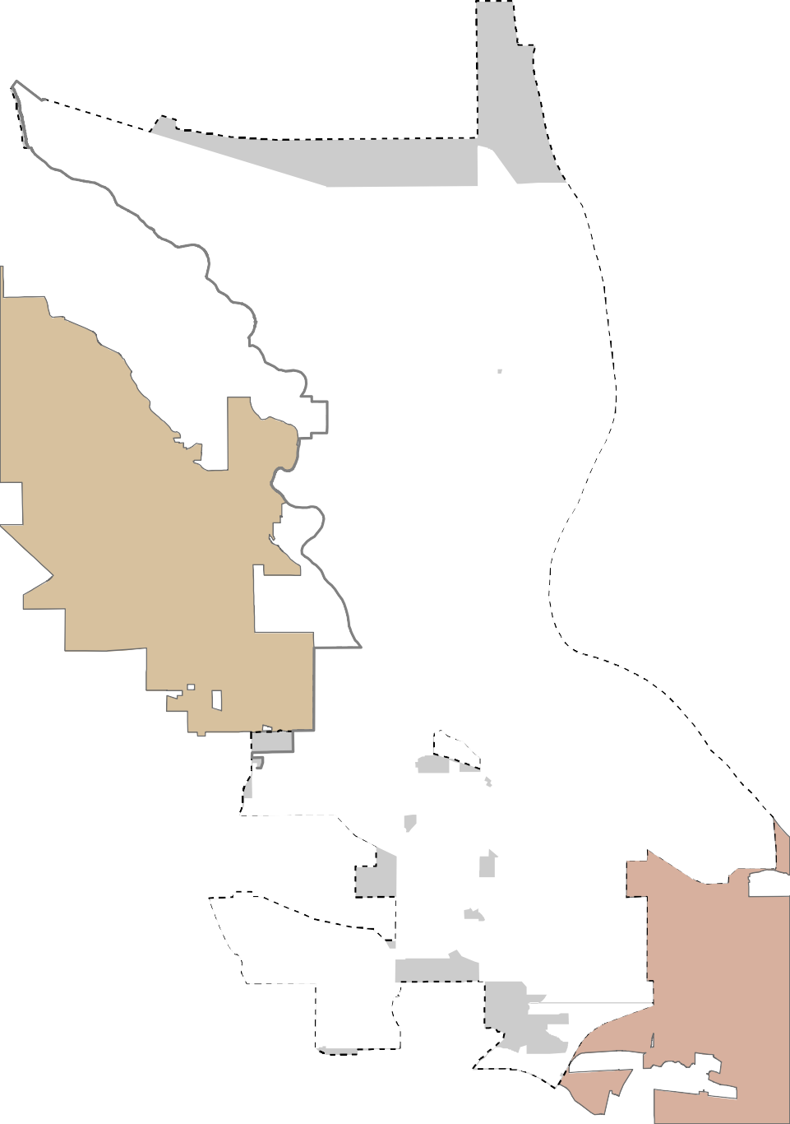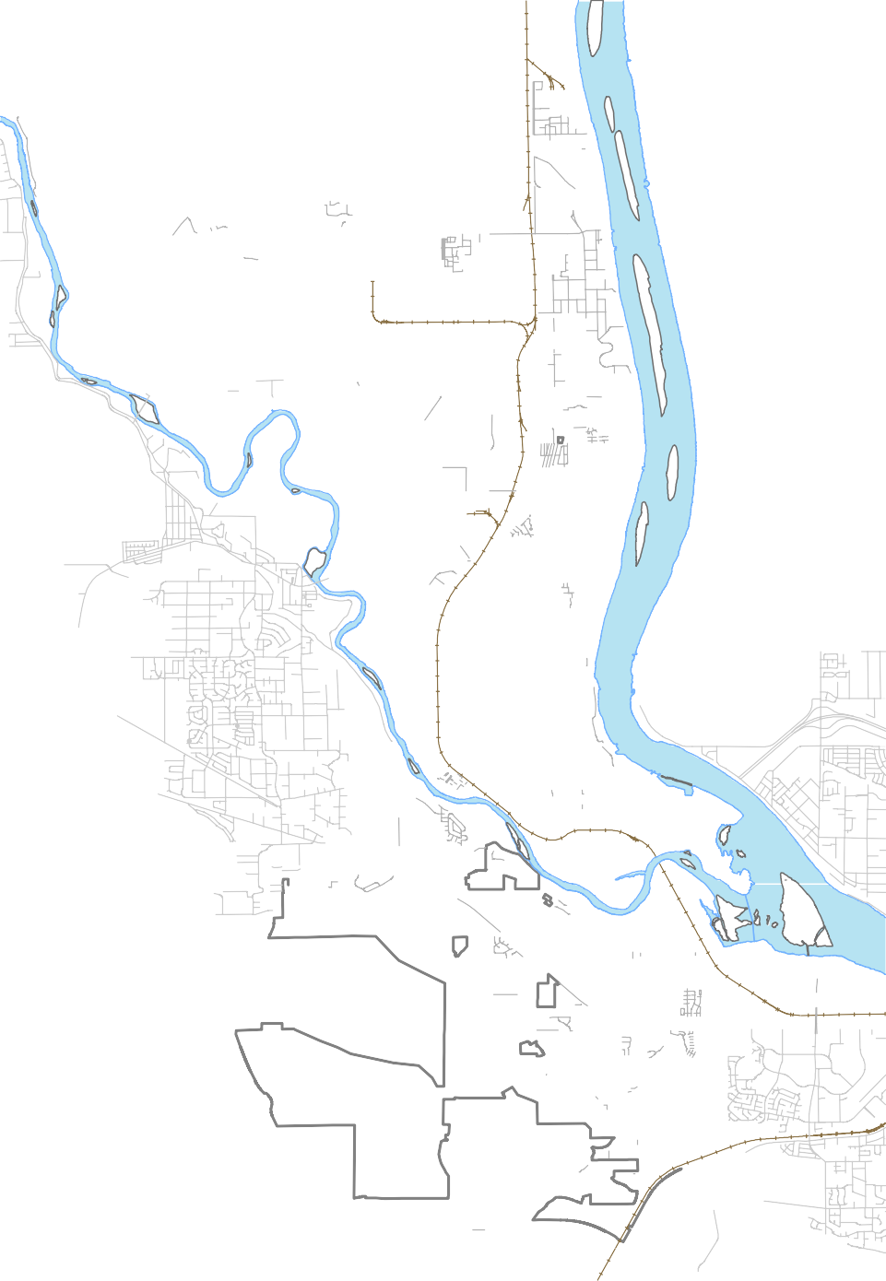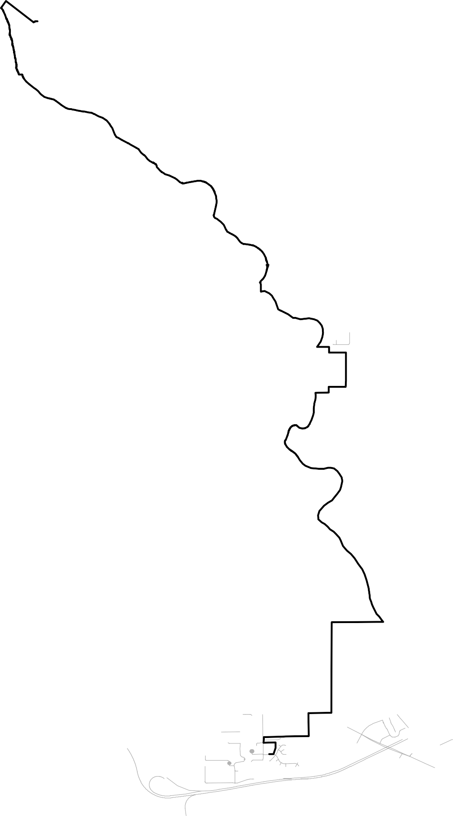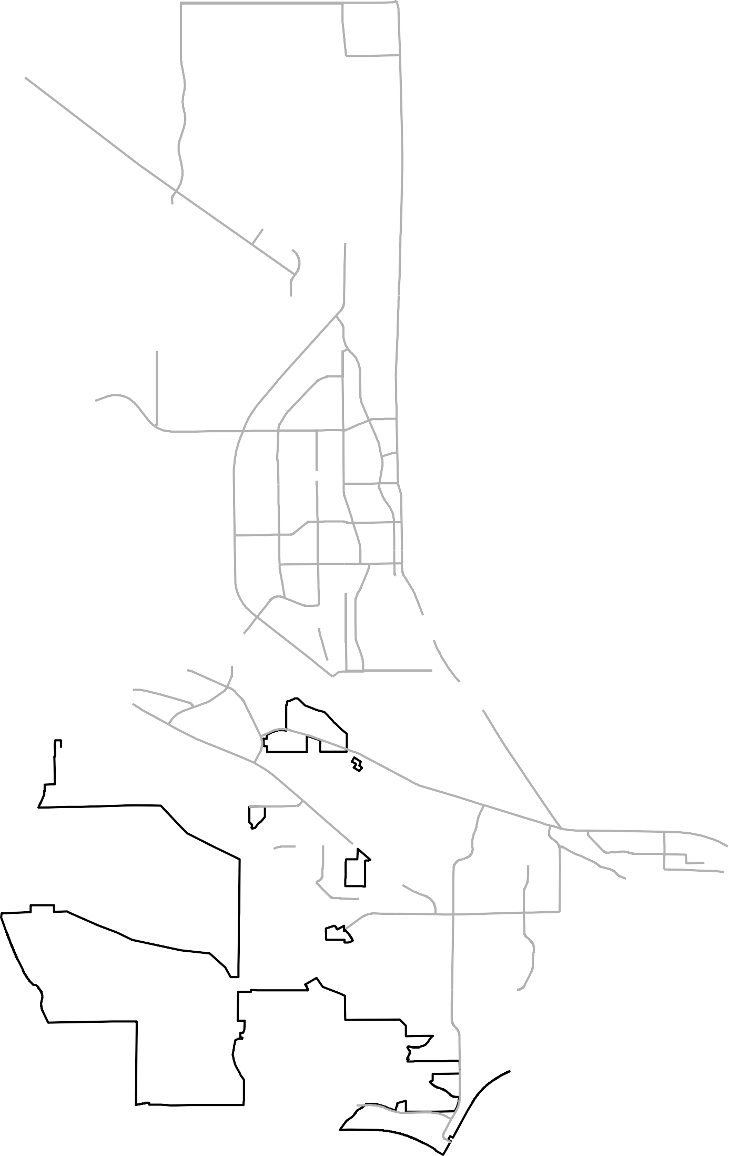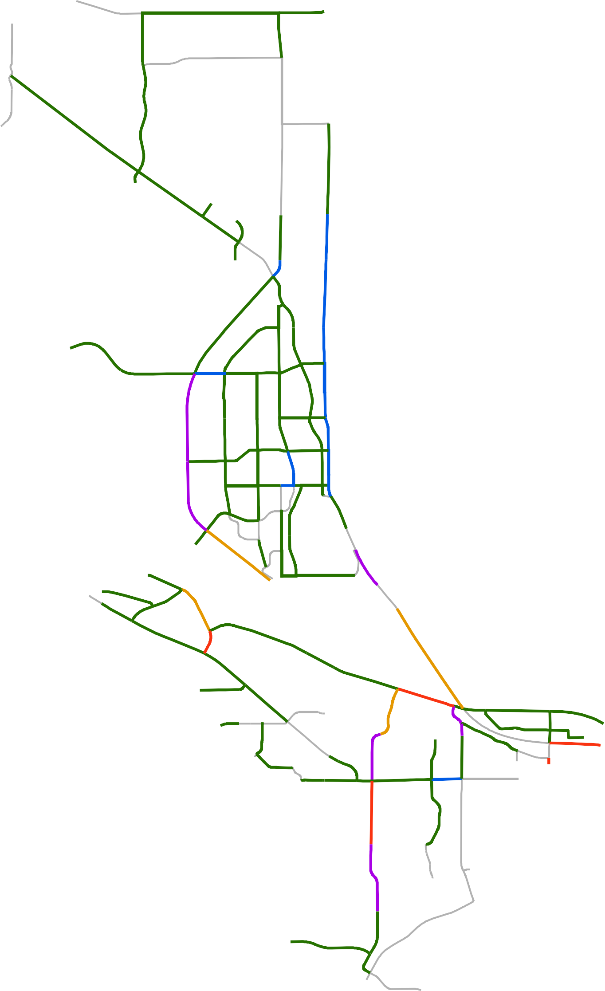Volume to Capacity Ratio

Up to 0.70
0.70 to 0.80
0.80 to 0.90
0.90 to 1.00 More than 1.00 No Count Data

§¦¨82

266 / 800
458 / 800 682 / 800

149 / 800

K e n n e w i c k

February 24, 2017

City of Richland
  - - Intersection Traffic Control Evaluations

UV240
!"$
Horn Rapids Rd
ìèéíë
$!"

$"!
Twin Bridges Rd
"$!
Battelle Blvd

èéìëí èéìëí

èéìëíUniversity Dèíëìér

(!
Kingsgate Way

$"!

(!

éìëèí

èìëíé èìëíé
íìèéë ëìéèí
!"$
íèéìëíéèìë
Stevens Dr

ëíìéè ëèéìí
éìëíè íëìèé
íëìéè

W e s t R i c h l a n d

!"$
Jones Rd

Vaèéìëín Gieseéìëíèn St

!"$

éëíèì

èéìëí ìëíèé
éìëí
íèìëé éèìëí

WilliamsëìèéíBlvd
Wright Ave
è

ëìéíè èíëìé

ìéèíëSwift Blvd
By-pass Hwy
éèìëí!(
Knighèéìëít èéìëíSt
Thayer Dr

íëìéè
$!"
2!!
íëìéèLeeìéèíëBlvdëìèíé"!$
2!! èéëíì
Wellsian Way
Goethals Dr
$!"
íëìéèìëíéè
éèíëìëìéèí
éèíëì

§¦¨182

!"$ !(
!"$ !( !(Aaron Dr

§¦¨182

éèíëì

!"$
íèéìë
(

!(
(!
!(

Shockley Rdèìëéí

UV240
!(

2!!

!$"

$!"

Westcliffe B!"$lvd
!$"
íëìéè

éèíìë
!(
$!"
Steptoe St
èéìëí!"$
$"!èéìëí

!$"
!"$
Dallas Rd
Leslie Rd
íëìéèéíëìè
ëìèíé
ëíéèì

Intersection Control Evaluation
$" Two-way Stop Controlled, acceptable Level of Service (24)

ìéèíë

K e n n e w i c k

!( Two –Way Stop Controlled, needs further evaluation (1)

(! Two-Way Stop Controlled intersection, proposed traffic signal or roundabout (6)

2
$"!

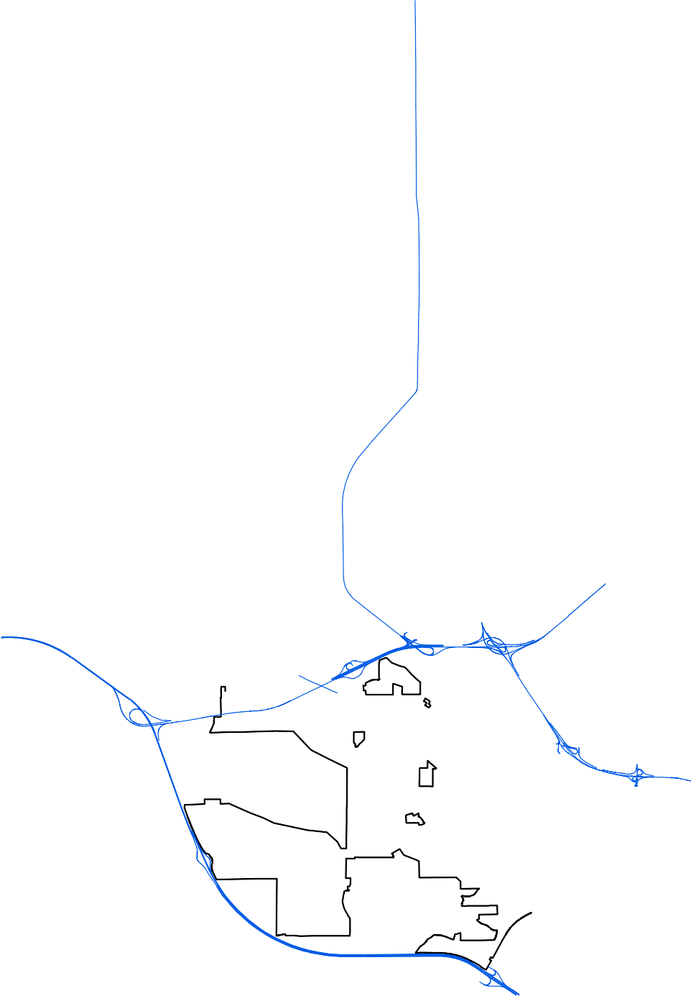!!

ìèëíé
(!

Roundabout, acceptable Level of Service (3)

Signalized intersection, acceptable Level of Service (58) Signalized intersection, improvements identified through study (6)
§¦¨82

February 24, 2017

City of Richland
  - - Future Functionally Classified Street Network

VU240
Horn Rapids Rd

Battelle Blvd
Twin Bridges Rd
Kingsgate Way

University Dr

Spengler St

Mcmurray St
Jones Rd

W e s t R i c h l a n d

Van Giesen St
Stevens Dr

Williams Blvd
Wright Ave

Swift Blvd
By-pass Hwy
Thayer Dr

Lee Blvd

§¨¦182
Wellsian Way
Goethals Dr

Aaron Dr

§¨¦182
Sirron Ave
VU240

Shockley Rd
Steptoe St

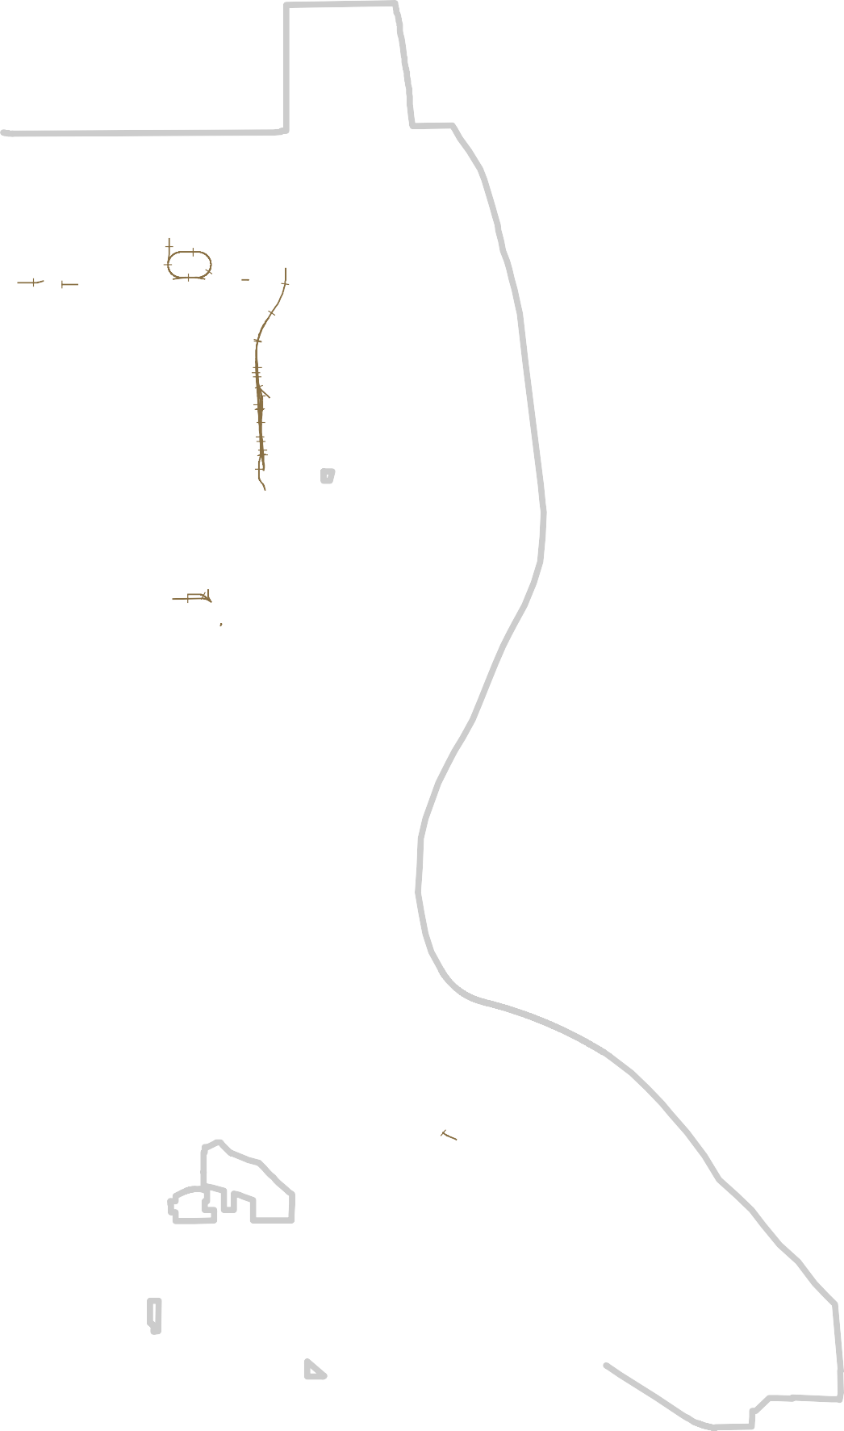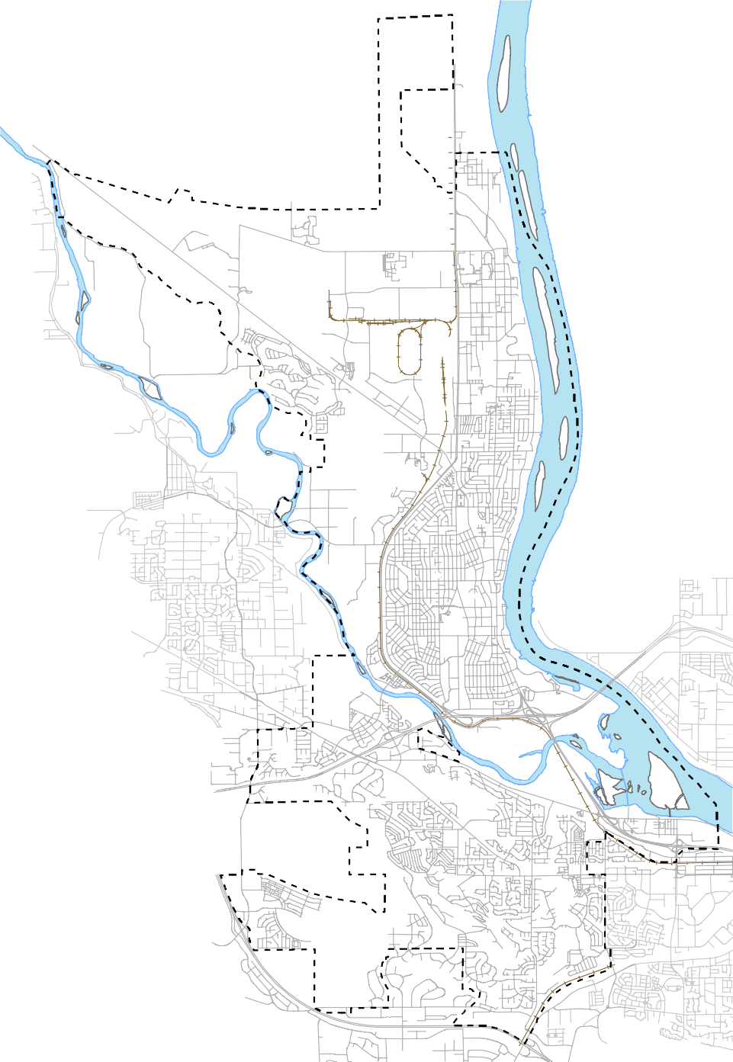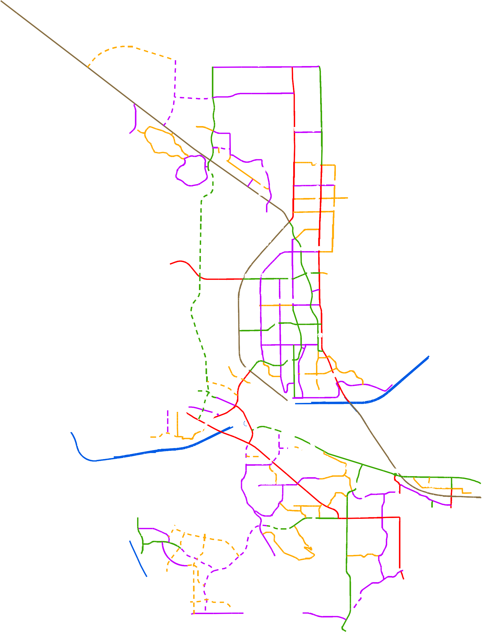
Richland City Limits Urban Growth Area Interstate

Other Freeway - Expressway Principal Arterial
Minor Arterial Major Collector Minor Collector Local Streets
Future Minor Arterial Future Arterial Collector Future Minor Collector
Future Interstate Ramp

Ava Way
Westcliffe Blvd

Gala Wy

§¦¨82

Oahu St

Broadmoor St
Dallas Rd
Leslie Rd

K e n n e w i c k

March 28, 2023

City of Richland
  - -Transportation Improvements

(!
Twin Bridges Rd
UV240
(!

Horn Rapids Rd

Battelle Blvd
Kingsgate Way

!( University Dr

(! Spengler St

W e s t R i c h l a n d

!( Mcmurray St
Jones Rd

Van Giesen St
Stevens Dr

Williams Blvd
Wright Ave

Swift Blvd
By-pass Hwy
Thayer Dr

Lee Blvd

(!
!( (!
Sirron Ave

!(
(! !((

!(
(! Aaron Dr
Wellsian Way
Goethals Dr
§¨¦182

§¦¨182

(!
Dallas Rd
( !

!(
Shockley Rd

Westcliffe Blvd

Gala Wy

Oahu St

VU240

!(
(!
Steptoe St
!(
(!
Leslie Rd

(!

Richland City Limits Urban Growth Area
Intersection Improvements
Ava Way

(!
!((!

(!!( !(

!(

(!

Broadmoor St

K e n n e w i c k

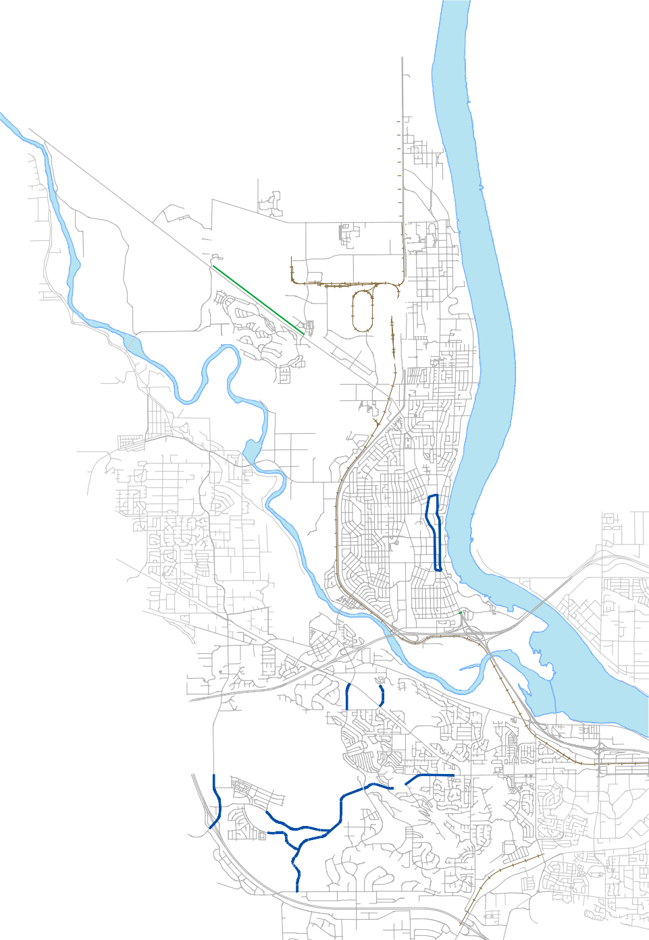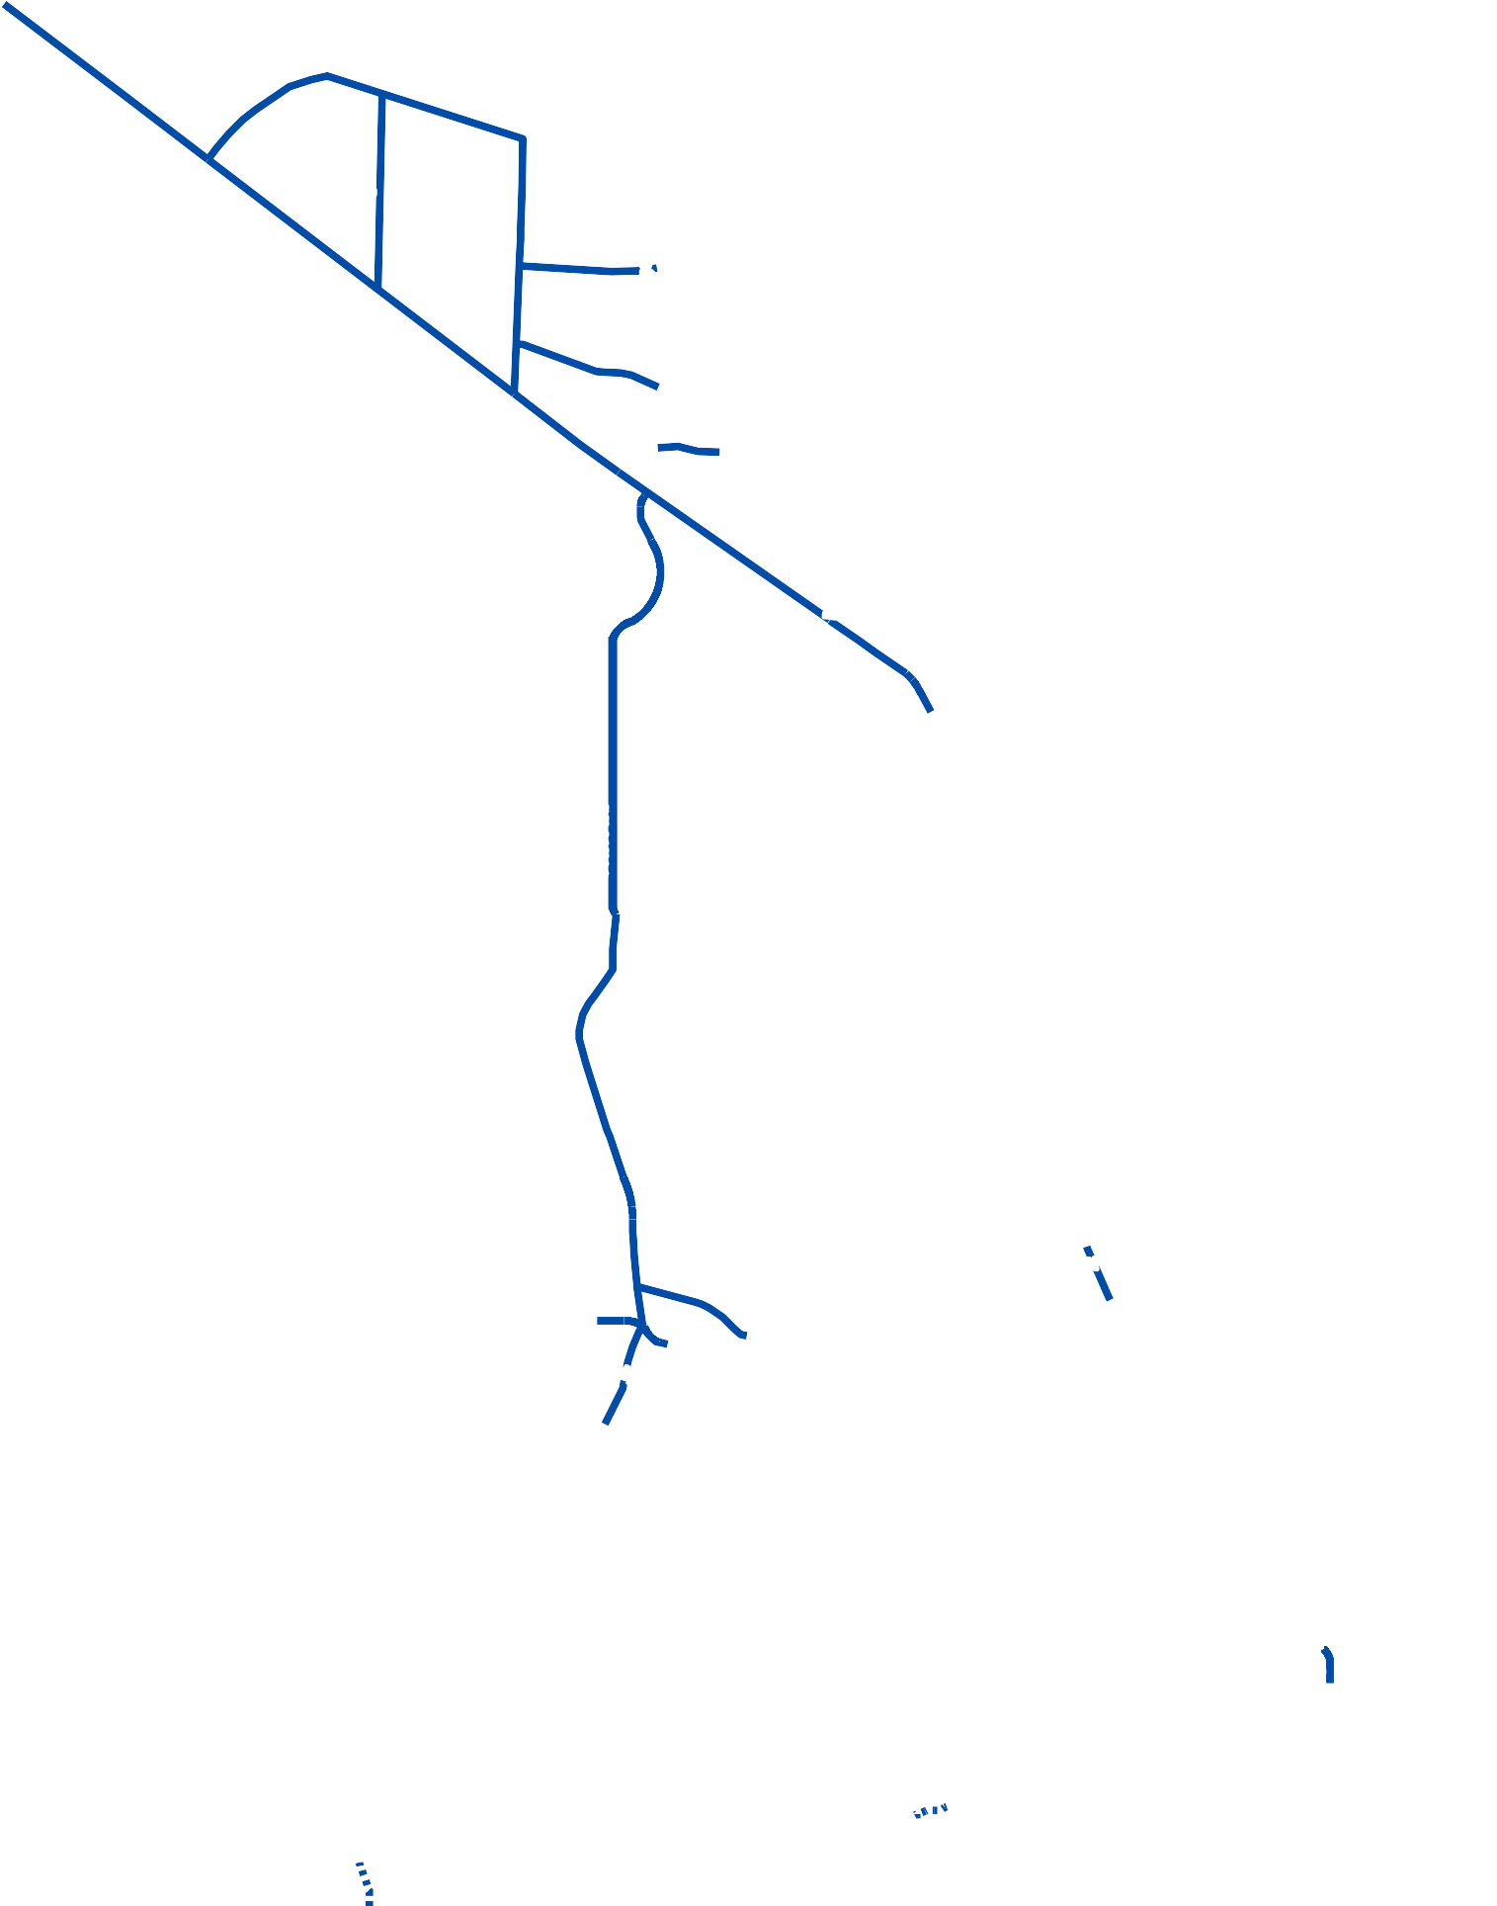
Other Transportation Improvements Multi-Use Trails
(
§¦¨82 (!

March 28, 2023

UTILITIES

SECTION ONE
This section was developed in accordance with RCW 36.70A070 to address utility service within the City of Richland over the next 20 years. It consists of the general location, proposed location, and capacity of all existing utilities in the UGA. General utility corridors are identified in utility and transportation elements as many utilities are placed in conjunction with the transportation corridors. Utilities include wastewater, water, storm water, solid waste, and energy services provided by the City. This section also discusses utilities served by other providers in Richland. These are natural gas supply, tele‐communications, and irrigation.
Figure U-1: Utility Service Areas
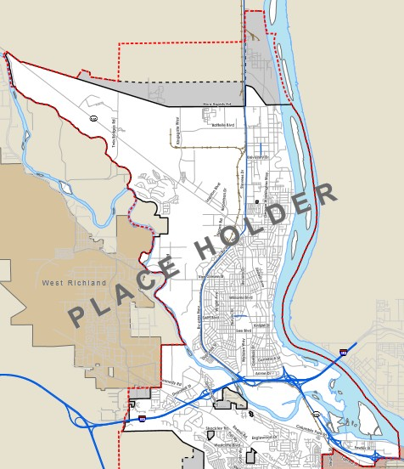

UTILITIES

SECTION ONE

INTRODUCTION
This section was developed in accordance with RCW 36.70A070 to address utility service within the City of Richland over the next 20 years. It consists of the general location, proposed location, and capacity of all existing utilities in the UGA. General utility corridors are identified in utility and transportation elements as many utilities are placed in conjunction with the transportation corridors. Utilities include wastewater, water, storm water, solid waste, and energy services provided by the City. This section also discusses utilities served by other providers in Richland. These are natural gas supply, tele-communications, and irrigation.
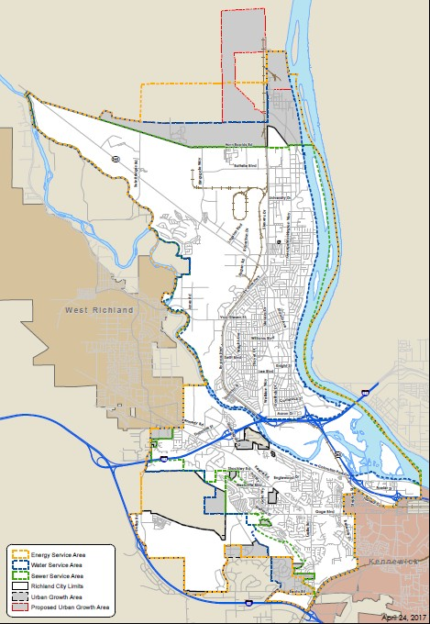Figure U-1: Utility Service Areas

SECTION TWO

WASTEWATER FACILITIES
EXISTING CONDITIONS
The Richland sanitary sewer system was originally developed to serve the area around the CBD and the surrounding residential areas, but has been extended to other areas as they have developed, including north Richland, the Badger Mountain area, and the Horn Rapids community. The City’s wastewater collection system serves the majority of Richland residents, but some outlying areas are still served by onsite septic systems; there are currently approximately 475 people served with onsite septic systems within the Richland City limits.
The sanitary sewer system includes a conveyance system, a wastewater treatment facility, and effluent disposal. Limited monitoring and analysis of the major trunks and interceptors were done in 1990s that showed that the system was in relatively good condition, with low levels of infiltration and inflow. However, the assessment data has become dated, and the City is planning on a more comprehensive assessment of the condition of the collection system in the next few years.
Sanitary Sewer Collection System
The existing Richland sanitary sewer collection system serves approximately 40 square miles of area, divided into seventeen drainage basins. The sewer service area boundary is shown in Figure U-2.
The collection system consists of over 262 miles of gravity collection pipes which range in size from six inches in diameter to 54 inches in diameter. Much of the Richland sewer service area is flat, making it difficult to construct sewers with the minimum slopes necessary for sewage flow. Pump stations receive sewage by gravity and augment the flow by pumping it to the treatment facility.
The City owns and operates 14 pump stations, ranging in size from 1.5 to 35 horsepower. Because of the cost of operation and maintenance, it is desirable to minimize the number of pump stations; many have already been eliminated by the interceptor improvements.
The 2015 General Sewer Plan Update included hydraulic modeling of all of the sanitary sewer pipes ten inches in diameter and larger. Overall, the collection system had adequate hydraulic capacity to convey current flows as well as future flows. Although the hydraulic analysis indicated relatively few capacity issues, the collection system is showing its age and a proactive renewal and replacement program has been developed to address this. A pipe replacement program was developed to prioritize sanitary sewer pipes with the greatest need for replacement each budget year. A significant element of this program includes an intensive survey of the existing pipes in order to determine condition ratings – this is scheduled to occur over the next three years.
The components of Richland’s wastewater flow are sanitary flow, infiltration, and inflow. Sanitary flow includes wastewater discharged to the sewer from residential, commercial, and industrial sources. Infiltration refers to groundwater that enters the collection system through cracks in pipes and loose connections. The rate of infiltration is likely to be higher in older sections of the City because of older pipes and construction methods. New sewers are usually constructed with precast manholes and rubber-gasketed pipe, which effectively limit infiltration. Inflow is surface water that enters the system through downspouts, area drains, ponding over manhole covers, or cross connections with storm drains. Due to Richland’s desert climate, storm-related inflow does not have a significant impact on the system.
Seasonal variations in wastewater flows are slight, with the total daily flow ranging from five to seven million gallons per day (MGD). The lowest flows occur during the winter months, the highest during

the summer. Because Richland has a fairly permanent population and does not experience high tourist or vacation activity, the higher flows appear to be caused by elevated groundwater levels from irrigation, which results in higher infiltration. The wastewater flow characteristics are given in Table U-1.

Table U-1: Wastewater Flow Characteristics
Average Daily Flow | 5.7 MGD
Peak Daily Flow | 7.1 MGD
Residential Population | 53,054 (2015)
Source: City of Richland General Sewer Plan, 2015
Wastewater Treatment Facilities
All flows collected by the Richland sanitary sewer collection system are transported to and treated at the Richland Wastewater Treatment Plant. Since its completion in 1985, the plant has consistently achieved the discharge requirements specified in its National Pollution Discharge Elimination System (NPDES) permit. The plant provides primary sedimentation, followed by secondary treatment using an activated sludge process. Plant effluent is disinfected with chlorine prior to discharge to the Columbia River. The design criteria and the current loadings for flow, organic loading, and suspended solids are summarized in Table U-2.
Table U-2: Richland Wastewater Treatment Plant Design Criteria

 | Design Criteria | 2015
Average daily flow for maximum month | 11.4 MGD | 6.25 MGD
BOD5 loading for maximum month | 17,250 lbs/day | 14,099 lbs/day
TSS loading for maximum month | 21,200 lbs/day | 18,146 lbs/day
NH3-N loading for maximum month | 2,750 lbs/day | 2,063 lbs/day
- BOD = biochemical oxygen demand
- TSS = total suspended solids
Source: City of Richland General Sewer Plan, 2015
The NPDES permit requires the City to submit a plan and a schedule for maintaining capacity whenever the actual flow or load reaches 85% of any one of the design criteria for three consecutive months. This is projected to occur in 2020.
LEVEL OF SERVICE
The service area for the City of Richland sewer system matches the UGA, although not all areas have sewer service. The City’s 2015 General Sewer Plan addresses proposed future system improvements based upon current land uses within the UGA.
Current LOS standards for elements of the wastewater facilities system, contained in the 2015 Plan, are listed in Table U-3. Improvements recommended in the City of Richland Comprehensive Plan Utilities Element are aimed at maintaining these guideline LOS standards.

Table U-3: Wastewater Guideline LOS Standards

Element | LOS Standard
Residential Unit Flowsa | 160 GPDUb
Commercial Unit Flows | 625 GPADc
Industrial Unit Flows | 1,250 GPADc
Manning pipe roughness coefficient | 0.012
Min velocity | 2 feet/second
- Based on 2.42 people per dwelling unit
- GPDU = gallons per dwelling unit
- GPAD = gallons per acre per day
Source: City of Richland General Sewer Plan, 2015

FUTURE DEFICIENCIES
The 2015 General Sewer Plan includes a CIP through the year 2024. For the planning period of 2017- 2022, planned costs amount to approximately $18 million.
The 2015 General Sewer Plan also includes a financial plan that allows the wastewater utility to remain financially viable during the planning period. The analysis considers the historical financial condition of the utility, the financial impact of executing the CIP, the sufficiency of the utility reserves to meet future financial and policy obligation, and rate affordability.
RECOMMENDATIONS
The improvements described in the 2015 General Sewer Plan will address deficiencies resulting from growth for the planning period. The General Sewer Plan includes long term improvement plans from 2015 to 2024. The 2017 Capital Improvement Program identifies the priority projects and associated financing as shown in tables U-4 and U-5 below.
Table U-4: Capital Improvement Project Costs

Facilities | Total Cost | Time-frame
City View Sewer Relocation | $180,000 | 2017
Collection System Renewal & Replacement | $12,244,000 | 2017 - 2022
WWTP Influent Upgrades | $2,183,000 | 2017
WWTP Renewal & Replacement | $3,343,000 | 2017 - 2022
Total | $17,950,000 | 2017 - 2022
Table U-5: Capital Improvement Funding Sources

Funding Source | Total Fund | Time-frame
Bonds - Future Issue | $2,183,000 | 2017
Rate Revenue | $11,567,000 | 2017 - 2022
Wastewater Facility Fees | $4,200,000 | 2017 - 2022
Total | $17,950,000 | 2017 - 2022

Long term projects include collection system upgrades for the Bellerive Lift Station in South Richland and the Upper North Interceptor in North Richland. These projects would cost approximately
$3,000,000 and will be funded by connection fees. In addition, there is about $4,000,000 projected cost for annual renewal/replacement projects for both the collection system and the Wastewater Treatment Plan. These will be funded by rates.

Figure U-2: Sanitary Sewer Mains

SECTION THREE

WATER SUPPLY SYSTEM
EXISTING CONDITIONS
The majority of the population within the corporate limits of the City of Richland is served by the City of Richland Water Utility. The Utility serves approximately 18,689 connections (as of 2016), which includes residential, commercial, and industrial users. The Utility is managed by the City as part of the Public Works Department.
The Richland water system was constructed during the 1940s to support the wartime activities at the Hanford Site. This temporary system has developed into the modern permanent water system used in the City today.
The utility service area is bordered on the southwest by the City of West Richland utility service area, which has a wholesale water service intertie agreement with Richland. This intertie is located along Keene Road. The City of Kennewick’s water and sewer utility area lies to the southeast and has an emergency intertie located at Gage Boulevard connection on Columbia Center Boulevard near Tapteal Drive. The Badger Mountain Irrigation District has a potable water service utility area that lies to the south of the City with an emergency intertie located on Rachel Road.
The City has one private water district within its corporate limits. Tri-City Estates, a residential housing development, maintains its own water supply system. It has an emergency water supply agreement whereby the City of Richland would supply water to that area if its system proves inadequate. Two private water districts exist beyond the City limits. The Badger Mountain Irrigation District (BMID) operates a potable water system that serves the Rancho Reata area beyond the southern boundary of Richland’s service area (an area north of I-82). The BMID uses a wholesale water supply intertie with the City.
The City’s water supply system consists of wells, a water treatment plant, pump stations and chlorinators, interties, water lines, and reservoirs.
Source of Supply
According to the 2016 Comprehensive Water System Plan (WSP), the City has a total available water right of 34,948 acre-feet per year and 43,786 gpm for instantaneous flow. This total available water right covers to a Maximum Day Demand (MDD) of 63.0 MGD. The 2015 population-based MDD is 38.4 MGD. The WSP projects that MDD will be 55 MGD in 2035. Therefore, the City appears to have adequate water rights for future growth.
The City’s potable water sources include a wellfield and the Columbia River Water Treatment Plant (WTP). The wellfield has a total capacity of 15 MGD while the WTP has a capacity of 36 MGD. The City maintains the quality and quantity of groundwater used for public water supplies through Best Management Practices in the wellfield and the Water Treatment Plant. Water supplied to the City of Richland is of high quality, meeting federal and state drinking water standards.
The locations of the sources of supply as well as the distribution system are shown in Figure U-3.
Distribution System
The City has approximately 340 miles of pipeline in the water distribution system ranging in size from two inches in diameter to 36 inches in diameter. There are ten storage facility sites that provide

approximately 22 million gallons of storage and ten booster pumping stations that provide direct water storage to seven pressure zones within the City.
The water system characteristics are summarized in Table U-6.
Table U-6: Water System Characteristics

Average Annual Supply | 6.2 billion gallons
Residential Population | 54,466 (2016)
Source: City of Richland Water System Plan, 2016

LEVEL OF SERVICE
The service area for the City of Richland water system matches the UGA. The City’s 2016 Water System Plan addresses proposed future system improvements based upon current land uses within the UGA.
Current LOS standards for elements of the water system facilities, contained in the 2016 Plan, are listed in Table U-7. Improvements recommended in the City of Richland Comprehensive Plan Utilities Element are aimed at maintaining these guideline LOS standards.
Table U-7: Water Guideline LOS Standards

Element | LOS Standard
Demand per ERUa | 1,032 gallons per day
Demand per ERUb | 181 gallons per day
MDDc/ADDd Factor | 2.33
PHDd/MDD Factor | 1.32
Service Pressure | 40 – 80 psi
- ERU = equivalent residential unit, assuming domestic water is used for irrigation
- ERU = assuming a non-domestic irrigation source
c.MDD = maximum daily demand
- ADD = average daily demand
- PHD = peak hour demand
Source: City of Richland Water System Plan, 2016

FUTURE DEFICIENCIES
The 2016 Water System Plan includes a CIP through the year 2036. For the planning period of 2017- 2022, planned costs amount to approximately $23 million.
The 2016 Water System Plan also includes a financial plan that allows the water utility to remain financially viable during the planning period. The analysis considers the historical financial condition of the utility, the financial impact of executing the CIP, the sufficiency of the utility reserves to meet future financial and policy obligation, and rate affordability.

RECOMMENDATIONS
The improvements described in the 2016 Water System Plan will address deficiencies resulting from growth for the planning period. The 2017 Capital Improvement Program identifies the priority projects and associated financing as follows.

Table U-8: Water System Capital Improvement Project Costs

Facilities | Total Cost | Time-frame
Automatic Meter Reading System | $3,235,000 | 2017-2018
Broadmoor Street Conversion from Tap I to Tap II | $107,000 | 2021
Chief Joseph Middle School Irrigation Well | $150,000 | 2018
Columbia River Intake Screen Upgrade | $4,630,000 | 2018 - 2020
Core Y Additional Plant Replacement Value (PRV) | $406,000 | 2021
Distribution System Repairs & Replacement | $1,950,000 | 2017 - 2022
Duportail Street Transmission Main | $750,000 | 2017
Duportail Street Well | $500,000 | 2017
High Meadows St. and Leslie Road PRV | $102,000 | 2021
Irrigation Utility Capital Improvements | $730,000 | 2017 - 2022
Orchard Way Conversion from Tap I to Tap II | $35,000 | 2021
Tapteal I Pump Station Upgrade | $500,000 | 2020-2021
Tapteal II Loop | $114,000 | 2020
Tapteal VI Water Main | $487,000 | 2021
Water Treatment Plant Renewals & Replacement | $1,716,000 | 2017 - 2022
WTP Solids Handling Improvements | $400,000 | 2021
Yakima River Crossing Pipeline Replacement | $7,499,000 | 2017 - 2019
Total | $23,311,000 | 2017 - 2022
Table U-9: Water System Capital Improvement Funding Sources

Funding Source | Total Fund | Time-frame
Facility Fees | $3,223,500 | 2017 - 2021
Federal Emergency Management Agency Grant | $1,893,301 | 2017 - 2018
Irrigation Utility Rate Revenue | $755,000 | 2017 - 2022
Private Development | $601,000 | 2017 - 2022
Rate Revenue | $6,202,500 | 2017 - 2022
Revenue Bond Issue | $9,935,699 | 2017 - 2020
Richland School District | $50,000 | 2017
Surplus Property Sale | $400,000 | 2021
West Richland | $250,000 | 2020 - 2021
Total | $23,311,000 | 2017 - 2022

Figure U-3: Water Mains

SECTION FOUR

STORM WATER SYSTEM
EXISTING CONDITIONS
The storm water service area in Richland is divided into nine drainage areas covering over 30,000 acres. These are: North Richland (NR), Columbia River (CR), Richland Core Area (RC), Yakima River North (YRN), Yakima River South (YRS), CID Main Canal (CM), Amon Wasteway (AW), Badger East Canal (BEC), and Badger Mountain South (BMS).
The City’s storm water system facilities consist of the following:
  - Collection and conveyance
  - Pumps
  - Underground injection control (UIC) facilities
  - Regional detention/ water quality facilities
  - Regional outfalls
The collection and conveyance system includes catch basins, manholes and pipes. Tables U-10 and U-11 indicates existing collection and conveyance facilities.
Table U-10: Storm Water Collection Structures

Owner | Catch Basins and Manhole Catch Basins | Catch Basins and Manhole Catch Basins with  OWS1 | Manhole | Manholes with OWS
City | 3,995 | 166 | 1,928 | 12
Port of Benton | 160 | 0 | 0 | 0
1 Oil Water Separator

Table U-11: Storm Water Conveyance Facilities (length in Units of Miles)

Gravity Pipe | Force Main | Perforated Pipe and Underdrain | Culvert | Open Chanel
127.3 | 0.7 | 2.6 | 3.2 | 11.5
The storm water system includes public and privately owned seven pump stations throughout the City as indicated in Table U-12 below.

Table U-12: Storm Water System Pumps

Name | Owner | Capacity (GPM)
Carriage Pump Station | City | 1,045
McMurray Pump Station | City | 5,790
Berkshire | City | Unknown
Corps of Engineers Pump Station | USACE | Unknown
Horn Rapids Triangle Pump Station | City | Unknown
Lawless Pump Station | Private | Unknown
Wellsian Pump Station | Private | Unknown
Some storm water runoff generated within the City is infiltrated via the City’s underground injection control facilities. There are over 280 UIC facilities in the City. The City’s regional detention/ water quality facilities include 22 ponds, 2 bioretention cells, 6 underground storm chambers, and 21 swales. Stormwater runoff that does not infiltrate within the service area is conveyed to surface receiving waters via regional outfalls that discharge to the Columbia River, the Yakima River, and the Amon Wasteway. There are 11 outfalls discharging to the Columbia River, two discharging to the Yakima River, and eight discharging to the Amon Wasteway.
The City’s 2016 Stormwater Management Plan provides detailed information on the system facilities. The Management Plan also provides guidance for the City’s maintaining the requirements of the Phase II Eastern Washington Municipal Stormwater Permit (Phase II Permit), received from the Department of Ecology. This Permit regulates operation of the City’s Municipal Separated Storm Sewer System (MS4).
FUTURE DEFICIENCIES AND RECOMMENDATIONS
The City strives to maintain the level of service of the storm water system by addressing existing and potential issues. Improvements are identified with the intent of reducing:
  - Existing conveyance capacity and flooding issues;
  - Potential future conveyance capacity and flooding issues;
  - Pollutant loading to receiving water bodies; and
  - Chronic system maintenance needs.
Identification of capital projects are based on the criteria such as projects previously identified in the management plan but not yet constructed, chronic maintenance issues identified by staff, etc.
The 2016 Stormwater Management Plan categorizes capital projects into one of four types based on the primary objective of the project:
  - Flood risk (FR) – Projects that primarily address hydraulic deficiencies to help reduce flooding or surcharging of the system.
  - Renewal and replacement (RR) – Projects that primarily repair or replace existing system components to help restore the original design function.
  - Water quality retrofit (WQ) – Projects that primarily address water quality through treatment of stormwater runoff prior to discharging to receiving waters.

  - Development Driven (DD) – Projects that may be built based on future development. These projects are assumed to be partially paid for by developers. See Section 8 for detailed documentation on funding assumptions.
The 2017 CIP identifies the priority projects and associated financing in Tables U-13 and U-14.
Table U-13: Storm Water Management Facilities Financing 2017-2030

Facilities | Total Cost | Time-frame
Leslie Road Storm Drain Replacement | $839,000 | 2018
Storm Water Rehabilitation & Replacement | $2,616,090 | 2015-2022
Water Quality Retrofit Program | $2,618,717 | 2015-2022
Total | $6,073,807 | 2017-2022

Table U-14: Storm Water Capital Improvement Funding Sources 2017-2030

Funding Source | Total Fund | Time-frame
Grant – WA State Department of Ecology | $759,717 | 2015-2016
Grant Funds (Unsecured) | $1,285,500 | 2017-2022
Rate Revenue | $4,028,590 | 2015-2022
Total | $6,073,807 | 2017-2022

Figure U4: Storm Water

SECTION FIVE

SOLID WASTE MANAGEMENT
GENERAL LOCATIONS AND CAPACITY
State RCW 70.95.030 defines solid waste or waste as “all putrescible and non-putrescible solid and semisolid wastes including, but not limited to, garbage, rubbish, ashes, industrial wastes, swill, sewage sludge, demolition and construction wastes, abandoned vehicles or parts thereof, and recyclable materials.” Each municipality may fulfill its solid waste management responsibilities in one of three ways:
- Prepare its own solid waste management plan for integration into the county comprehensive solid waste plan;
- Participate with the county in preparing a joint city-county plan for solid waste management; or
- Authorize the county to prepare a plan for the City’s solid waste management for inclusion in the county comprehensive plan.
The City of Richland has chosen the first option. RCW 70.95.080(3)(a) defines that option as: “Prepare and deliver to the county auditor of the county in which it is located its plan for its own solid waste management for integration into the comprehensive county plan”.
In 2009, the City chose to develop their own solid waste management plan as a tool to guide the continued development of their collection system and landfill. The City’s Plan was updated in August 2011. This updated Plan was prepared in accordance with the Department of Ecology’s “Guidelines for Development of Local Comprehensive Solid Waste Management Plans and Plan Revision”, January 2010. The City’s Plan was submitted for inclusion in Benton County’s 2013 update of its Solid Waste and Moderate Risk Waste Plan. The County’s 2013 Plan was subsequently approved by the Washington State Department of Ecology. The Department of Ecology’s action formalized the completion of the City’s planning responsibilities under RCW 70.95.030.
The City’s Solid Waste Management includes these goal statements as guiding principles for its solid waste services:
  - Goal 1: Manage solid waste in compliance with State and local regulations to promote and protect human and environmental health and safety.
  - Goal 2: Optimize the solid waste management system to provide for long-term stability in a cost-effective manner.
  - Goal 3: Provide solid waste programs with emphasis on customer service and satisfaction.
  - Goal 4: Identify the types of recyclables and establish programs to efficiently and effectively recycle and market these materials.
  - Goal 5: Promote programs and balance incentives and disincentives to encourage reduction, reuse, and recycling.
  - Goal 6: Educate businesses and the public on opportunities available for waste reduction, reuse, and recycling.
  - Goal 7: Encourage and support the research and development of new technologies for solid waste management and recycling.

Solid Waste Collection and Disposal
The City of Richland Solid Waste Division provides municipal solid waste collection and disposal services to residences and businesses within the City limits. Solid Waste Collection services for lands outside the City limits is provided by private waste haulers licensed through the Washington State Utilities and Transportation Commission. This City’s landfill accepts waste from the surrounding areas on an individual load basis. The City has no disposal contracts with private haulers or other government agencies.
Solid waste collection services for the City of Richland are provided by the City’s Public Works Department, except in newly annexed areas. The Department administers user-fee-funded refuse collection services, and bills its customers through the City Administrative Services Department. Solid waste collection in Richland is available five days a week. Industrial and commercial pickup is provided by the City of Richland. Commercial waste pickup can range from one to five times a week.
Collection services within newly annexed areas are provided by private solid waste hauling companies operating under contracts with the City. The contracts, which are required by State law, provide for a ten-year transition period during which the private solid waste haulers continue services in keeping with their State-authorized permits. The haulers do not align their services with the City’s Solid Waste Management Plan. At the expiration of the contracts the City may choose to extend the contracts or assume service to the area customers. When the City elects to assume these service areas, it will provide services consistent with the Solid Waste Management Plan and its adopted rate structure.
About 26 percent of solid waste is recycled in Richland based on the 2015 data of generation, recycling, and disposal as shown in the table below:
Table U-15: Solid Waste Generation

 | Tons | %
Generation | 77,697 | 100
Recycling | 22,216 | 26
Disposal | 55,481 | 74
Petroleum-contaminated soils are accepted occasionally at the Richland landfill. They are treated in a separate area on the landfill property and ultimately disposed of in the landfill. Dewatered bio- solids from the City’s wastewater treatment plant are combined with yard waste in a composting process conducted at the Richland landfill. The finished compost material is tested to confirm compliance with U.S. Composting Council quality criteria and marketed to area contractors, nurseries, and local agencies.
Richland residents can dispose of self-hauled waste at the resident rate. Oil, antifreeze, and automotive batteries are accepted for recycling at the landfill. Benton County operates a household hazardous waste program that accepts many other categories of wastes that are not accepted at the Richland landfill.
Solid waste collected by service type is shown in table below.

Table U-16: Solid Waste Collection

Service Type | % of Total Tonnage Collected
Residential | 40%
Commercial | 40%
Dropbox | 20%

Richland Landfill
The City of Richland owns and operates the Richland Landfill (also known as the Horn Rapids Landfill), located on 275 acres of designated landfill space approximately 3.5 miles northwest of the City center on Highway 240 (see Figure CF-3, Facilities Map). Approximately 46 acres are permitted for solid waste disposal. The Benton Franklin Health District has issued a permit in 2017, for use of an additional 90 acres for landfill disposal. Also on the landfill property are a 14-acre composting facility, a residential and small commercial customer transfer station, scalehouse and administration building, and an operations and equipment maintenance building.
The current capacity of the permitted disposal area will be exhausted by the year 2020.
The Richland Landfill currently meets minimum functional standards (Chapter 173-351 WAC) and operates under a solid waste disposal permit issued and renewed annually by the Benton Franklin Health District. The site is designed and operated as an arid-climate landfill, and therefore, has no bottom liner or leachate collection system. Vadose zone moisture monitoring has been implemented within a portion of the current 46 acre fill area for data collection. In the late 1990’s groundwater contamination with volatile organic compounds was detected in several of the landfill’s monitoring wells. The City installed the methane gas extraction / flare stations. The City initially implemented an independent remedial action program in compliance with Washington State Law (RCW 70.105D.040). In 2017 the City entered into an Agreed Order with the Washington State Department of Ecology to advance the characterization and remediation of the contamination.
Recycling
The City of Richland offers curbside recycling to its residential and commercial customers. In addition, the City currently operates seven drop-box recycling collection centers throughout the City and delivers the collected recyclable items to Clayton-Ward Recycling in Richland, which prepares the recyclable material and transports it to material processing facilities in the Portland or Seattle areas.
The recycling centers currently accept scrap paper, plastic beverage containers, tin and aluminum cans, newspaper, telephone directories, magazines, catalogs and calendars, glass jars and bottles, cardboard, and brown paper bags. In 2015, the City collected 1,524 tons in the drop box collection centers and 1,099 tons through curbside collection.
Composting
The Horn Rapids Compost Facility is a treatment facility for bio-solids coming from the City’s Wastewater Treatment Plant, the residential green waste program and green waste self-haul. The compost facility opened in 2010, and accepts residential green yard waste with no charge to the resident. It saves landfill space and provides finished compost material to the public through a number of wholesale customers.

Household Hazardous Waste
The Benton County Moderate-Risk Waste Facility is located at a facility on Ely Street in Kennewick and which can collect Household Hazardous Waste and Small Quantity Generator Waste from residents of Benton County. The facility is jointly funded by the Washington Department of Ecology, Benton County, and the Cities of Kennewick, Richland, West Richland, Prosser, and Benton City.
Moderate-risk waste includes material such as waste oil, paints, flammable materials, and anti-freeze. The facility also collects hazardous waste from commercial businesses classified as small quantity generators (SQG). SQGs are conditionally exempt from federal and state regulation when they generate or accumulate hazardous waste in quantities below a 220 pound per month threshold.
LEVEL OF SERVICE
According to Richland’s Solid Waste Management Plan, the following solid waste management facility areas will likely require no major capital improvements during the 20-year planning period:
  - Domestic and Commercial Waste Collection Services - No current deficiencies are identified in the service provided by the City’s Solid Waste Utility.
  - The City’s existing curbside and drop boxes recycling program is sufficient to meet customer demands. A minority of residents indicate through surveys that they favor universal curbside recycling. To date the costs of this service expansion and the compulsory nature of it have not been adopted by the City Council.
FUTURE DEFICIENCIES
Estimates of solid waste generation are based on population projections. Based on Richland’s 2011 Solid Waste Management Plan (Appendix H), annual waste generation is forecast to increase to 80,000 tons in 2031. This forecast utilizes the per capita rate of 6 pounds per person per day and population projections.
The current capacity in the Landfill will be exhausted sometime in 2020. The City is planning for its future solid waste disposal capacity by exploring two options:
- Expand landfill capacity on the current site by building a landfill that meets current state and federal design regulations; as part of preparing for the possible expansion of the landfill, the City has submitted and received a permit from the DOH for expansion of approximately 90 acres. or
- Building a transfer station and hauling waste to a large regional landfill.
A consultant is assisting City staff in preparing information to support this decision. It is expected that a decision will be made in calendar year 2017, after which preparations will be made to construct the necessary facilities. Regardless of the disposal alternative selected, the City anticipates maintaining its current customer service levels at the Richland landfill.
RECOMMENDATIONS
It is recommended that the City:
  - Selects a preferred solid waste disposal approach that is cost effective, maintains service levels, and mitigates risk to the City; and
  - Provides and maintains collection services to all City residents consistent with adopted service levels and Solid Waste Management Plan goals and objectives.

Table U-17: Solid Waste Management Facilities Financing 2014-2030

Facilities | Total Cost | Funding Sources | Time Frame
Disposal Capacity Improvements | 8,003,512 | Bonds – future issue | 2017-2019
Landfill Closure, Phase 2 | 3,780,000 | Solid waste fund | 2017-2020
Container Maintenance Facility/ Facility Improvements | $185,000 | Rate Revenue | 2017-2018

Figure U-5: Solid Waste

SECTION SIX

ENERGY/ELECTRICAL POWER
EXISTING CONDITIONS
Richland’s electrical service is provided primarily by Richland Energy Services (RES) Department. RES provides electric service to over 25,000 residential, commercial, industrial, and irrigation customers throughout the City’s 50-square mile service territory, using 552 miles of primary line and eight substations. Ownership and operation of these facilities is shared by the City and the Bonneville Power Administration (BPA). Bulk transmission of electrical power supply to customers in the UGA has historically been provided from the BPA transmission grid, with the local utilities providing final pass-through services. BPA is contractually obligated to supply all of the City’s power requirements through 2028.
Electric system planners design and build facilities to follow population and employment projections for the City and county. The electric load is determined from these plans and projections. An electric system plan is then developed to serve those loads at the reliability level prescribed by the individual utility, taking into account environmental, economic, financial, and operational factors. Utility construction is coordinated with the appropriate jurisdictions and agencies, and is typically phased in as actual growth occurs. Transmission lines and substations are installed based upon projections and early growth while electrical distribution lines are installed at customer request with the continued growth.
Future electrical service plans are designed not only to provide for future growth and accommodate new and increased loads, but also include changes to the existing systems to improve reliability, maintain power quality, and maintain redundancy backup service in the system.
The City has service area agreements with Benton County PUD (BPUD) and Benton Rural Electric Association (BREA). Approximately 102 customers within the City service area are being served by BPUD while no customers within the City service area are served by BREA. The City transfers remaining customers served by BPUD within the City service area based upon the terms within the service area agreement. All 102 are expected to be transferred by 2021.
Table U-18: City of Richland Electric Substations

Substation | Total Capacity | Used Capacity (2014) | Remaining Capacity (2014)
Sandhill Crane | 45,000 KVA | 31,000 KVA | 14,000 KVA
First Street | 45,000 KVA | 32,000 KVA | 13,000 KVA
Snyder | 23,000 KVA | 20,000 KVA | 3,000 KVA
Stevens | 46,000 KVA | 41,000 KVA | 5,000 KVA
Thayer | 53,000 KVA | 29,000 KVA | 24,000 KVA
Richland Switch | 23,000 KVA | 10,000 KVA | 13,000 KVA
Tapteal | 45,000 KVA | 37,000 KVA | 8,000 KVA
City View | 23,000 KVA | 19,000 KVA | 4,000 KVA
Total System | 303,000  KVA | 219,000 KVA | 84,000 KVA
Source: City of Richland 2014 Long Range Plan – Richland Energy Services

Energy Efficiency Program
RES offers energy efficiency programs to its commercial and residential customers. Commercial and industrial customers are offered incentives for lighting and custom projects that reduce energy use. Custom projects include heating, ventilation, and air conditioning (HVAC), motor efficiency upgrades, etc. For residential customers, Richland offers rebates and low-interest loans to qualified customers for energy efficient HVAC equipment and weatherization measures including insulation, windows, and doors. Customers can select a rebate only or apply for a low-interest loan with a rebate. Richland also offers energy efficiency program specifically designed for low-income families for insulation, duct sealing, ductless heat pumps, windows, and doors for their home.
Renewable Option Program
Through the City’s partnership with the Renewable Option Program offered by the Bonneville Environmental Foundation (BEF), Richland residents can affordably purchase the environmental benefits of wind power generated throughout the Pacific Northwest. BEF’s Green-e Energy Certified Renewable Option Renewable Energy Credits (RECs) represent renewable energy sources from Pacific Northwest projects where clean zero-emission wind energy has been delivered to the North American power grid to replace fossil fuel based electricity.
Each block of Renewable Option RECs represents the environmental attributes of 100 kilowatt-hours of electricity generated from wind energy facilities throughout the Pacific Northwest.
Solar Power and Net Metering
The City offers low-interest loans to promote the use of solar power. The loan period is up to 10 years for up to $5,000 per installed kilowatt (kW), not to exceed $15,000. The customer must agree to maintain the system and allow the City to claim the environmental benefits.
LEVEL OF SERVICE (UTILITY SERVICE AREA)
The level of service set by the RES and BPA for their respective portions of the system is based on performance. The goal is an N-1 contingency, which means that one failure in system equipment will not cause the failure of other system components, and the failure can be picked up by other components within eight hours.
The City of Richland currently provides electrical service throughout most of the UGA. Under its Utility Service Area Policy, it is the City’s goal to provide service throughout the City limits, UGA, and service area agreements with adjoining BPUD and BREA utilities. The greater of the City limits, UGA, and service area agreements constitutes its current utility service area and planned future service areas.
FUTURE DEFICIENCIES AND RECOMMENDATIONS
The City has identified power supply system capital improvement projects that will be needed to meet the demands of growth as detailed in the Energy Service Department’s Capital Facilities Plan for 2016-2027. The list consists of electrical projects with an estimated cost of approximately $60 million during this period. The $60 million capital cost is derived from the latest long-range capital expenditure forecast and extrapolating the average annual expenditure through calendar year 2027.
Specific projects have been identified for the second planning period. Critical service deficiencies in this period could result unless needed capital improvements are identified and implemented.

The Energy Services Department has identified electric utility capital improvement projects that will be needed to meet the demands of growth through calendar year 2022. Cost of service and sources of funding are identified in Table U-19.
Table U-19: Electrical Power Facilities Improvement and Fund Resources

Facilities | Total Cost | Time-frame
Miscellaneous Electrical Projects | $81,754,000 | 2017-2022
Funding Source | Total Fund
Benton PUD Contributions | $1,250,000 | 2016-2020
Bonds - Future Issue | $21,955,000 | 2018-2022
Bonds - Prior Issue | $21,254,000 | 2016-2018
Facility Fees | $6,200,000 | 2016-2022
RAISE (LRF) | $980,000 | 2017-2022
Rate Revenue | $30,115,000 | 2016-2018
Total | $81,754,000
Long-range capital projects for the power supply system are identified and will be based on the need for improvements to serve growth in the second planning period and on the ability of the City to finance them. Implementation of improvements will be planned as part of an overall finance plan for all City-owned utilities and capital facilities. Projects and related costs identified through 2022 by the Energy Services Department include:
  - Dallas Road Area Improvement - Plan, design, and construct a new electrical system substation and connect via new and existing transmission power lines into the electric system grid. Total Estimated Cost: $9,222,000.
  - Kingsgate Substation - New substation for the Horn Rapids Industrial Park. One 28,000 KVA capacity transformer and major materials purchased by City. Substation to be constructed and commissioned by the end of 2021. Total Estimated Cost: $4,236,000.
  - Leslie Rd Substation - Plan, design, and construct a new electrical system substation and connect into the electrical system grid operated by the BPA. Additionally, plan, design, and construct primary underground distribution feeders from new substation to the City's new and existing electrical system. Total Estimated Cost: $10,081,000.
  - Smart Grid – Advanced Metering Infrastructure - Complete a detailed design and implement an electrical utility smart grid program to cost-effectively improve utility operations and provide the utility customers with options to control their power consumption and usage patterns. Total Estimated Cost: $10,600,000.
  - Purchase Southwest Service Area Infrastructure - Per 2005 Electrical Service Area Agreement, purchase the depreciated value of BPUD infrastructure currently serving Hidden Hills Phase 1, Badger Mountain Irrigation District pumping station, and Reata Ridge in 2015 and other PUD facilities in 2020 serving any new City-annexed properties in the southwest service area. Total Estimated Cost: $812,000.
The capital improvements identified by the City will address deficiencies resulting from growth during the second planning period. Mitigating system improvements will have to be identified by the City for the second planning period.

Figure U-6: Major Electrical Transmission Lines

UTILITIES BY OTHER PROVIDERS

SECTION ONE

NATURAL GAS SUPPLY
EXISTING CONDITIONS
Cascade Natural Gas Corporation builds, operates, and maintains natural gas distribution facilities serving the City of Richland. Cascade is an investor-owned utility serving customers in 68 communities in Washington and Oregon. Interstate pipelines transmit Cascade's natural gas from production areas in the Rocky Mountains and western Canada. The Cascade headquarters is located in Kennewick, WA (Cascade Natural Gas, 2017).
Cascade's service areas are concentrated in western, central, and southeast Washington; and central and eastern Oregon. Richland’s natural gas supply system currently meets existing demand.
LEVEL OF SERVICE
Natural gas service and availability are currently sufficient to meet existing demand. Cascade Natural Gas works with its suppliers to ensure that local gas supply needs are met.
Future levels of availability and service will be maintainable through market demand. Cascade Natural Gas and its affiliates will need to coordinate with the City to ensure that future service extensions are consistent with local growth plans.
FUTURE DEFICIENCIES AND RECOMMENDATIONS
Natural gas will be made available concurrently with growth to the best of the purveyor’s ability. No deficiencies in the natural gas supply have been identified. The City will promote locating utility distribution lines together and using existing utility easements wherever possible.

SECTION TWO

TELECOMMUNICATIONS
EXISTING CONDITIONS
Telecommunications is the transmission of information by wire, radio, optical cable, electromagnetic, or other similar means. In Richland, telecommunication utilities include telephone, cellular telephone, Internet, and cable television.
The telecommunications industry is undergoing tremendous advances in technology as cellular and optical fiber technologies transform the way service is delivered. Additionally, advances in computer technology, particularly the Internet, will have an impact on the type and quantity of services provided by the industry. As the distinctions that separate data, video, and voice technologies disappear, it becomes more difficult to assess the future configuration of telecommunications service.
Many telecommunication utilities are under the directive by their licensing agency and franchise agreements to provide a specific level of service to their service area. Most of these utilities are regulated at the state level by the Washington Utilities and Transportation Commission.

Nearly all land uses require one or more of the utilities involving telecommunications. As growth occurs within the residential, commercial, and industrial areas throughout the City and urban growth area, demand for reliable telecommunication services is placed on these utilities.
Many new providers have entered the market and provide options that create a very competitive environment in the telecommunications field; therefore, it is very difficult to accurately assess the way in which telecommunications will be provided throughout the City.
While the provision of advanced communications technology is important to the City’s residents and businesses, and vital to the continued economic development of the City, the associated infrastructure can be aesthetically unattractive and present negative impacts to existing services. The City strives to encourage and facilitate the continued development of high quality communications infrastructure while minimizing any associated adverse impacts upon the community or upon the reliability of existing services that are often delivered via the public rights-of-way.
Cable TV
The City of Richland currently franchises Charter Communications Holding Company, LLC, to serve its population in compliance with Federal Communications Commission (FCC) regulations.
Charter Communications provides television services in the Tri-Cities area from a central facility to individual subscriber sets. An electronic control center (“head-end” site) processes reception and generation for distribution through the cable system. The signal can be received from a hard line (cable), a satellite dish, a microwave antenna, or a TV antenna.
Charter Communications’ direct cable facilities in Richland include trunk lines and smaller distribution lines. Distribution lines run either along poles on space leased from an electrical or telephone utility, or underground, along the street right of way.
Phone and Internet
Basic and enhanced telecommunication services in Richland and much of the Northwest is provided by Frontier. For the cellular network, almost all nation-wide companies serve the City such as Verizon, Cellular One, U.S. Cellular, AT&T Wireless, T-Mobile, and Cingular Wireless.
Cell towers may be located on tall poles, lattice towers, or buildings. Each cellular site facility includes antennas, radios, air conditioners, and computerized switching equipment. Most sites also contain backup power equipment. Sites located on buildings typically house the associated equipment in self- contained shelters. Cell sites do not emit smoke or loud noise during normal operation. The location of cell sites is typically affected by terrain, other existing cell sites with which new sites must interact, and the cellular company’s ability to reach agreement on leases with potential land owners.
The Federal Communications Commission (FCC) licenses cellular companies to operate within strict guidelines. The license allows the licensee the right to use a group of radio frequencies to provide telephone service.
LEVEL OF SERVICE
Federal and state regulations require that telecommunications purveyors provide adequate telecommunications services on demand.
FUTURE DEFICIENCIES & RECOMMENDATIONS
No deficiencies in the telecommunications system were identified under the Comprehensive Plan, therefore, no improvement recommendations were developed.

SECTION THREE

IRRIGATION DISTRICT FACILITIES
EXISTING CONDITIONS
Irrigation is not typically considered an urban service, nor is it a public service or utility provided by the City. However, irrigation water is used for lawns and landscaping by public facilities and grounds, schools, and residential subdivisions. Irrigation water lessens the demand on public drinking water supplies for these urban irrigation purposes.
Only portions of the City of Richland currently have irrigation services. The southern part of the City is served by the Columbia and Kennewick Irrigation Districts. Columbia Irrigation District operates an irrigation canal and a pump station in that area.
Within the unincorporated UGA, irrigation services are provided by the Columbia, Kennewick, and Badger Mountain Irrigation Districts. The Kennewick Irrigation District is composed of local improvement districts which collectively provide irrigation water for a large area in Richland. It serves an area along Keene Road and Gage Boulevard via Division 4 Canal and Amon Pump Lateral. The Badger Mountain Irrigation District serves irrigation water to 4,800 acres in the Badger Mountain vicinity. The service area in Richland City limits includes the Heritage Hills, Westcliffe, Crested Hills, and Country Ridge subdivisions; Badger Mountain School and Park; and Cherrywood and Sundance Badger Mountain School.
FUTURE RECOMMENDATIONS
No improvement recommendations are made as part of this Comprehensive Plan.

CAPITAL FACILITIES

SECTION ONE

INTRODUCTION
PURPOSE OF THE ELEMENT
The Capital Facilities Element, required under the Washington State GMA, addresses capital facilities needs in the City of Richland and UGA and represents the City’s policy plan for the next 20 years.
This Capital Facilities Element was developed to be consistent with the Benton CWPP and integrated with all other plan elements to ensure consistency throughout the Comprehensive Plan. The Capital Facilities Element considers the public capital facilities necessary to support the other Comprehensive Plan elements.
The Capital Facilities Element promotes efficiency by prioritizing capital improvements for the first planning period, 2017 through 2022, and second planning period, 2023 through 2037. Long-range financial planning enables the City to schedule projects so that the steps in development logically follow one another based on relative urgency, economic desirability, and community benefit. The identification of adequate funding sources results in the prioritization of needs and allows tradeoffs between projects to be evaluated explicitly. The Capital Facilities Element will guide decision-making to achieve the community goals as defined in the Comprehensive Plan.
According to the GMA Procedural Criteria, Chapter 365-195 WAC, the Capital Facilities Element should contain at least the following features:
  - An inventory of existing capital facilities;
  - A forecast of the future needs for such capital facilities;
  - Proposed locations and sizes of expanded or new capital facilities;
  - A six-year plan to finance such capital facilities; and
  - A requirement to reassess the Land Use Element if funding falls short of meeting capital facilities’ needs, and to ensure consistency between the Land Use Element and the Capital Facilities Element and associated Finance Plan.
The Capital Facilities Element documents all capital projects needed to accommodate projected growth. The Finance Plan identifies the City-provided facilities and the sources and levels of financial commitment and revenues necessary to meet the concurrency requirements of the GMA. Concurrency means that needed capital facilities must be installed and available for use at the time of development, or within a reasonable time period following completion of the development.
Richland CIP uses many revenue sources to fund the capital investment projects identified in the plan, including sales tax, business and occupation tax, utility rates, state revenues, bonds, and grants. City also collects park impact fees to mitigate park impacts. Impact fees collected from specific park zones are used within that park district to address the impact by providing park and facilities according to the standards set in the Parks, recreation and Open Space Plan.
The capital facilities covered in this element are as follows:
  - Parks, Recreation and Open Space Facilities
  - Municipal Facilities
  - Fire and Emergency Service Facilities

  - Police Service Facilities
  - Library Facilities
  - Schools

SECTION TWO

PARKS, RECREATION, AND OPEN SPACE
EXISTING CONDITIONS
Existing Parks and Recreation Sites
The City of Richland has a total of 2,286 acres of city-owned park land within its corporate limits. Richland’s park land inventory includes neighborhood, community, regional, linear, natural open space, and special use parks. Richland’s open space is discussed under the Land Use Element.
Neighborhood parks are intended to serve specific neighborhoods within one mile. It is generally located in the center of a service area and adjacent to, or in close proximity to other open space or school sites. Community parks serve multiple neighborhoods and are larger in size than the neighborhood parks. Regional parks offer recreational opportunities that attract a diverse group of people from the Tri-Cities metropolitan or county area. Special use parks offer major specialized or single-purpose facilities, with a service area generally being community wide or larger. Linear parks are developed for recreational travel, or to enjoy linear resources such as waterways, shelterbelts, streetscapes, or similar amenities. They are typically long and narrow in shape, with a community wide or larger service area. Detailed criteria for each type of park are identified in the Parks, Trails, Open Space and Facilities Master Plan, 2014-2019.
Table CF-1: Park Area Total

Park type | Acres | Number of Parks
Neighborhood Parks | 78.6 | 25
Community Parks | 220 | 4
Regional Parks | 170 | 2
Special Use Areas | 702 | 11
Linear Parks | 240 | 9
Natural Open Space | 873.98 | 7
Total Parks and Recreation Areas | 2,285.6 | 58
Each park’s classification, acreage, and development status is shown in Table CF-2. The location of all parks is shown in the parks and open space map in the Comprehensive Plan.
Table CF-2: Inventory of Existing City Parks

Park | Acreage | Type1
Barth Park | 0.35 | Neighborhood park, developed
Beverly Heights Park | 2.6 | Neighborhood park, developed
Brookshire Park | 2.5 | Neighborhood park, developed

Park | Acreage | Type1
Chaparral Park | 3 | Neighborhood park, developed
Craighill Park | 3.41 | Neighborhood park, developed
Crested Hills Park | 5.8 | Neighborhood park, developed
Desert Rim Park | 2.84 | Neighborhood park, developed
Drollinger Park | 1.5 | Neighborhood park, developed
Frankfort Park | 2.86 | Neighborhood park, developed
Gala Park | 3 | Neighborhood park, developed
Goethals Park | 2 | Neighborhood park, developed
Heritage Hills Park | 1.59 | Neighborhood park, developed
Hills West Park | 2.06 | Neighborhood park, developed
Jadwin/Stevens Triangle | 1.41 | Neighborhood park, developed
Jason Lee Park | 4.1 | Neighborhood park, developed
Jefferson Park | 8.71 | Neighborhood park, developed
Lynnwood Loop Park | 10.9 | Neighborhood park, developed
McMurray park | 3.04 | Neighborhood park, developed
Meadows East Park | 3.04 | Neighborhood park, developed
Oak Park | 3.1 | Neighborhood park, developed
Overlook Park | 0.91 | Neighborhood park, developed
Paul Liddell Park | 2.75 | Neighborhood park, developed
Rodney Block Park | 3.1 | Neighborhood park, developed
Stevens Park | 1.41 | Neighborhood park, developed
McMurray Park | 3.04 | Neighborhood park, undeveloped
Westwood Park | 0.89 | Neighborhood park, developed
Wye Neighborhood Park | 3.15 | Neighborhood park, developed
Unnamed Park in Badger Mountain South | 6.0 | Neighborhood park, undeveloped
Badger Mountain Community Park | 80 | Partially Developed
Claybell Park | 46 | Community park, partially  developed, includes natural open space
Hanford Legacy Park | 117 | Community park, partially developed
Trailhead park | 40 | Community park, partially developed
Unnamed Park in Badger Mountain South | 30 | Community park, undeveloped and undedicated
Howard Amon Park | 45.91 | Regional park, developed
Leslie Groves Park | 149.2 | Regional park, developed

Park | Acreage | Type1
Abbott Shelterbelt | 4.1 | Linear park, developed
Bypass Shelterbelt | 55.74 | Linear park, developed
Gillespie Parkway | 2.9 | Developed
Goethals Shelterbelt | 15 | Linear park, developed
Haines Levee | 19 | Linear park, developed
James Lawless Park | 34 | Linear park, undeveloped
Keene Road Trail Corridor | 78.7 | Linear park, undeveloped
Marjorie Sutch Greenway | 14.6 | Linear park, partially developed
Stevens Islands | 16.27 | Linear park, developed
Amon Basin Natural Preserve | 75 | Natural open space, undeveloped
Badger Mountain Park | 80 | Community park, partially  developed, includes natural open space
Bateman Island1 | 160 | Natural open space, undeveloped
Chamna Natural Preserve1 | 293 | Natural open space, undeveloped
Columbia Point South | 116 | Natural open space, undeveloped
W.E. Johnson Park | 236 | Natural open space, partially developed
Wye Levee | 21 | Developed
Bradley Boulevard Park | 0.2 | Special use areas, developed
Carol Woodruff Plaza | 0.1 | Special use areas, developed
Columbia Park West2 | 65 | Special use areas, partially developed
Columbia Playfield (includes George Prout Pool) | 28.89 | Special use areas, developed
Columbia Point Golf Course | 170 | Special use areas, developed
Columbia Point Marina Park | 13.2 | Special use areas, developed
Horn Rapids Athletic Complex | 24 | Special use areas, developed
Horn Rapids ORV Park | 300 | Special use areas, developed
Jeanette Taylor Park | 2.02 | Developed
John Dam Plaza | 3.9 | Developed
South Columbia Point | 116 | Special use areas, partially developed
1 “Developed” is used for parks using irrigation and landscape at a minimum; “partially developed” describes parks that include both developed and natural open space
2 US Army Corps of Engineers owned, leased to the City of Richland

Trails and Bicycle Paths
The City has a system of trails, consisting of Class 1 trails, secondary trails, and soft trails as identified in Table CF-3 below. See Figure T-6 for bike and route maps within the City.
Table CF-3: Inventory of Existing Trails

Park Type | Acres
Existing Class 1 Trails
Richland Riverfront Trail (Horn Rapids Road to I-182 Bridge) | 7.22 mi
Leslie Groves Bike Trail | 1.6 mi
Bypass Shelterbelt (Wellsian Way to Jadwin Ave) | 4.36 mi
Sacagawea Heritage Trail | 3.67 mi
Chamna/Coulee Street Trail | 0.96 mi
Keene Road/ Gage Boulevard Trail | 4.5 mi
Stevens Drive Trail | 0.82 mi
Existing Secondary Trails
Aaron Drive Trail | 0.54 mi
Badger Mountain Community Park | 0.71 mi
Crested Hills Park | 0.34 mi
Desert Rim Park | 0.25 mi
Urban Greenbelt Trail | 2.68 mi
Lynwood Loop Park | .25 mi
McMurray Park | 0.35 mi
Paul Liddell Park | 0.14 mi
Sagewood Meadows Open Area | 0.56 mi
Claybell Park | 0.56 mi
Existing Soft Trails
W.E. Johnson Park | >5 mi
Badger Mountain Centennial Preserve1 | 6 mi
Trailhead Park canyon trail 0.26/Badger Flats Trail 0.4 | 0.3
Claybell Park | >2 mi
Tapteal Greenway Trail | 2 mi
Badger Mountain Overlook | >1 mi
Riverview Management Unit2 | 2 mi
Chamna Natural Preserve2 | > 11 mi
Bateman Island2 | > 2 mi
James Lawless Park | >1 mi
Amon Basin | >2 mi
South Columbia Point | >2 mi
Rivers to Ridges Trail (Falconcrest) | 0.36 mi

Park Type | Acres
1 Owned and maintained by Benton County; portion of the park is in the City’s UGA
2 US Army Corps of Engineers owned, leased to the City of Richland
In addition to facilities mentioned above, the Barker Ranch trail exists as an easement on City property also encumbered by an irrigation main easement. The City is in the process of relocating this trail to City property adjacent to the irrigation main.
Other Recreational Activities
In addition to City-owned park land and indoor recreational facilities, other facilities include the 647- acre Badger Mountain Centennial Preserve owned by Benton County, 1,112 acres of USACE-owned open space, and various Richland School District facilities. The USACE manages two open space preserves in the Yakima River delta area, the Yakima Delta Habitat Management Unit totaling 1,112 acres. Other private entities such as private schools, neighborhood clubs, private health clubs, and employers provide many indoor and outdoor sports, recreational, and health facilities.
Community Center
The Richland Community Center is available to all citizens of Richland. The Center serves as the venue for a wide variety of programs and activities designed for individuals and groups of all ages. The Center is used for City sponsored and administered recreational activities and programs, and for rental. A number of the facility’s rooms are designed and used as multi-purpose spaces for a variety of activities.
Hanford Reach Interpretive Center
The Hanford Reach Interpretive Center is located in Columbia Park West. It opened to the public in 2014. This is a center exhibiting local culture and history and it promotes education and tourism. The structure is owned by the Richland Public Facilities District (PFD) on USACE property leased by the City of Richland and subleased to the PFD.
Motor Cross
The Off Road Vehicle Park (ORV Park) has a public motor cross (MX) course, an All-Terrain Vehicle (ATV) course, open trails, mini/pee-wee MX track, and RV camping. Portions of the park are leased for remote controlled airplanes and go-karts.
The Horn Rapids Athletic Complex provides a public Bicycle Motor Cross (BMX) course and four men’s softball fields.
Aquatic Facilitates
The George Prout Aquatic Complex provides public swimming and swim classes. The facility has a 25-meter pool with dive tank and a 1,100-square foot wading pool. The Howard Amon Park has a 1,962-square foot wading pool, and Badger Mountain Park has a 6,000-square foot splash and spray park. Both Leslie Groves and Howard Amon Parks have roped off areas for swimming in the Columbia River.
Water-Oriented Facilities on the River
Boat launches and moorage are provided at Leslie Groves Park, Howard Amon Park, Columbia Point Marina Park, and Columbia Park West. A dock for large watercraft is provided at the end of Lee Boulevard in Howard Amon Park. Primitive launch sites are provided at Wye Park, the north end of

Snively Road, Hyde Road, and Duportail Street. Transient moorage is provided at Columbia Point Marina Park and Columbia Park West. Private moorage is available at Columbia Park West.
Sports Facilities
Columbia Playfield provides five game-ready lit softball fields. Badger Mountain Community Park and Jefferson Park provide five additional game-ready little league fields. Many City Parks and School District facilities contain backstops for informal ballfield practice.
Jeannette Taylor Park contains a 22,000-square foot concrete skate park for skateboards and BMX bicycles. Many of the City parks provide shared areas or dedicated practice fields for soccer, baseball, and basketball. Football fields are mostly provided within the school facilities. Columbia Point provides a golf course; James Lawless Park includes one 18-hole disc golf course. Table CF-4 indicates current facilities within the City.
Private Recreational Facilities
Several neighborhoods, apartment complexes, private businesses, and churches throughout Richland have built private facilities, such as swimming pools, tennis courts, gymnasiums, golf courses, and playgrounds for their residents, members, and employees. While these amenities are not considered in the inventory of available public facilities, private facilities reduce the demand on public facilities.
LEVEL OF SERVICE
Parks
City of Richland level of service standards have been established for the location of neighborhood and community Parks. Neighborhood parks should be available within a one-mile radius from any dwelling unit. The level of service for community parks is a two-mile radius from any dwelling unit. For the purpose of establishing level of service standards, community and regional parks are considered to provide Neighborhood Park service. Park area level of service standards have not been established for the other park types, as they are developed based upon specific activity needs of the City.
Trails
There are no established national standards for trails. The City of Richland has chosen not to identify a level of service standard for trails. Currently, Richland has 30 miles of paved Class 1 trails, or 0.49 miles per 1,000 population.
Natural Open Space
There are no established national standards for open space. The City of Richland has chosen not to identify a level of service standard for natural open space. As discussed in Table CF-1, the City has 874 acres of natural open space in seven parks. With additional acres managed by other government agencies within, or adjacent to the City limits, the total natural open space area in the City limits and UGA is 2,476 acres (Table LU-1). This equates to approximately 40 acres per 1,000 population or 1,730 square foot per resident.
Aquatics
The National Recreation and Park Association’s (NRPA) Recreation, Park, and Open Space Standards and Guidelines recommend that the City of Richland should provide one swimming pool per 20,000 residents and the pools should be able to accommodate 3-5 percent of the total population or 1,964

people at a time. The City has no adopted standards for aquatic facilities. Several private, neighborhood pools exist in the City and are not included in this evaluation.
Recreation Programing
The City of Richland Recreation Department provides recreational opportunities on a continuous, year-round basis, with up-to-date event/activity guides and calendars available online for the public. These facilities and programs are intended to enhance residents’ health and provide comfortable access to their local government and other community amenities. Listed below is a brief sample of activity categories with categories changing based on demand.
  - Aquatics-swim lessons, lap swim, open swim pre-school educational activities
  - Arts & Crafts, General Education-chess, juggling, hunter education, first aid and more
  - Dog training, park ranger programs, geocaching, hikes and classes
  - Home and garden, language, computer and technologies
  - Fitness
  - Yoga, martial arts, dance, wellness-check-ups
  - Sports: team and individual sports
  - Adventure camps-for youth
  - Cards, socials trips
FUTURE DEFICIENCIES
Parks
The City is not in need of any additional neighborhood park land. The development of Horn Rapids and Badger Mountain South neighborhood parks will provide adequate park service. New areas near City View re-designated with this Comprehensive Plan update will require one additional community park to serve the area.
The four community parks (Badger Mountain, Claybell, Hanford Legacy, and Trailhead) provide adequate land for development of needed park amenities. There is a need to complete the park amenities at Badger Mountain Park and Hanford Legacy Park. Master plans have been completed for each community park with the exception of Trailhead Park.
Natural Open Space
An analysis on park land in low density cities indicates only eight cities in US have more than 40 acres per 1000 population of park land, which Richland has (The Trust for Public Land, 2015). With the park and natural open space combined, Richland has 79 acres per 1000 people. With the projected 20 years’ population, this ratio will be 55 acres per 1000 people. The land use changes indicated in Tables LU-6 and LU-7 will increase the Natural Open Space, and decrease the Developed Open Space. Approximately 38 acres of Urban Reserve land along the Yakima River is re-designated to Natural Open Space (Table LU-6). With these changes, Richland will have about 78.7 acres of open space per 1000 people. For the next 20 years’ population, this ratio will remain about 55 acres of open space per 1000 people. The proposed land use changes will result in 54 acres of increase in Natural Open Space and 67 acres of decrease in Development Open Space with a net reduction of 17 acres.
Although Richland includes more open space than communities around the nation, there is a community interest in preserving and expanding open space. The need of open space should be further assessed through stakeholder and public involvement.

Recreation
Table CF-4: Recreational Facilities Inventory and Deficiency

Facility Type | Existing Inventory | Build-out Demand | Additional Need
Youth Baseball Game Fields | 10 Fields | 10 Fields | 0
Youth Baseball Practice Fields | 12 Fields | 18 Fields | 6 Fields
Youth Softball Game Fields | 5 Fields | 6 Fields | 2 Fields
Youth Softball Practice Fields | 10 Fields | 16 Fields | 6 Fields
Adult Softball Fields | 4 Fields | 6 Fields | 2 Fields
Indoor Basketball Practice Courts | 7 Courts | 16 Courts | 9 Courts
Indoor Basketball Game Courts | 5 Courts | 7 Courts | 2 Courts
Indoor Volleyball Courts | 21 Courts | 14 Courts | 4 Courts
Youth Soccer Practice Fields | 27 Fields | 38 Fields | 15 Fields
Youth Lacrosse Game Fields | 0 Fields | 8 Fields | 4 Fields
Youth Lacrosse Practice Fields | 0 Fields | 2 Fields | 2 Fields
Youth Football Game Fields | 1 Field | 3 Fields | 2 Fields
Youth Football Practice Fields | 0 Field | 0 Fields | 0 Fields
Golf Driving Ranges | 1 Range | 2 Ranges | 1 Range
Golf, 18-Hole Courses | 1 Course | 2 Courses | 1 Course
Archery Ranges | 1 Course | 2 Courses | 1 Course
Skateboard Park | 22,700 sf | 30,000 sf | 7,300 sf
Outdoor Tennis Courts | 28 Courts | 45 Courts | 17 Courts
Indoor Swimming Pools | 1 Pool | 4 Pools | 3 Pool
(Based on a 2030 Population 70,000; Source: 2014-2019 Parks, Trails, Open Space and Facilities Master Plan)

RECOMMENDATIONS
Table CF-5: Parks, Trail, Recreation, and Open Space Financing

Facilities | Total Cost1 ($) | Funding Sources | Time Frame
Badger Mountain Park | 1,950,000 | Park Reserve Fund Park Districts 5 RCO Grant  General Fund | 2019 - 2020
Columbia Playfield Improvement | 1,096,109 | Right-of-way Sale Lodging tax Grant  Re Excise tax 1st ¼% | 2018
Gateway Entrance Improvement | 361,000 | Re Excise tax 1st ¼% | 2012 - 2017
Hanford Legacy Park | 7,600,000 | Lodging tax Fund RCO Grant | 2013 - 2030

Facilities | Total Cost1 ($) | Funding Sources | Time Frame
 |  | Re Excise tax 1st ¼%
John Dam Plaza Improvements | 2,000,000 | Business License reserve Fund Private Donations  Re Excise tax 1st ¼% | 2018
Park, Facilities and Trail Signage | 1,70,000 | Undesignated Park Reserve Fund  Re Excise tax 1st ¼% | 2017 - 2030
Park, Facilities Deferred Maintenance | 2,140,725 | Park Districts 3  Undesignated Park Reserve Fund  RCO Tier 1 Big Grant Donation | 2013 - 2030
Shoreline Deferred Maintenance | 280,000 | Undesignated Park Reserve Fund  Re Excise tax 1st ¼% | 2014 - 2030
Tree Replacement and Deferred Maintenance | 120,000 | Re Excise tax 1st ¼%  WCIA Insurance Settlement Payment | 2014 - 2030
West Village Park at Badger Mountain South | 250,000 | Park District 4 | 2017
1Includes amount that has already been spent in previous years starting in 2012; projects with budget already spent before 2017 is not included in this table.
Park and recreational facility improvements will be met through proactive long-term planning. Programs and planning shall be done in accordance with the Parks, Trails, Open Space and Facilities Plan. The 2014 – 2019 Parks, Trails, and Open Space Facilities Master Plan indicates major facilities proposed for parks and recreation and their funding sources for a timeframe between 2017 and 2030.
The 2017 Capital Improvement Plan provides a detailed project list for 2017 through 2022. Additional projects in the CIP include:
  - Bypass Shelterbelt, budgeted for $1,206,458 in 2020 through 2022
  - Conversion of State Funded Recreation Land Mitigation, budgeted for $60,000 in 2017
  - Craighill Park, budgeted and spent $50,000 in 2016
  - Drollinger Park, budgeted for $120,000; remains $60,000 for 2018
  - Gala Park, budgeted for $398,386; remains $70,000 for 2019
  - Horn Rapids Athletic Complex, budgeted for $650,000 for 2017 through 2021
  - Parks Facilities ongoing maintenance, budgeted for $4,192,000 for 2017 through 2022
Land use change indicated in Tables LU-6 and -7 will result in 50 acres on increase in Natural Open Space and 67 acres of decrease in Development Open Space with a net reduction of 17 acres of Open Space. However, this will increase Commercial Recreational land that will offer water-oriented recreational opportunities.

Figure CF-1: Parks, Schools and Open Space

SECTION THREE

MUNICIPAL FACILITIES
EXISTING CONDITIONS
The City of Richland provides many services at municipal facilities throughout the City. Many of these services are discussed in detail in other sections of this Capital Facilities Element and in the Utilities Element. This section describes the City of Richland’s administrative buildings and civic center municipal facilities, including City Hall, City Hall Annex, Community Center, Development Services Center, and the City Shops and Warehouse Facility.
City Hall in downtown Richland houses the Council Chambers, Finance Division, and Administrative Services. It also houses the Cable Communications and the Public Information Officer. The City Hall Annex, adjacent to City Hall, houses the City Manager’s office, Assistant City Manager and City Clerk, City Attorney, and Hanford Communities.
The Community Center, a 13,000-square foot facility built in 2002, serves a dual role as a new senior center and a recreation and meeting facility. The facility has a dividable multi-purpose assembly room, game room, commercial kitchen, meeting rooms, and fitness facility. It also houses the administrative offices of the Parks Department.
The Development Services Center houses the Building and Permit Services Division, the Housing Resource Division, Electrical Administration and Engineering, and Public Works Administration and Engineering groups. The building was acquired from the Federal government as surplus property and renovated to become a one-stop planning and development facility during the City’s construction expansion period. The renovated area provides increased space and improved working conditions for existing staff. With these services becoming centralized, productivity and efficiency improvements are being recognized.
Staffing for these operations includes 217 employees. The location of major municipal facilities is shown in Figure CF-3, Facilities Map. No municipal facilities are located in the unincorporated areas of the UGA.
In 1994 the City purchased a 160-acre parcel near the Kennedy Road/I-182 interchange, of which 33 acres are dedicated to the construction of a new city shops complex. This campus-style complex completed in 1999 houses the Information Technology and Human Resource Divisions and the construction and maintenance divisions of the electric, water, and solid waste utilities, parks and facilities, fleet services, as well as purchasing and warehousing. In 2010 the City constructed an addition that houses the Information Technology Data Center. The complex consists of three separate buildings and outdoor storage.
LEVEL OF SERVICE
Planning for municipal facilities is based on employment trends, current occupancy, life cycle of the building, efficiency of use, and expansion requirements. Space plans are also determined based on the program objectives of individual departments. Studies prepared by ALSC Architects in April 1992 and 2003, evaluated municipal buildings and recognized that some municipal facilities within the City of Richland were operating at a substandard level.
Assessment of Facilities
City Hall is a 27,914-square foot two-story building. Apart from a minor cosmetic remodeling of the Council Chambers and addition of technology, minimal improvements have been made since it was

constructed in 1959. A facilities analysis, completed by ALSC Architects in April 1992 and again in 2003, evaluated each building for the adequacy of architectural, structural, mechanical, electrical, and safety qualities. The study identified facility needs for City divisions to remain at the site after relocation of the Service Functions and Senior Center. The study concluded that the City Hall Complex is inadequate in size and flexibility and is not in compliance with basic accessibility and energy code requirements. The HVAC system is well beyond its intended life cycle and consists of an electric steam boiler original to the building and a cooling tower. Currently, the City is undertaking a review of its various administrative facilities.
The 5,600-square foot Administrative Building was built in 1977 and has only had minor cosmetic improvements. The ALSC study concluded that the building is basically sound and, is in compliance with building codes. Minor additional aesthetic improvements to the interior finish and carpeting in part of the building were recommended. The HVAC system is running at half of its design capability and cannot be repaired without significant investment.
FUTURE DEFICIENCIES
Municipal facility needs that are affected by growth include equipment and space needs as well as additional staff time to process building permits, conduct development plan reviews, and perform City administrative functions. Future growth and development will place increased demand on the City’s municipal facilities and services. However, many factors that influence the need for municipal facilities space do not correlate directly with population growth. With technological advances that affect space demands and the trend toward the “right-sizing” of government, it cannot be assumed that municipal facility needs will increase proportionally with growth.
RECOMMENDATIONS
Currently a plan is underway for the construction of a new City Hall that will combine the City Hall, the City Hall Annex, and the Development Services Building into one facility, therefore eliminating three aging buildings. Construction of a 46,000-square foot facility will begin in 2017 and be complete in 2018.
The Facilities Matrix below in Table CF-6 evaluates major facilities’ lifecycles. The lifecycle of a facility can be measured based on the age of a building and cost of operation and maintenance over time. Efficiency in the building design can reduce the maintenance cost. Maintenance and operation cost rises as the building gets older until it reaches a point when maintenance is no longer cost-effective. The average age of an office building can range from 30 to 50 years. However, a building can reach its lifecycle sooner if it does not meet current code and safety requirements, and the cost of retrofitting outweighs the benefit. Future municipal facilities planning should assess the lifecycle of facilities and plan in advance to maintain desired level of service.

Table CF-6: Municipal Facilities Matrix and Lifecycle Assessment

Facilities | Year Built | Status of the Facility | % of the Lifecycle Remaining | Improvement/ Replacement  Allocation in CIP ($)
City Hall | 1959 | Inadequate in size and flexibility; not in | The facility has passed its effective | 18,500,000 for  new facility to
 |  | compliance with energy | lifecycle. The | be completed in
 |  | code or ADA | building is in year | 2018
 |  | requirements; major | 59 of a 50 year
 |  | MEP components are | lifecycle and will be
 |  | failing and the cost of | replaced within 2
 |  | maintenance is | years.
 |  | increasing every year
City Shops | 1998 | The facility is still | The facility is on a
100, 200, 300 |  | functioning very well for  its intended purpose. | 50-year lifecycle. If  a proactive
 |  | The MEP systems have | maintenance
 |  | been well maintained | program continues,
 |  | and are performing as | the building should
 |  | expected. The roof | meet its intended
 |  | material has failed and | lifecycle. The
 |  | will need to be replaced | current remaining
 |  | in 2018 | lifecycle is 60%
Development | 1944 | Major MEP failure | The facility has | 18,500,000 for
Services Building |  | throughout the building | passed its effective lifecycle and will be | new facility to be completed in
 |  |  | replaced within 2 years as part of the | 2018
 |  |  | new City Hall
Fire Station | 1953 | Even though the facility | The facility is | $5, 000,000
71 |  | was remodeled in 1992, it is not performing well. | currently on year 64 of a 50 year
 |  | The MEP systems are | lifecycle. The
 |  | failing | facility is well past
 |  |  | its effective
 |  |  | lifecycle and is
 |  |  | requiring
 |  |  | significant
 |  |  | maintenance to
 |  |  | keep it functioning
 |  |  | properly
Fire Station 72 | 1991 | The facility has sustained water damage | The facility was intended for a 50
 |  | over the years based on | year lifecycle.
 |  | a poor roof and parapet | Based on the
 |  | design. The facility will | current status, its

Facilities | Year Built | Status of the Facility | % of the Lifecycle Remaining | Improvement/ Replacement  Allocation in CIP ($)
 |  | require a significant remodel in 2017 to address the water damage. Overall, the major MEP components are functioning properly | actual lifecycle has been reduced based on water damage. The remaining lifecycle  is approximately 40%
Fire Station 73 | 1958 | The facility is not performing well and requires significant maintenance to sustain operations. The MEP  systems are at the end of their life | The facility is currently on year 59 of a 50-year lifecycle. It is well past its effective lifecycle | $4,100,000
Fire Station 74 | 2015 | The facility is  performing extremely well | 98% lifecycle remaining
Landfill | 1977,  additions and updates 2001,  2003, 2008 | Customer areas such as transfer station and administrative offices scheduled for update or relocation as part of  capacity improvements 2018-2019 | 5% - 10% | $8,003,512
Police Station | 2001 | The facility has performed well other  than normal MEP and building maintenance | 70% lifecycle remaining
Richland Community Center | 2001 | The facility has performed well other than normal MEP and building maintenance. The roof is an area of  concern and will require significant maintenance | 70% lifecycle remaining
Richland Library | 2009 | The facility has performed well other than normal MEP and building maintenance. The roof has been a concern and will require replacement well before  its intended lifecycle | 80% lifecycle remaining | Money is being held in the library reserve fund to replace the roof

Facilities | Year Built | Status of the Facility | % of the Lifecycle Remaining | Improvement/ Replacement  Allocation in CIP ($)
Water  Treatment Plant | 2005 | Renewal/Replacement  projects scheduled for 2017-2021 |  | $4,382,770
Waste Water Treatment Plant | 1985/1986 | Repair/Replacement of influent building and treatment facility are scheduled for update in 2017-2018 |  | $2,283,000 –  Influent Upgrades  $6,611,369 –  Treatment Facility

Figure CF-2: Municipal Facilities

SECTION FOUR

FIRE AND EMERGENCY SERVICES AND FACILITIES
EXISTING CONDITIONS
Fire and emergency medical services are a key part of public safety services for the citizens of Richland and the thousands of visitors and workers who pass through the City. The City of Richland has a professional fire department, which provides fire and life safety protection, emergency medical services (EMS), technical rescue, and hazardous materials response to citizens, visitors and the business community.
The Richland Fire & Emergency Services Department also provides Advanced Life Support EMS through Interlocal Agreements to segments of unincorporated areas of Benton County.
Existing Fire Stations are located as follows:
  - Fire Station 71 at 1000 George Washington Way.
  - Fire Station 72 at 710 Gage Blvd.
  - Fire Station 73 at 1900 Jadwin Avenue.
  - Fire Station 74 at 2710 Duportail Street.
The map indicates existing and future Fire Stations serving the City.
LEVEL OF SERVICE
Emergency Response Standard
Richland Fire & Emergency Service historic LOS dates back prior to 2000. Minimum level of service goal is a response time of 5 minutes to 90% of all emergency calls within the City of Richland. The 5- minute response time is defined from time of dispatch to arrival on scene.
Professional Industry Standard
Richland Fire & Emergency Services was given an Insurance Service Office (ISO) rating of 3 following an evaluation conducted in 1994 and again in 2016. ISO ratings range from 1 to 10, with lower numbers being better.
FUTURE DEFICIENCIES
  - Inability to meet the City’s historic minimum level of service in the northern and southern perimeters of the City as outlined in CFPS Goal 1 policies 1, 2 & 3.
  - Enhanced difficulties maintaining WAC training compliance without having access to a training complex.
RECOMMENDATIONS
The following facility recommendations are based on the Comprehensive Plan goals and desire to maintain a level of service standard for the time period of 2017 to 2037.
Short Term 2017-2021 Capital Cost Estimate $12.9 to $14.1 million
- Relocation of the north station (Jadwin & McMurray) further north near the intersection of SR 240 and Stevens Drive (Capital cost estimate: $4.1 million). Optimal timing for relocation of north station is simultaneous with the completion of the Duportail Bridge. Historic note:

earlier comprehensive plans from the 1990s identified the replacement of station 73 (Jadwin & McMurray) in 2004.
  - Secure property and change zone and land use designation.
  - Construct emergency response facility
- Construct a satellite/decentralized fire and emergency services facility in north Richland (Capital cost estimate: for facility $1.8 to $3 million based on existing or new construction plus $1 million for apparatus).
  - Secure property in appropriate geographic area in North Richland for future facility (Science/tech Park)
  - Construct emergency response facility
  - Include cost of apparatus: Fire Engine and Ambulance
- Secure property in appropriate geographic area in northwest Richland for future facility (Horn Rapids Golf Community). City currently owns land in targeted area. Need to confirm zoning and land use change (Capital cost estimate: $5.7 million).
- Relocation of Central Fire Station #71 located at George Washington Way & Swift Boulevard to an area near the Richland Police Station (Capital cost estimate: $5 million).
- Construct a decentralized fire and emergency services facility in southeast Richland.
  - Secure property in appropriate geographic area in southeast Richland for future facility (Capital/property cost estimate: $500,000).
- Construct a satellite/decentralized fire and emergency services facility in Badger South area of Richland.
  - Secure properties in appropriate geographic areas in South Badger for future facilities (Capital/property cost estimate: $500,000; total cost: 4.5 million).

Figure CF-3: Emergency Service Zone

SECTION FIVE

POLICE SERVICE FACILITIES
EXISTING CONDITIONS
The City of Richland has its own Police Department to provide law enforcement services within the City limits. Law enforcement within the unincorporated UGA is currently provided by the Benton County Sheriff’s office. The Police Department is located at 871 George Washington Way. The Department employed commissioned officers and civilian employees.
The Richland Police Department established a partnership with the Washington State Department of Corrections (DOC) in 2002 to better monitor criminals who are under active DOC supervision and living in Richland. At present, Richland Police is also leading the Benton County Emergency Management Agency’s activities.
Crime rates are decreasing in some categories, while increasing in other categories, based on 2015 and 2016 National Incident-Based Reporting System (NIBRS) data for Richland. Robbery, motor vehicle theft, and stolen property offences have increased slightly, but kidnapping and burglary have decreased. For code enforcement cases, calls for service, code violations, and citizen complaints have decreased as shown in the Table CR-7 below.
Table CF-7: NIBRS Crime Statistics for Richland
Crime Categories | Total Crimes 2015 | Total Crimes 2016
Robbery | 6 | 11
Aggravated Assault | 53 | 69
Simple assault | 337 | 313
Kidnapping | 15 | 5
Burglary | 217 | 178
Arson | 6 | 6
Larceny | 1111 | 1100
Motor vehicle theft | 48 | 80
Fraud | 190 | 179
Stolen property offences | 29 | 42
Destruction/ vandalism | 461 | 444
Drug/ Narcotic offences | 175 | 201

Figure CF-4: Code Enforcement Incidents
2000
1800
1600
1400
1200
1000
800
600
400
200
0
2015
2016
Calls for service Nuisance code Citizen complaint
violations cases
Current average response times to high priority calls range from one to seven minutes, depending on the type of call and location. The priority categories of police response to calls for service are as follows:
- Priority I calls are where the safety of people is involved and in progress calls, officers will respond with all urgency, using emergency response equipment when justified.
- Priority II calls are calls that just occurred. These calls do receive a high-priority response, again using emergency equipment when justified.
- Priority III calls do not require an emergency response. These calls will be handled as soon as practical but will have lower priority than Category I or II calls. Officers answer Priority III calls when time allows.
Law enforcement within Richland’s unincorporated UGA is provided by the Benton County Sheriff’s Office. The City of Richland and Benton County have signed a Consent Agreement for Mutual Aid Peace Officers Powers in accordance with the Washington Mutual Aid Peace Officers Powers Act (Chapter 10.93 RCW). By signing this agreement, the jurisdictions agree to provide cooperative enforcement of the law beyond their territorial boundaries as requested by the jurisdiction in need of assistance.
The Police Services Division occupies a police station constructed in 2001.
LEVEL OF SERVICE
Richland Police provides a value-based service. Instead of measuring levels of service by officers per population, Richland measures its levels of service for public safety based on the committed and uncommitted time of the officers and support staff. A balance of committed vs. uncommitted time allows for an efficient response to citizen’s calls for service while allocating uncommitted time to allow for proactive police work throughout the community. This balance generally needs to stay at 60 percent committed time and 40 percent uncommitted time.
FUTURE DEFICIENCIES
Future growth will increase demand for police protection services and police department community programs. This may result in a need for additional police officers, equipment, and support staff in the long term.

RECOMMENDATIONS
The Police Department is currently not seeking an increase in the number of police officers as it aims to meet its demand through an efficient allocation of committed time. It continues its current programs of community services and crime prevention programs.

Figure CF-5: Police Patrol Zone

SECTION SIX

LIBRARY FACILITIES
EXISTING CONDITIONS
Library services for Richland residents are provided primarily by the Richland Public Library, operated by the City of Richland Parks and Public Facilities Department. Additional library services are available at the Washington State University (WSU) Consolidated Information Center (CIC), Columbia Basin College in Pasco, and the Mid-Columbia Library System in the adjacent jurisdictions. The Kadlec Neurological Resource Center has a specialized library on neurological disorders that is open to public. The PNNL campus master plan also indicates an on-campus library that is available only to PNNL staff and visiting officials. The Richland Public Library and the WSU CIC are both located within Richland City limits. In addition to those listed above, other library facilities in Richland include school libraries at each school in the Richland School District except Rivers Edge High School.
The Richland Public Library is located at 955 Northgate Drive, is a single facility with no bookmobile or branch outlets. The library serves all of Richland’s population and the population in the region. The current library facility was expanded and remodeled in 2009 with state of the art facilities, such as two 19 feet x 24 feet meeting rooms with adjustable lighting and dividers. Each room can accommodate 32 people and the rooms can be combined into a single 38 feet x 24 feet room accommodating 64 people. A 62 feet x 32 feet room seating 132 people was also added. This room features a projector, retractable movie screen, retractable black-out shades as well as conventional shades, a sound system, and DVD player.
The remodel also included the addition of a second floor, which allowed for the expansion of the library’s collection as well as the addition of multiple study tables, a fire place, and upholstered seating.
The remodeled lobby features exhibit space that is highly sought after for the display of paintings and sculptures. Glass display cases, a vendor kiosk, and a bookstore were also a part of the building’s expansion. During an average week, the library is open 69 hours. Hours of operation vary from winter to summer months. During winter months the library is open from 9:30 a.m. to 9:00 p.m. on Monday through Thursday, 9:30 a.m. to 5:00 p.m. on Friday and Saturday, and 1:00 p.m. to 5:00 p.m. on Sunday. During summer months, the library is closed on Sundays.
LEVEL OF SERVICE
The library facilities are currently operating to serve the population within the City and the UGA. Its service and capacity level is adequate to serve its existing population.
FUTURE DEFICIENCIES
With the future growth of the City, there may be a need for additional library facilities on the south side of the City.
RECOMMENDATIONS
Based on the current Urban Growth Boundary and population growth projections, the City of Richland should look forward to one or more branches or explore other ways to expand service.

SECTION SEVEN

SCHOOLS
EXISTING CONDITIONS
Richland is mostly served by the Richland School District. Table CF-8 describes all facilities that serve residents within the UGA although some schools are located outside the UGA. Table CF-9 lists the special purpose facilities, such as gymnasiums and libraries, in those schools.
Table CF-8: School Buildings

 | Building Area (square feet) | Grounds (acres) | Main Buildings | Classrooms
Richland School District
Elementary Schools
Badger Mountain | 48,371 | 15 | 1 | 25
Jason Lee | 78,905 | 17 | 1 | 28
Jefferson | 50,882 | 12 | 2 | 24
Lewis and Clark | 43,412 | 15 | 1 | 20
Marcus Whitman | 43,312 | 13 | 1 | 20
Orchard | 72,000 | 12.33 | 1 | 27
Sacajawea | 44,100 | 16 | 1 | 21
Tapteal | 48,371 | 15 | 1 | 25
White Bluffs | 72,626 | 15 | 1
William Wiley | 49,138 | 13.5 | 1 | 25
Amon Creek Elementary | 76,218 | ≈ 13 | 1 | 38
Middle Schools
Carmichael | 107,066 | 26 | 1 | 31
Chief Joseph | 116,837 | 22 | 1 | 31
Enterprise | 91,300 | 40 | 1 | 36
High Schools
Richland High | 271,536 | 35 | 6 | 69
Hanford High | 243,031 | 72 | 8 | 75
Rivers Edge | 8,811 | 1 | 1 | 6
Three Rivers HomeLink  (located on Jason Lee Elementary) | 16,780 | N/A | 1 | 8
Kennewick School District
Elementary School
Vista | 38,026 | 11.5 | 1 | 20
Middle School
Desert Hills | 88,362 | 20 | 4 | 37

 | Building Area (square feet) | Grounds (acres) | Main Buildings | Classrooms
High School
Kamiakin | 192,841 | 30 | 5 | 67
Special Schools Outside Richland
Delta High School (Science, Technology, Engineering, Math) 2 | 44,013 | 6 | 1 | 20
Tri-Tech Skills Center1
1 Serves the region and operated by multiple school districts.
2 Located in Pasco. Serves the region and operated by multiple school districts. Students are selected by lottery. Richland has a lottery allocation of 133 students accepted per year.
Table CF-9: Special Purpose Facilities

School | Gymnasiums | Auditoriums | Cafeterias | Libraries
Badger Mountain | 1 | 0 | 0 | 1
Jason Lee | 1 | 1 | 1 | 1
Jefferson | 1 | 0 | 0 | 1
Lewis and Clark | 1 | 0 | 0 | 1
Marcus Whitman | 1 | 0 | 0 | 1
Orchard | 1 | 0 | 1 | 1
Sacajawea | 1 | 0 | 0 | 1
Tapteal | 1 | 0 | 0 | 1
White Bluffs | 1 | 0 | 1 | 1
William Wiley | 1 | 0 | 0 | 1
Carmichael | 2 | 1 | 1 | 1
Chief Joseph | 2 | 1 | 1 | 1
Richland High | 3 | 1 | 1 | 1
Hanford High | 3 | 1 | 1 | 1
Rivers Edge (Alternative) | 0 | 0 | 0 | 0
Source: Richland School District, 2017.

LEVEL OF SERVICE
Schools will be designed to accommodate the following:
  - Elementary: 500 to 600 students per school;
  - Middle: 650 to 800 students per school; and
  - High: 1,500 to 1,750 students per school.
DEFICIENCIES AND RECOMMENDATIONS
The Richland School District is required by the State of Washington to provide annual enrollment projections. The District uses the Cohort Survival Method, with consideration of other factors, as the basis for these projections. The Cohort Survival Method uses a five-year average of the percent of

students progressing from grade to grade. The average over the most recently completed five-year period is used to project enrollment for the next five years.
A long range planning study, done for the school district by E.D. Hovee & Company in 2011, developed projections and long range enrollment trends in four areas of the school district: north Richland, central Richland, south Richland, and West Richland. These planning projections, summarized below, were used to develop the bond issue in 2013.
The planned growth of the Badger Mountain South area (BMS) is creating the need for future schools in that area of the city. The school district owns approximately 54 acres in BMS for schools. Improved transportation to meet the access needs of the new schools will also need to be planned. Construction of a middle school (Leona Libby Middle School) is underway and is expected to open in 2017 near Belmont Boulevard and Keene Road, West Richland. The Richland School District purchased 72 acres for a potential high school near the Leona Libby Middle School site. An elementary school is also being planned in this area.

Figure CF-6: Schools

SECTION EIGHT

ESSENTIAL PUBLIC FACILITIES
According to the GMA, Essential Public Facilities (EPF) include those facilities that are typically difficult to site, such as airports, state education facilities, state or regional transportation facilities as defined in RCW 47.06.140; regional transit authority facilities as defined in RCW 81.112.020; state and local correctional facilities, solid waste handling facilities, and inpatient facilities including substance abuse facilities, mental health facilities, group homes, and secure community transition facilities as defined in RCW 71.09.020.
EXISTING FACILITIES
The City provided essential public facilities are already identified under the Utility Elements. This includes Richland’s landfill in the Horn Rapids area. Other facilities within the City but operated by the state or other public agency include the existing airport, Interstate Highway I-182, interregional State principal arterials of SR 240 and SR 224, and the freight railroad system (BNSF, Union Pacific, Port of Benton). The Columbia-Snake River System is also identified as an EPF as it provides an important inter-modal commercial transportation network for the state extending to the Pacific Ocean. Other EPF provided by institutions in Richland include mental health facilities associated with Kadlec and the Lourdes Counseling Center.
SITING
The siting process should be consistent with the Benton CWPP. Policy 11 of the CWPP indicates that the County and Cities, along with public participation, shall develop a cooperative regional process to site essential public facilities of regional and statewide importance. The objective of the process shall be to ensure that such facilities are located so as to protect environmental quality, optimize access and usefulness to all jurisdictions, and equitably distribute economic benefits/burdens throughout the region or county.
At the Countywide and multi-county level, the following action should be accomplished:
1. Develop a uniform siting procedure which enables selection of optimum project sites and appropriate size and scale relative to intended benefit area.
Richland’s Capital Facilities Goal 2 Policy 3 states to locate capital facilities identified as essential public facilities so as to provide the necessary service to the intended users with the least impact on surrounding land uses.
The City establishes the siting criteria with the understanding that some EPF may not pose any siting difficulties beyond those associated with commercial or public developments. Richland reviews the siting of essential public facilities with a process established in the Richland Municipal Code (RMC 23.42.060, Essential Public Facilities). This process first identifies criteria for determining if the facility is to be reviewed as an EPF. The process reviews and addresses mitigation of potential impacts.

REFERENCES
Anchor QEA, 2014. City of Richland Shoreline Inventory, Analysis and Characterization Report. 2014.
Benton-Franklin Health District, 2014. People in Benton and Franklin Counties, 2014 Demographic & Socioeconomic Report.
Cascade Natural Gas, 2017. Cascade Natural Gas Corporation. Available from: https://www.cngc.com/utility-navigation/about-us. Accessed on March 17, 2017
The Trust for Public Land, 2015. 2015 City Park Facts. April 2015.

TRIDEC 2016. Tri-Cities Washington 2016 Factsheet. Available from: https://www.tridec.org/wp- content/uploads/2016-Fact-Sheet-Updated-April-2016-for-TRIDEC-Website.pdf. Accessed on February 16, 2017

